

**Data Mining and Predictive Modeling**

**Group 19 Final Report**

**Bank Loan Status Classification**

|  |
| --- |
| Project Title: Bank Loan Status Classification |
| Intake: APU2F2211CS(DA) / APD2F2211CS(DA) |

|  |  |  |
| --- | --- | --- |
| TP Number | Name | Intake Code |
| TP065116 | Neaw Aik Ka (L) | APU2F2211CS(DA) |
| TP060922 | Tai Rui Xian | APU2F2211CS(DA) |
| TP061818 | Chin Min Hwei | APD2F2211CS(DA) |

# Table of Contents

Table of Contents 2

1 Introduction 3

2 Business case and domain knowledge 5

2.1 Problem Statement 5

2.2 Goal, Scope, and Objective 7

2.3 Methodology Selection – CRISP-DM 8

3 Modeling 11

3.1 Exploratory Data Analysis (EDA) 11

3.1.1 Metadata 11

3.1.2 Class Variable Summary Statistic 13

3.1.3 Interval Variable Summary Statistic 14

3.1.4 Overview of Attributes 15

3.2 Data Preprocessing 29

3.2.1 Data Cleaning 29

3.2.2 Transformation 40

3.2.3 Resampling and data partition 44

3.3 Model Construction and Optimization 47

3.3.1 Neural Network – Neaw Aik Ka TP065116 47

3.3.2 Clustering analysis – Neaw Aik Ka TP065116 65

3.3.3 3rd Degree Forward Polynomial Regression – Tai Rui Xian TP060922 73

3.3.4 2nd Degree Backward Polynomial Regression – Tai Rui Xian TP060922 86

3.3.5 Decision Tree – Chin Min Hwei TP061818 100

3.3.6 HP Tree – Chin Min Hwei TP061818 109

4 Model Comparison 117

5 Discussion 122

6 Conclusion 123

7 References 124

# Introduction

The Bank Loan Status dataset is a significant source that helps banks to analyze loan risk and calculate loan values along with categorizing the loan pay ability of an individual. This dataset from Kaggle contains attributes that are associated with borrowers which are able to build predictive models in order to identify loan status and borrower integrity. This assists the bank to prevent financial losses while the credit demand is increasing. Currently, banks struggle to accurately evaluate the loan applicant’s creditworthiness. The decision for loan approval requires several considerations, including the borrower's financial status, credit card history, job information, etc. In order to minimize the risk and maximize loan profitability, banks must analyze these attributes competently.

Additionally, this dataset makes it easier to forecast borrower reliability, which is essential in protecting banks from potential losses. Also, banks can understand more about loan applicants' credibility and financial reliability by analyzing the dataset attributes given. Leveraging the dataset of bank loan status has important consequences. The predictive models built from this dataset may be used by banks to evaluate the risk related to loan applicants. Subsequently, the banks may identify the appropriate amount of loan approval as well as customize loan specifications accordingly. These models facilitate banks to make decisions wisely which will protect their financial interests and result in a fair and ethical lending procedure.



Figure FICO scores calculation

We use the dataset from Kaggle that is based on the FICO scores calculation, the paper will at the end come up with a credibility classification model and identify the attributes that affect individuals' credibility the most as a guide to the borrowers on how to improve their credibility in loan applying.

Dataset Link: <https://www.kaggle.com/datasets/zaurbegiev/my-dataset>

# Business case and domain knowledge

## Problem Statement

The classification of loan status and credibility of individuals is to help fintech companies in lending capital to them with the consideration of risk and reward of the loan. However, individual risk assessment is getting difficult when fintech companies cannot access their customer personal data. Some of the obligors might have a perfect financial portfolio to apply for and get loans from authorities. However, due to the environmental change and uncertainties, the model prediction is lagging behind and this will directly affect the companies’ decision on issuing the loans. For example, the COVID-19 pandemic is unprecedented and there are no data to fit into the model in order to predict the credibility of individuals accurately. Hence, by analyzing their purpose, credit portfolio, economic condition, and market trend, fintech companies are able to come up with data-driven credit risk assessment results using machine learning algorithms. (Abhishek Anand et al., 2022)

SMEs offer around 7 million work opportunities and two-fifths of Malaysia's GDP. (OECD, 2022) In Indonesia, these SMEs are most of the time struggling for the capital to help them in hiring more employees and expanding their business because of the financial exclusion problems in the formal financial ecosystem. (Tambunan et al., 2021) People nowadays also have large demands on micro-finance and small loans when financial exclusion happens to them. Financial exclusion is believed that is caused by conventional financial institutions only serve for those upper-class customers but those underdeveloped groups and poverty, leading to loan issuing discrimination. Hence, rising of P2P lending (also called Internet finance) is expected to solve this problem. (Zhong & Jiang, 2021)

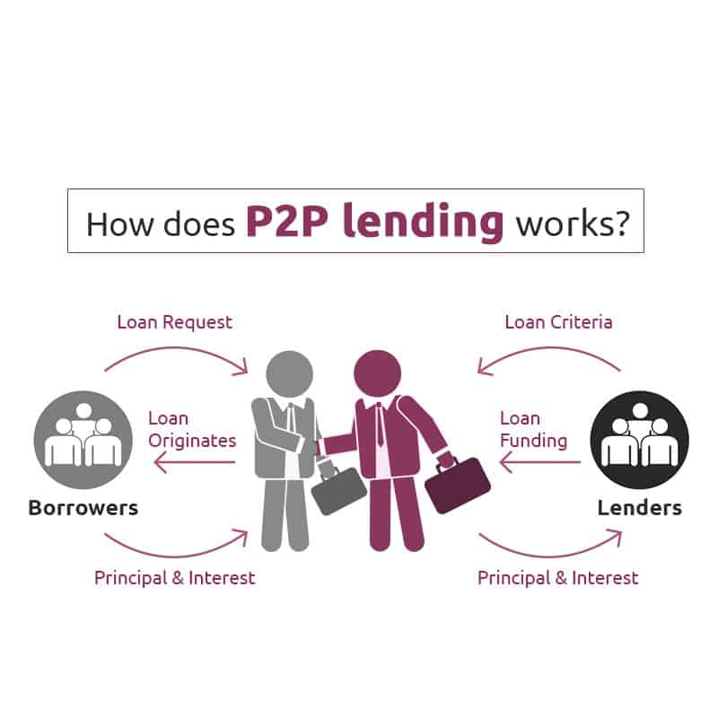

Figure P2P lending process

With the rising of Peer-to-Peer Lending (P2P / Person-to-Person Lending), there is a need for P2P lending platforms to reduce the fees for middlemen. However, these lenders and borrowers have no approach to calculate the risk of borrowing to certain borrowers and ensure their expected return. Malaysia is the leading P2P lending platform and services provider in Southeast Asia. However, it is still a major concern that the credibility of individuals, considering that the sensitive info of individuals can not be disclosed to the borrowers easily on the platform. Meanwhile, while handling so many loans on the platform, the platform can only depend on some financial and personal information to issue the loan or provide credibility endorsement for the individuals and SMEs. Lacking trustworthy algorithms to guarantee the repayment ability of borrowers has always stopped investors from investing money in P2P lending platforms. (Khan, 2022)

## Goal, Scope, and Objective

The goal of this project is to accurately determine the tax and loan pay ability of applicants by using classification techniques and predictive modeling. From this study, banks will get valuable understandings that enable them to rank the risk of loan granting approvals. A reliable model has developed not only categorizes loan applications into different loan status but also give valuable insight into their financial conditions and ability of loan repayment. Hence, banks can decrease potential losses by optimizing their credit portfolio and making sure the loan values agreed upon are in line with the applicant’s financial capability.

This study focuses on the following specific objectives:

1. To build a model that can classify the bank loan quality that individuals possess.
2. To identify the undiscovered patterns of the individual’s loan status.
3. To identify the loan-paying ability of applicants.
4. To prevent banks from approving loans to poor credit individuals.

Scope

* Time period: none
* Geography: none
* Department – Bank loan status analysis

## Methodology Selection – CRISP-DM

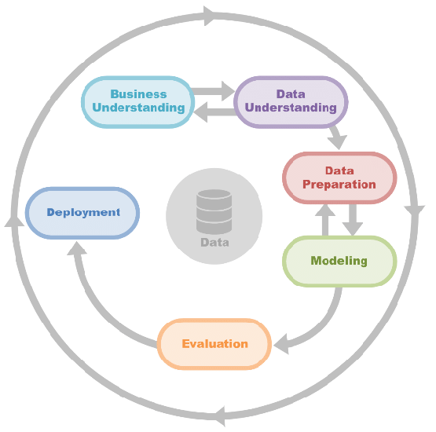

Figure  CRISP-DM

CRISP-DM is a process model and methodology from the data science process, also known as **Cr**oss **I**ndustry **S**tandard **P**rocess for **D**ata **M**ining. The CRISP-DM process model offers a summary of the data mining life cycle, it is more customized and flexible. This methodology will emphasize data exploration and visualization to uncover suspicious patterns than modeling. (IBM, 2021) To fulfill the CRISP-DM methodology, six phases are required on it.

**Phase 1: Business Understanding**

The business understanding phase is implemented to learn the customer’s needs deeply. It used to involve the section on determining the business objective, assessing the current situation, determining data mining goals, and producing a project plan. While in this phase, we should thoroughly understand customer achievement from the business perspective, address the question, ‘What does the business need?’ and set goals for the big data projects. Developing a strong business understanding is regarded as building a house base, which means it is essential for the project.

**Phase 2: Data Understanding**

The second phase data understanding phase emphasizes identifying, collecting, and analyzing the data that could assist in the project goal. It is required to acquire the data listed in the project resources, for instance, it makes perfect sense to load your data into this tool if you use it for data understanding. From the phase, we could address the question, ‘What data do we have/need? Is it clean?’ set the data and data source and determine whether the available data can meet the project’s objectives. The four main tasks allocated under the second phase are collecting initial data, describing data, exploring data, and verifying data quality. (Brian, 2021)

**Phase 3: Data Preparation**

According to the research, 80% of the project is under data preparation. The data preparation stage, also known as the data munging stage, to perfect it, the question could address is, ‘How do we organize the data for modeling?’. The data preparation phase prepares the final dataset for the modeling stage, and the data is transformed in the cases that are necessary for the big data process. To accomplish it, there are five main tasks: selecting data, cleaning data, constructing data, integrating data, and formatting data. (smartvision, na)

**Phase 4: Modelling**

The fourth phase of modeling is the shortest phase of the project, it involves building and implementing a few different modeling techniques and algorithms for the most accurate output. The question that could be addressed here is, ‘What modeling techniques should we apply?’ and accomplish the four-step: Select algorithm, generate test design, build model, and assess the model. We could keep the process iterative based on CRISP-DM characteristics until we find the best model. Execute the algorithms that can satisfy the project objective the most. (Rodrigues, 2020)

**Phase 5: Evaluation**

The evaluation phase will focus on which model best fits the nosiness and determine the next step. We can focus on ‘Which model best meets the business objectives?’ to investigate the output, the result will be presented, analyzed, and disseminated. Evaluate results, review the process, and determine the next step is the routine under this phase.

**Phase 6: Deployment**

The deployment stage’s complexity depends on the business requirement and the question, ‘How do stakeholders access the results?’ strategic decisions are taken to follow, A model is not that valuable unless a customer can access its result. The four main tasks under the phase are plan deployment, monitoring and maintenance, producing the final report, and reviewing the report. (Hotz, 2023)

# Modeling

## Exploratory Data Analysis (EDA)

### Metadata

Original dataset records: 100,000

Number of attributes: 18

|  |  |  |  |
| --- | --- | --- | --- |
| **Column** | **Description** | **Data types** | **Value** |
| Loan ID | Unique identifies for each loan | String |  |
| Customer ID | Unique identifier for each customer | String |  |
| Current Loan Amount | The current loan amount of the loan | numeric | 10.8k to 100mil |
| Term | The term of loan | categorical | Long-term, short-term |
| Credit Score | The credit score of customers | numeric | 585 to 7510 |
| Annual Income | The annual income of the customer | numeric | 76.6k to 166mil |
| Years in current job | The number of years the customer has been in the current job | categorical | < 1 year, 1 year, 2 years, 3 years, 4 years, 5 years, 6 years, 7 years, 8 years, 10+ years |
| Home ownership | The ownership status of customer home | categorical | Home_mortgage, own_home, rent |
| Purpose | The purpose of apply loan | string | Debt consolidation, other, … |
| Monthly debt | The monthly debt amount of customer | numeric | 0 to 436k |
| Years of credit history | The number of credit history years the customer has | numeric | 3.6 to 70.5 |
| Months since last delinquent | The number of months since last delinquent payment | numeric | 0 to 17 |
| Number of open accounts | The number of open accounts by customers | numeric | 0 to 76 |
| Number of credit problems | The number of credit problems the customer has | numeric | 0 to 15 |
| Current credit balance | Customer’s current credit balance | Numeric | 0 to 32.9mil |
| Maximum open credit | The maximum open credit allowed for customer | numeric | 0 to 1.54bil |
| Bankruptcies | The bankruptcies status of customer | numeric | 0 or 1 |
| Tax liens | The number of tax liens the customer has | numeric | 0 to 15 |
| Loan status | The status of loan | String | Fully paid, charged off |

Table 1 metadata table

##### Chi-Square Graph

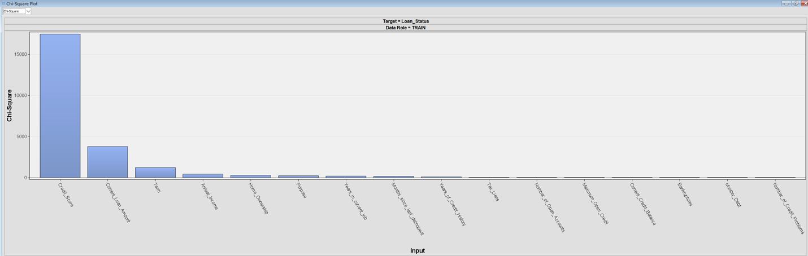

Figure Chi-square graph

The chi-square testing is to identify the potential association of the categorical value. The Term is the most important indicator that affects the result of individuals' credibility, followed by Homeownership, purposes, and years in the current job.

##### Variables Worth Graph

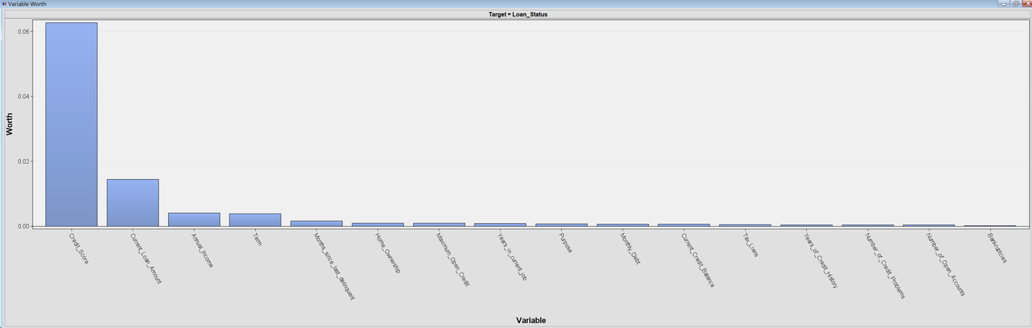

Figure Variable worth graph

Among the attributes in the dataset, Credit_score, Current_Loan_Amount, and Term are the top 3 attributes in the variables worth the graph. The higher the variable worth, the more important the variable is in determining the result of the target variable (Loan_Status). For those variables that are worth less than 0.01, we might consider eliminating them from the training dataset during the data preprocessing stage. However, deleting data might also lead to information loss and henceforth we will further consider the elimination and adjust the way we treat the dataset attributes when the modeling is finished.

##### Target variable distribution

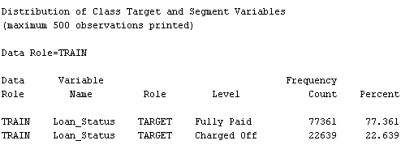

Figure target variables distribution table

The distribution of loan status in this dataset is likely to be 80:20 for the positive case (Fully paid) and the negative case (Charged off). They record 77361 and 22639 observations respectively.

### Class Variable Summary Statistic

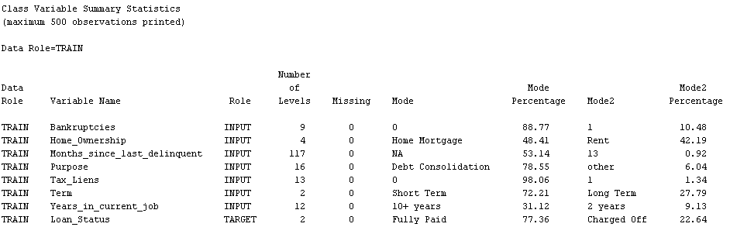

Figure class variable summary statistics

According to the summary of the dataset's categorical variables, most of the attributes have no missing values except Months_since_last_delinquent. Notably, the proportion of mode 1 (the most in the columns) and mode 2 (the second most in the column) should not have a big gap in its percentage value. However, this imbalance occurs in Bankruptcies, Months_since_last_delinquent, Purpose, Tax_Liens, Term, Years_in_current_job, and Loan_Status. In other words, these imbalances will trigger the bias for the modeling outcome at the end and the model we trained will not be able to accurately predict the minority class and thereby greatly affect the result of prediction and classification. Henceforth, we should propose the resampling techniques for this dataset in the analysis later.

Besides, when the missing value in an attribute column has more than 50%, the analyst should consider dropping it as replacing so many missing values in one column causes the training data unable to reflect the real situation of the problems that this project tries to deal with. ‘Months_since_last_delinquent’ is the column with a great portion of missing data.

### Interval Variable Summary Statistic

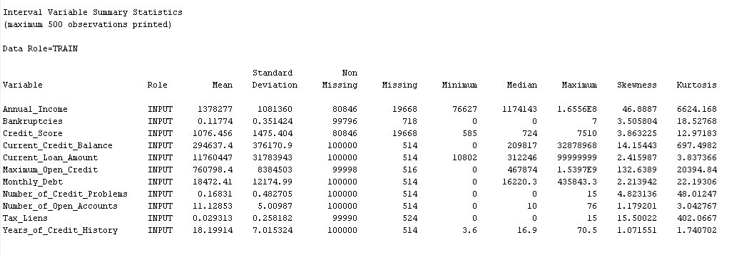

Figure interval variables summary statistics

The numerical variables in this loanStatus dataset are mostly having missing values. The most ideal solution to impute these missing values are always the median value of the column as the median value does not affect the standard deviation of the columns. For skewness, Annual_Income, Current_Credit_Balance, Maxium_Open_Credit are highly skewed with values of more than 3. For the kurtosis value, all attributes also showing highly skewed characteristics with values beyond 3. Therefore, data transformation will be necessary to apply these attributes. Common data transformation includes box-cox transformation, min-max transformation, logarithmic, square root, and so on.

**Variable Summary**

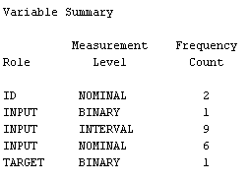

Figure Variable Summary

From the dataset variable summary above shown, there are two nominals in the ID role, 6 in the input role, one binary in the input role and one binary measurement level in the target role, and 9 interval inputs.

### Overview of Attributes

##### Years in current job

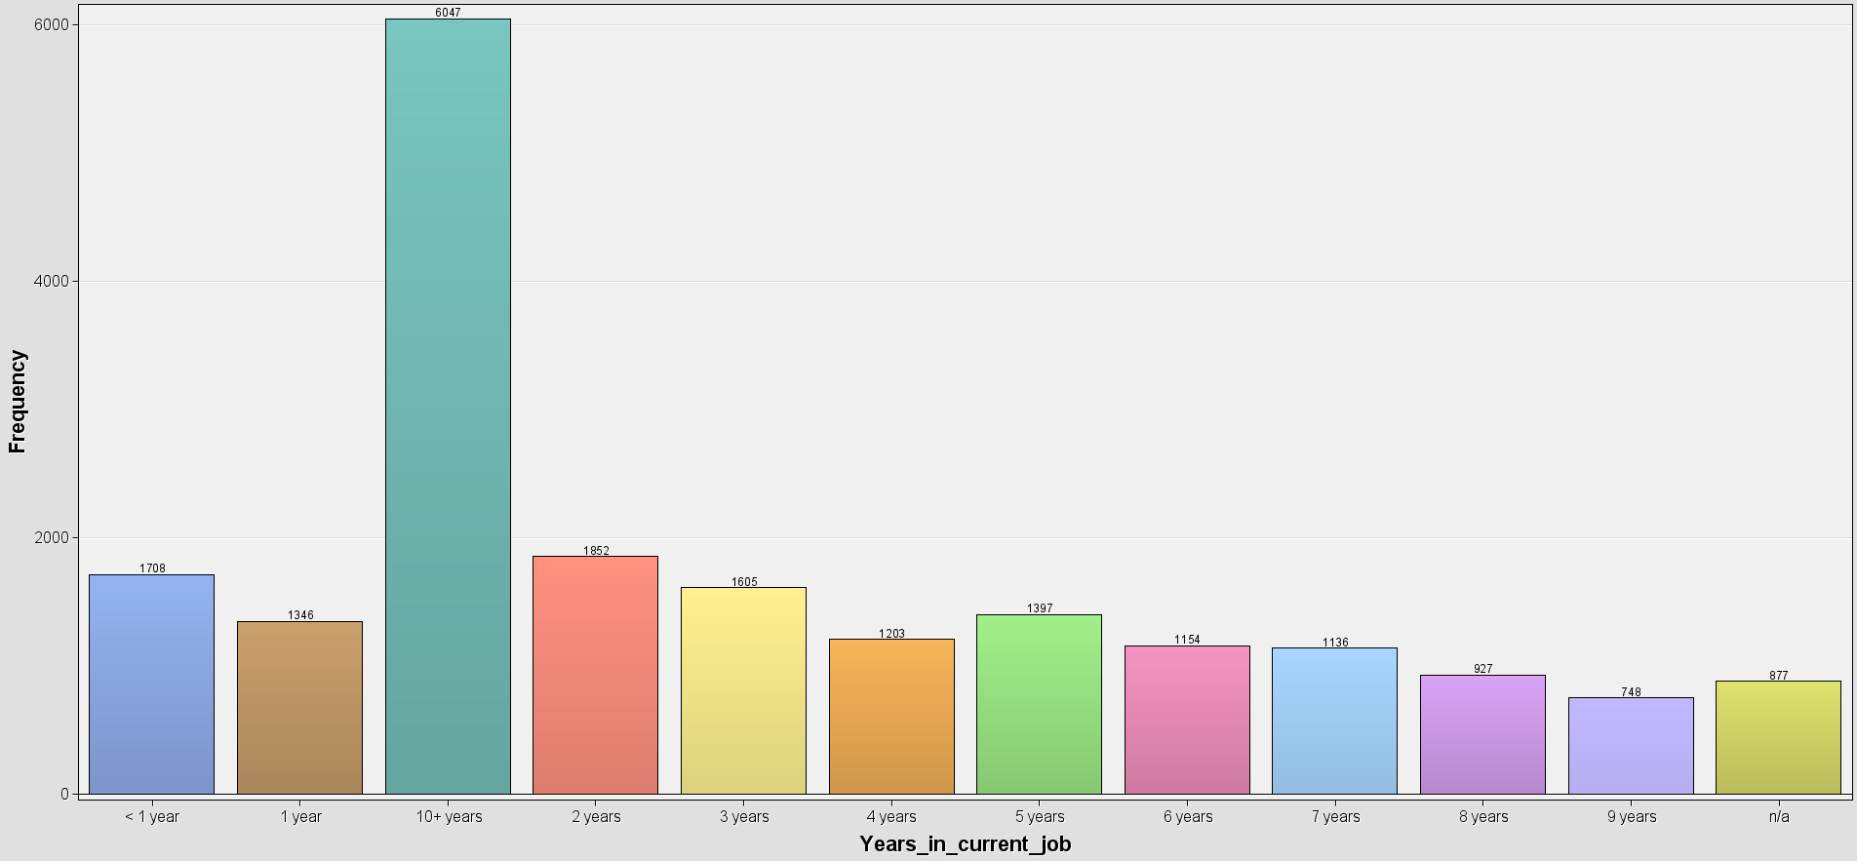

Figure years in current job bar chart

Years in the current job show the duration of the loan applicants stay at their current position in the past. Understanding the employment situation of the applicants help loan issuers to determine whether individuals have financial ability in terms of income stability and repayment ability. Most of the applicants in this dataset have been staying in their current job for more than 10 years.

##### Maximum Open Credit

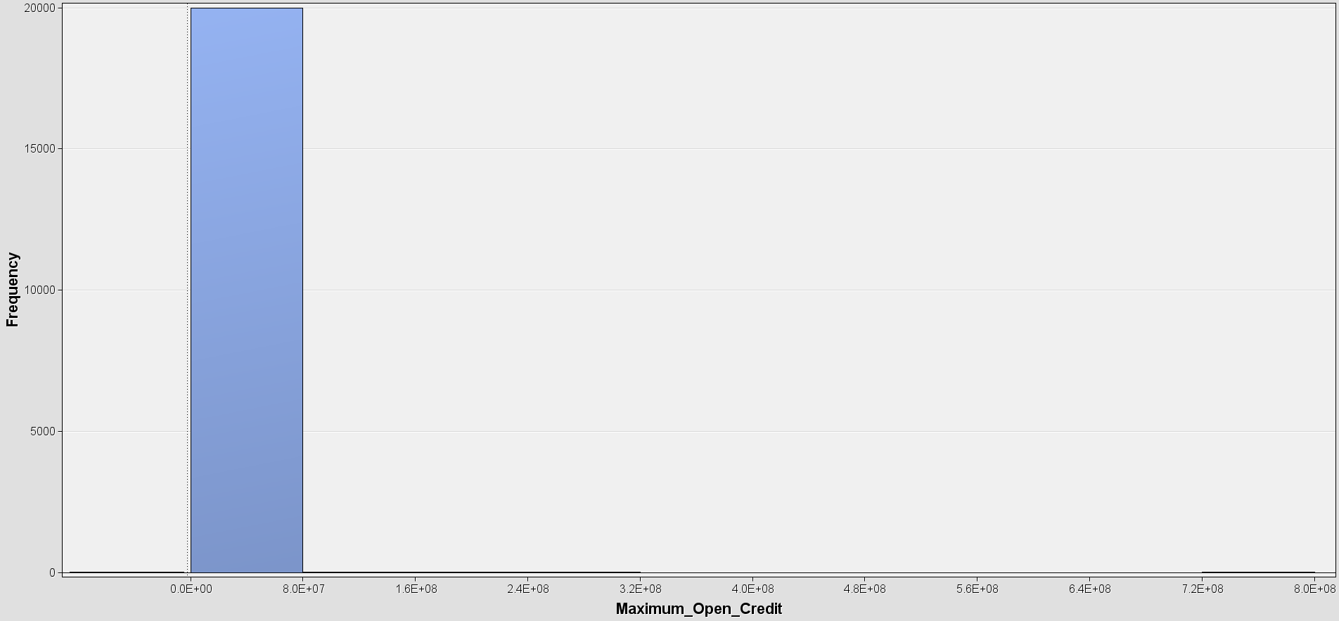

Figure maximum open credit histogram

The maximum open credit of individuals symbolizes the individual’s creditworthiness. The higher the maximum open credit of individuals, the better the credibility of individuals. Most of the loan applicants have maximum credit below 8 million.

##### Purpose

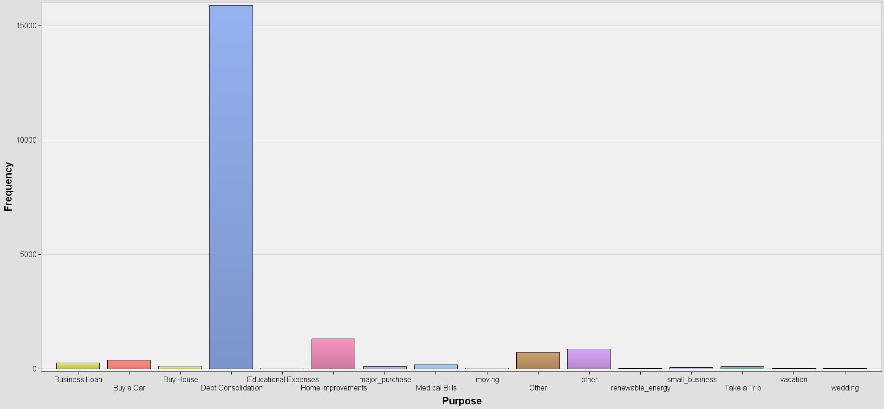

Figure loan purpose bar chart

The purpose of applicants to have loan are mostly due to debt consolidation. Other purposes like home improvement and other purposes are also the main reason driving the applicants to apply for the loan. Here we also notice a data inconsistency for the ‘other’ category that the capital letter of ‘o’ causes there are 2 columns for the ‘other’ purpose.

##### Bankruptcies

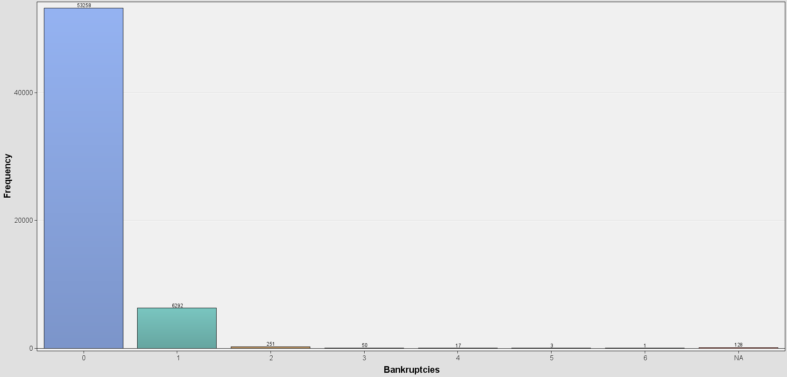

Figure bankruptcies level bar chart

Bankruptcies are one of the columns that are included in the dataset to make the prediction on loan quality expectations. Most of the bankruptcies’ status is 0, followed by 1. Only a few of them have serious bankruptcy cases with 3 to 5.

##### Current Credit Balance

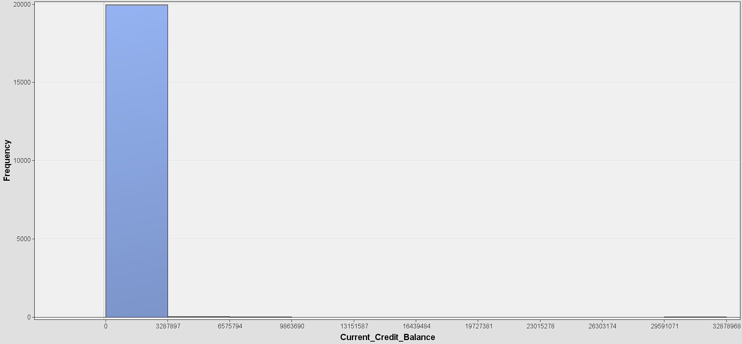

Figure current credit balance histogram

The above diagram is the histogram of the applicant's current credit balance. Most of the applicants have around 328k credit balance.

##### Current Loan Amount

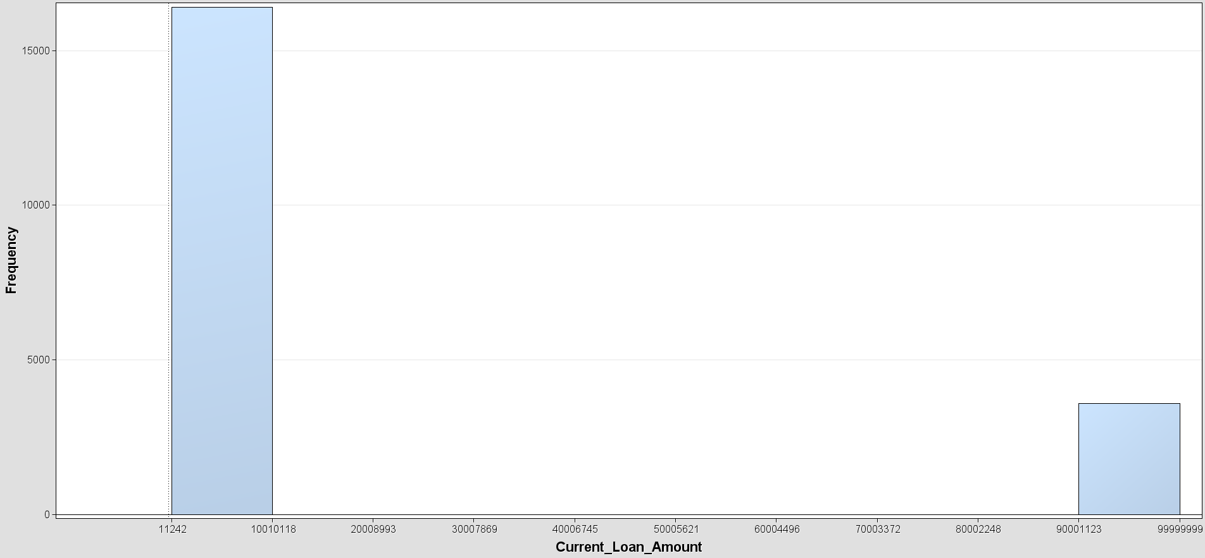

Figure current loan amount histogram

For the current loan number of applicants, most of them have a 10 million to 251k loan amount. The loan amount might affect the financial and repayment ability of individuals. The loan issuer always checks on the current debt of the applicant.

##### Number of Open Accounts

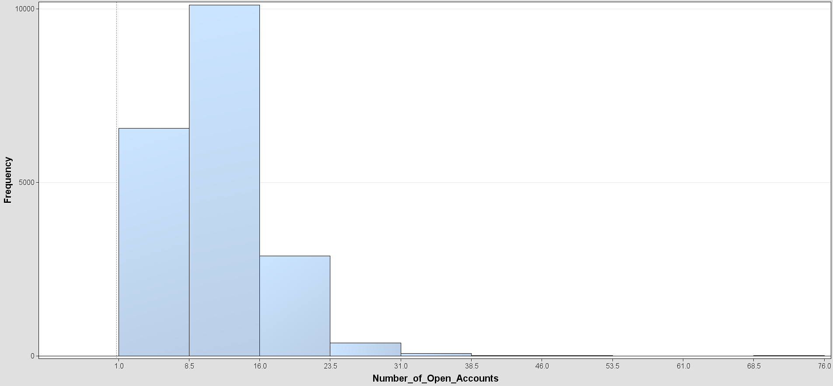

Figure number of open accounts histogram

Applicants have many bank accounts for different uses. It can be in one bank or any bank. The applicants in this dataset mostly have 8.5 to 16 accounts.

##### Months since last delinquent

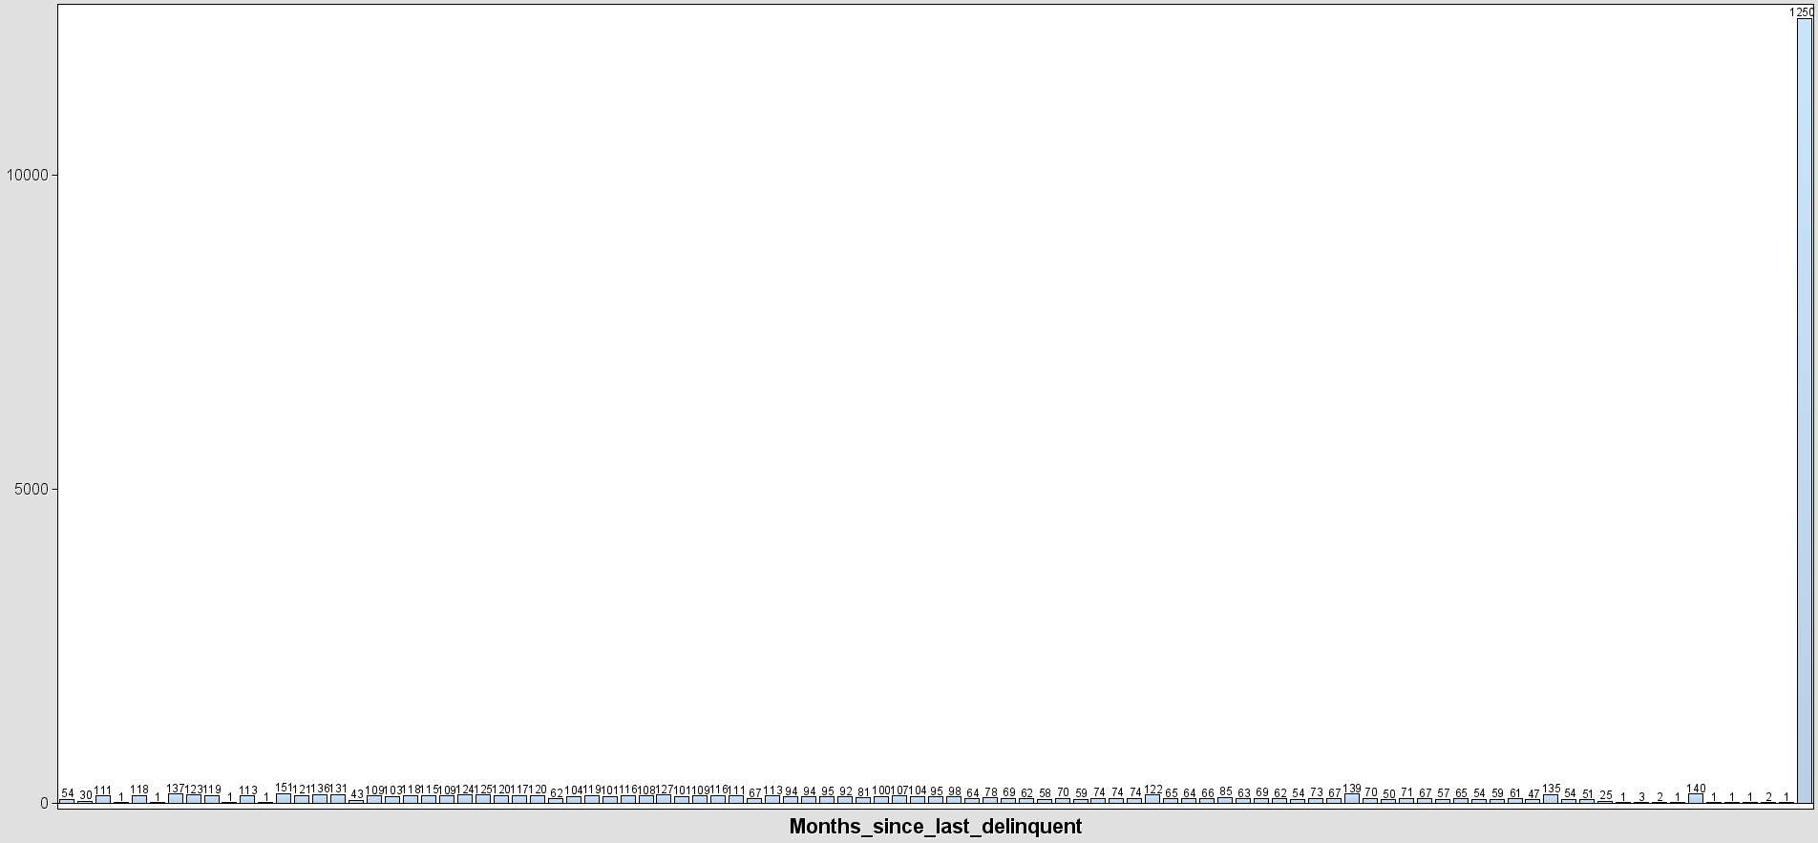

Figure months since last delinquent histogram

Delinquent behavior and history determine whether he or she is highly reliable as the customer's payability is in doubt when they make the payment needed after the due date stated. The last delinquent record of the applicants are mostly recording for 125 months.

##### Number of Credit Problems

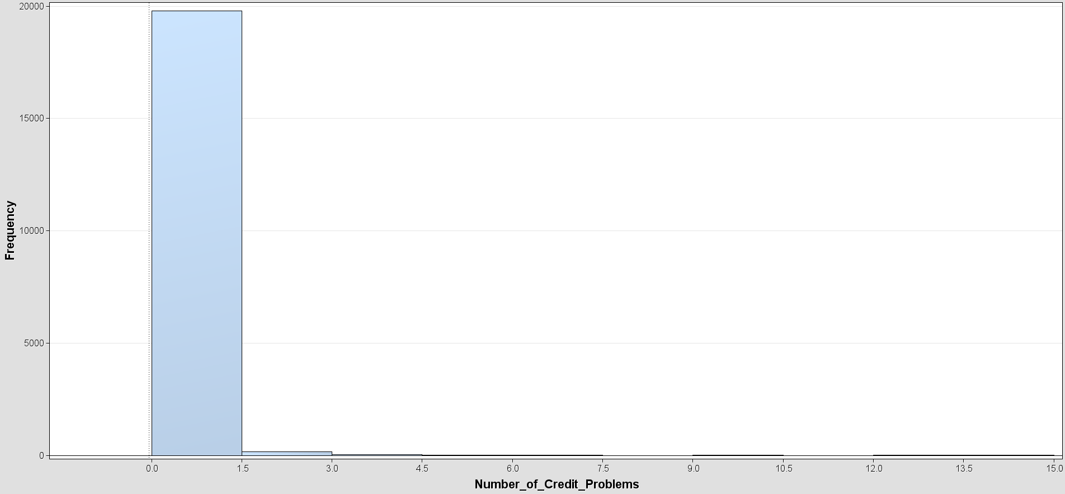

Figure number of credit problems histogram

The number of credit problems indicates the repayment ability of the individuals. Most of the applicants have great credibility with 0 credit problems, and some of them have 1 to 15 problems with themselves.

##### Years of Credit History

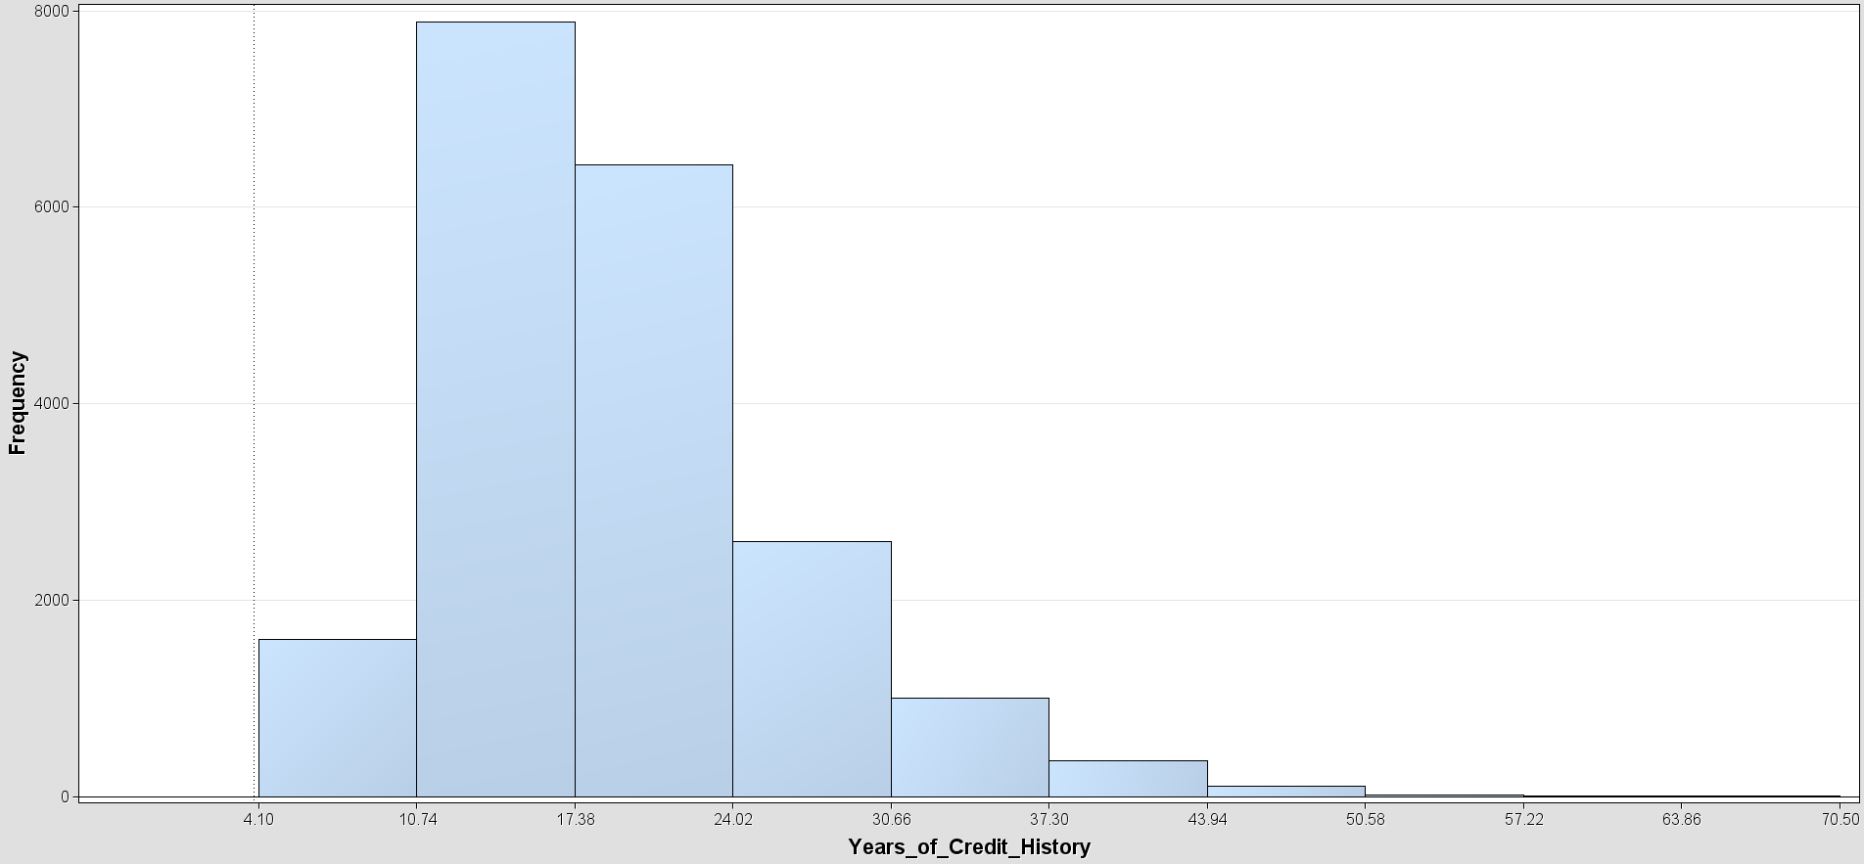

Figure years of credit history histogram

The years of credit history data ensure that the record of applicants is reliable as short credit history is not able to reflect the real credibility of one. The credit history years of applicants mostly drop to 10 to 17 years.

##### Credit Score

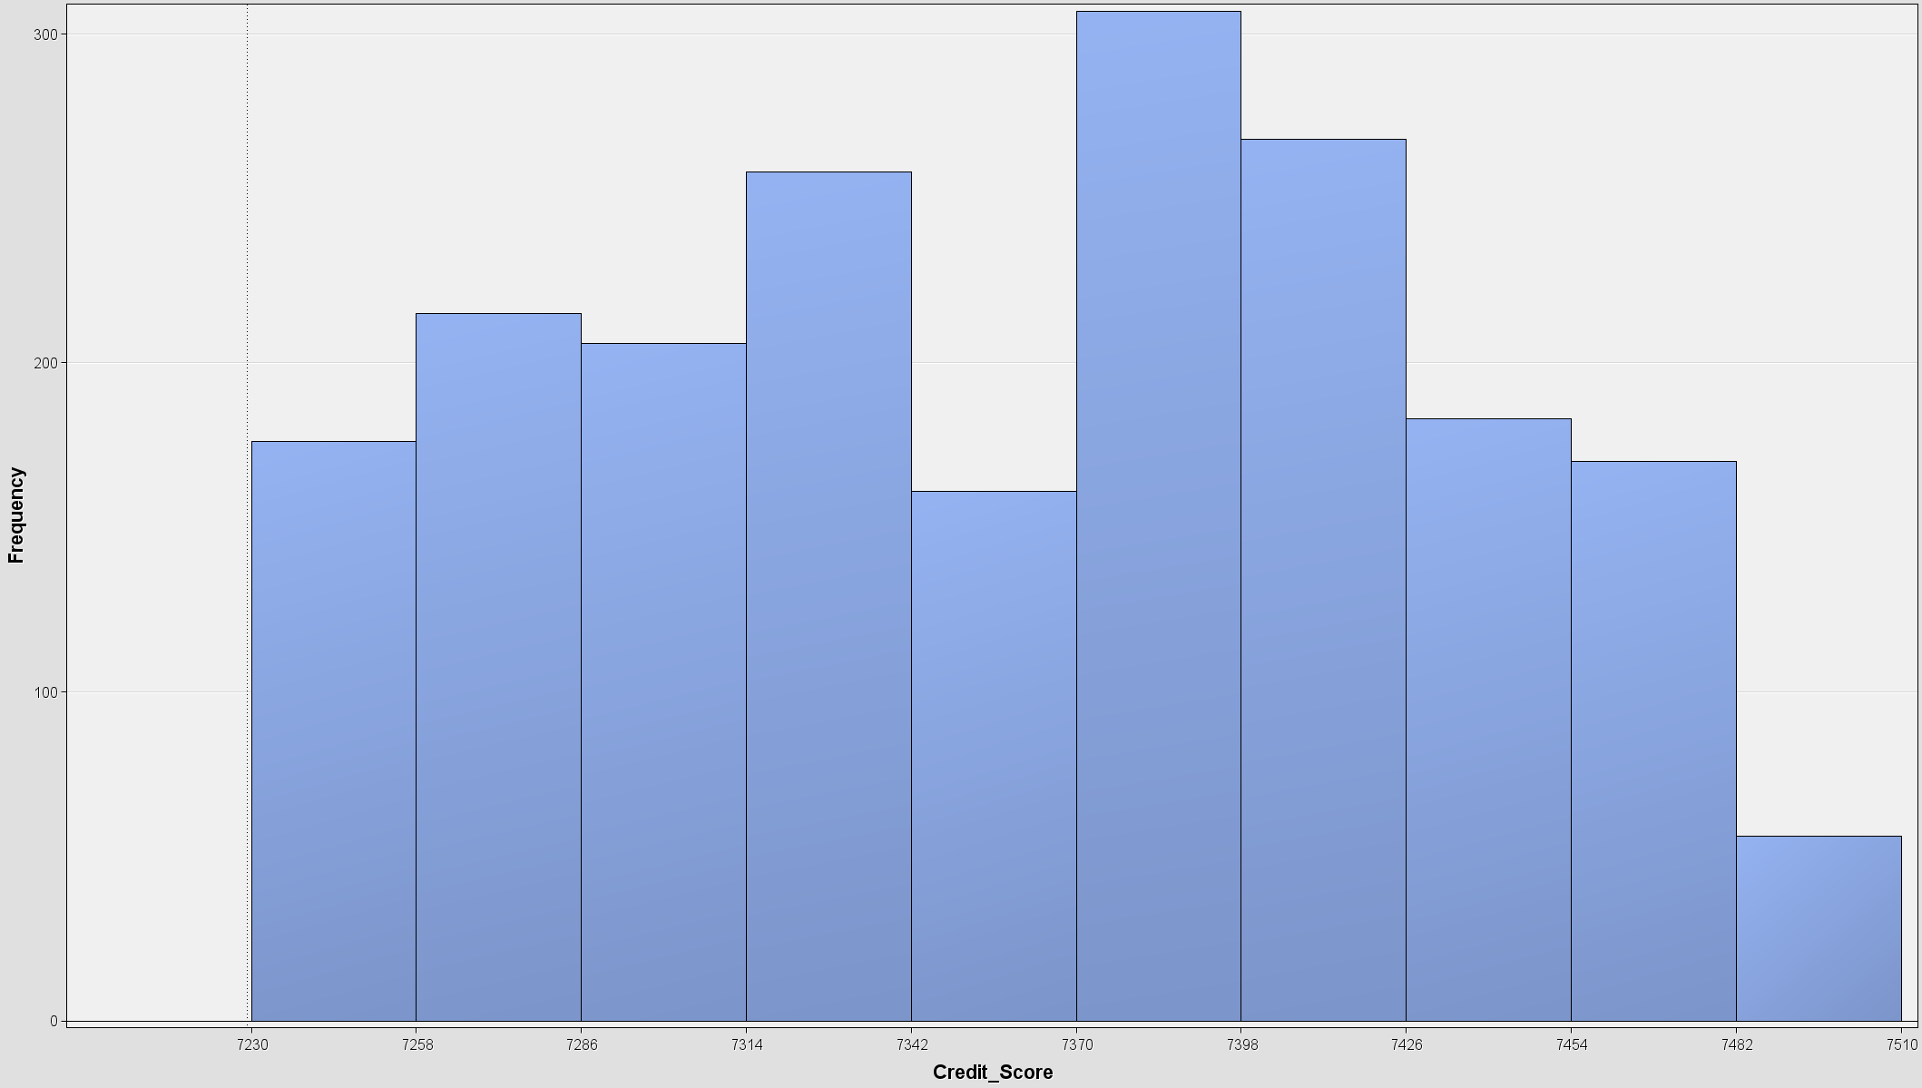

Figure credit score histogram

The credit score is the method to estimate the reputability and payability of individuals. The individual data we included in this dataset mostly having credit scores between 7370 to 7398.

##### Annual Income

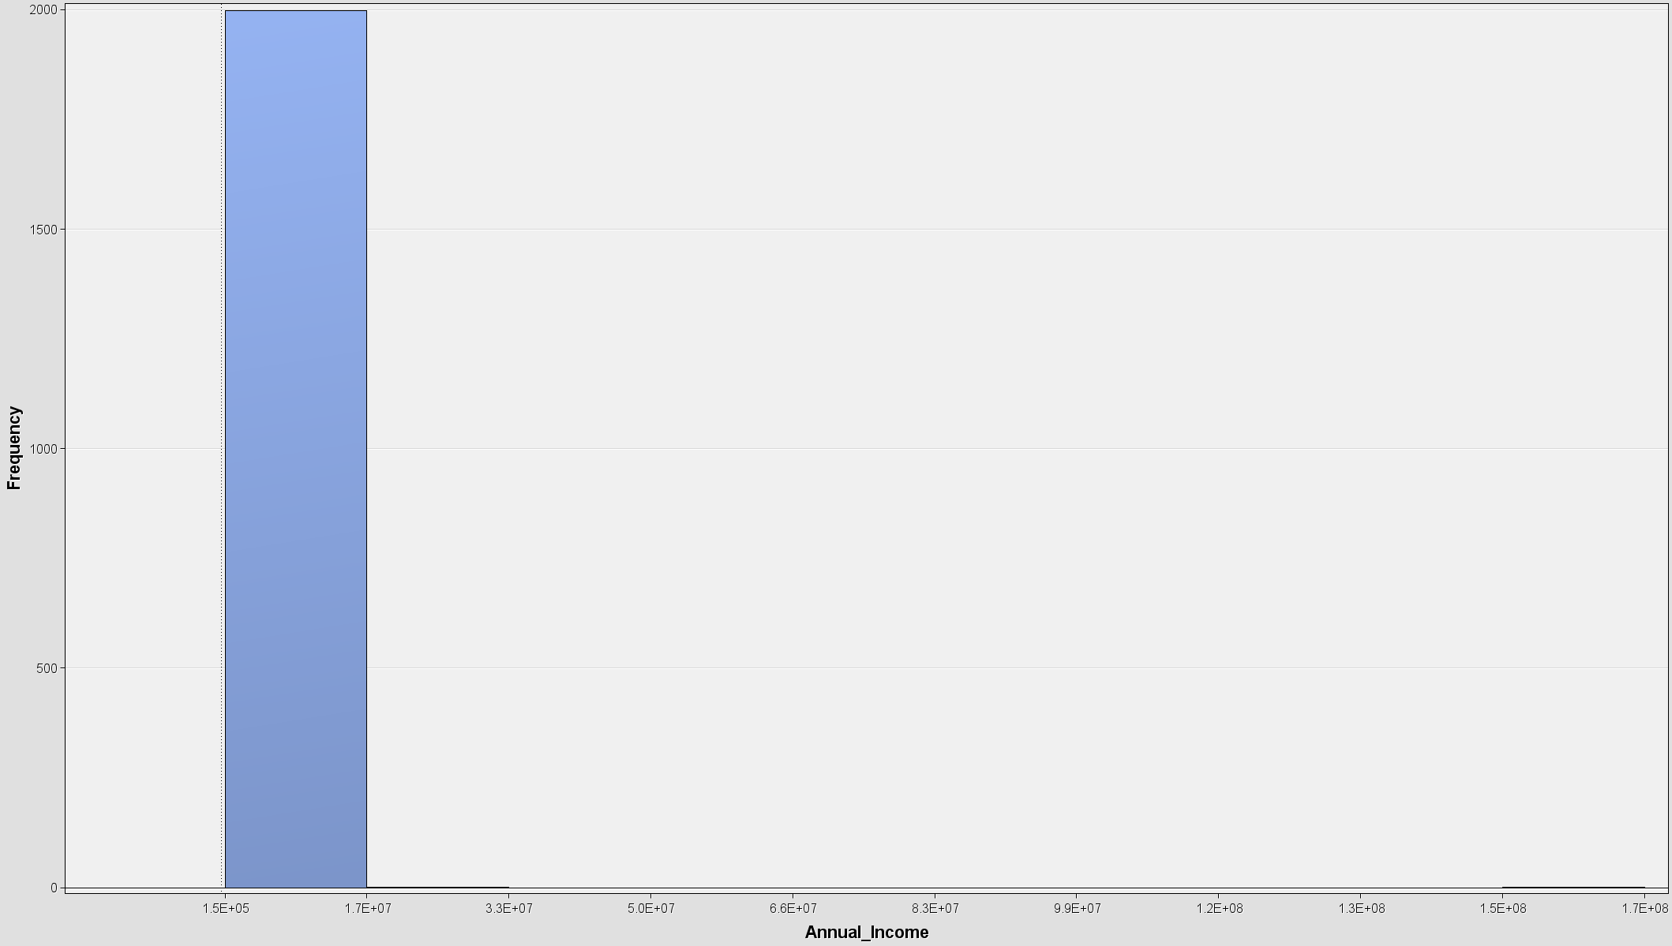

Figure annual income histogram

The individual who has a higher income has more flexibility in allocating his money to pay the loan. According to the annual income of the individual, normal people have an annual income of 110k to 170k.

##### Home Ownership

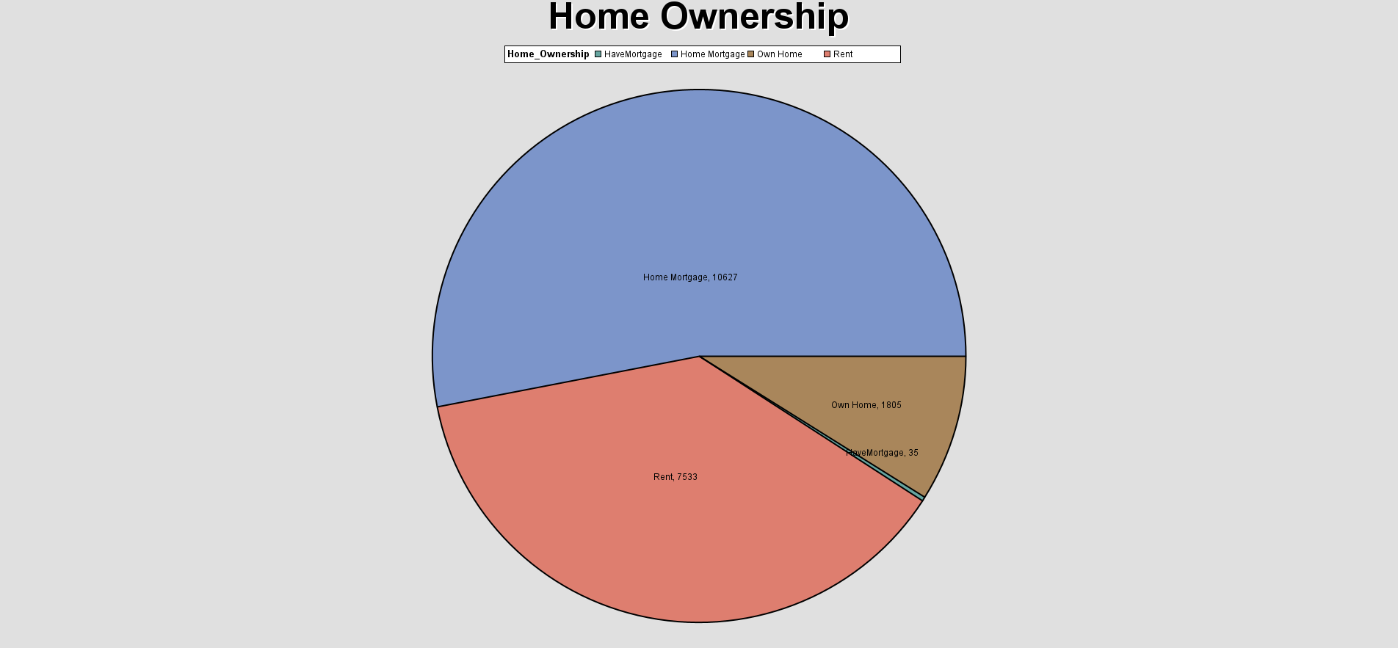 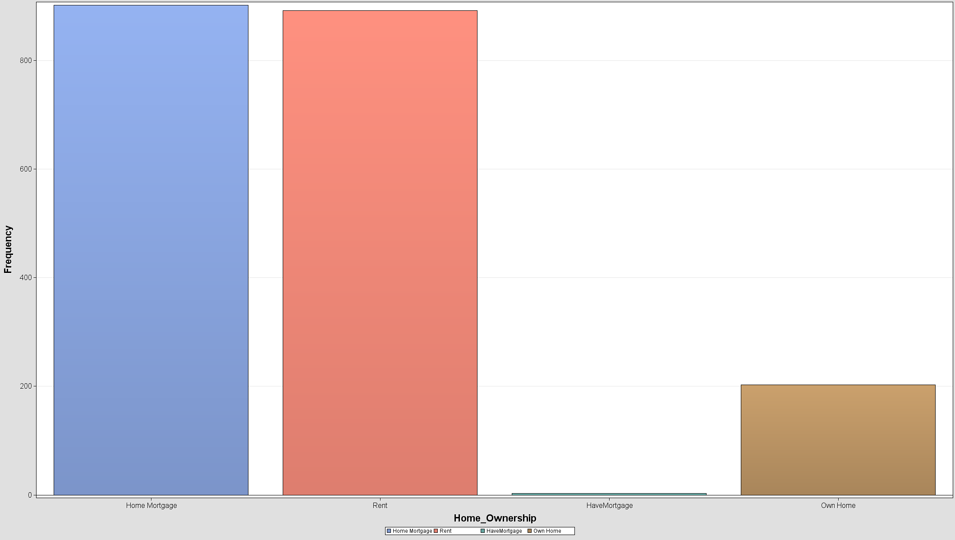

Figure homeownership bar chart and pie chart

Homeownership shows whether the individual has the property to be taken out as a mortgage to the bank or not. The quality of the mortgage also affects the decision of the bank whether to issue the loan as it might affect how much money the bank can get back when the individual fails to make repayment. Most of the individual in the dataset has mortgaged their house while some of them rent their current house or own their own house. Notably, the inconsistency occurs here as ‘HomeMortgage’ and ‘Home Mortgage’.

##### Term

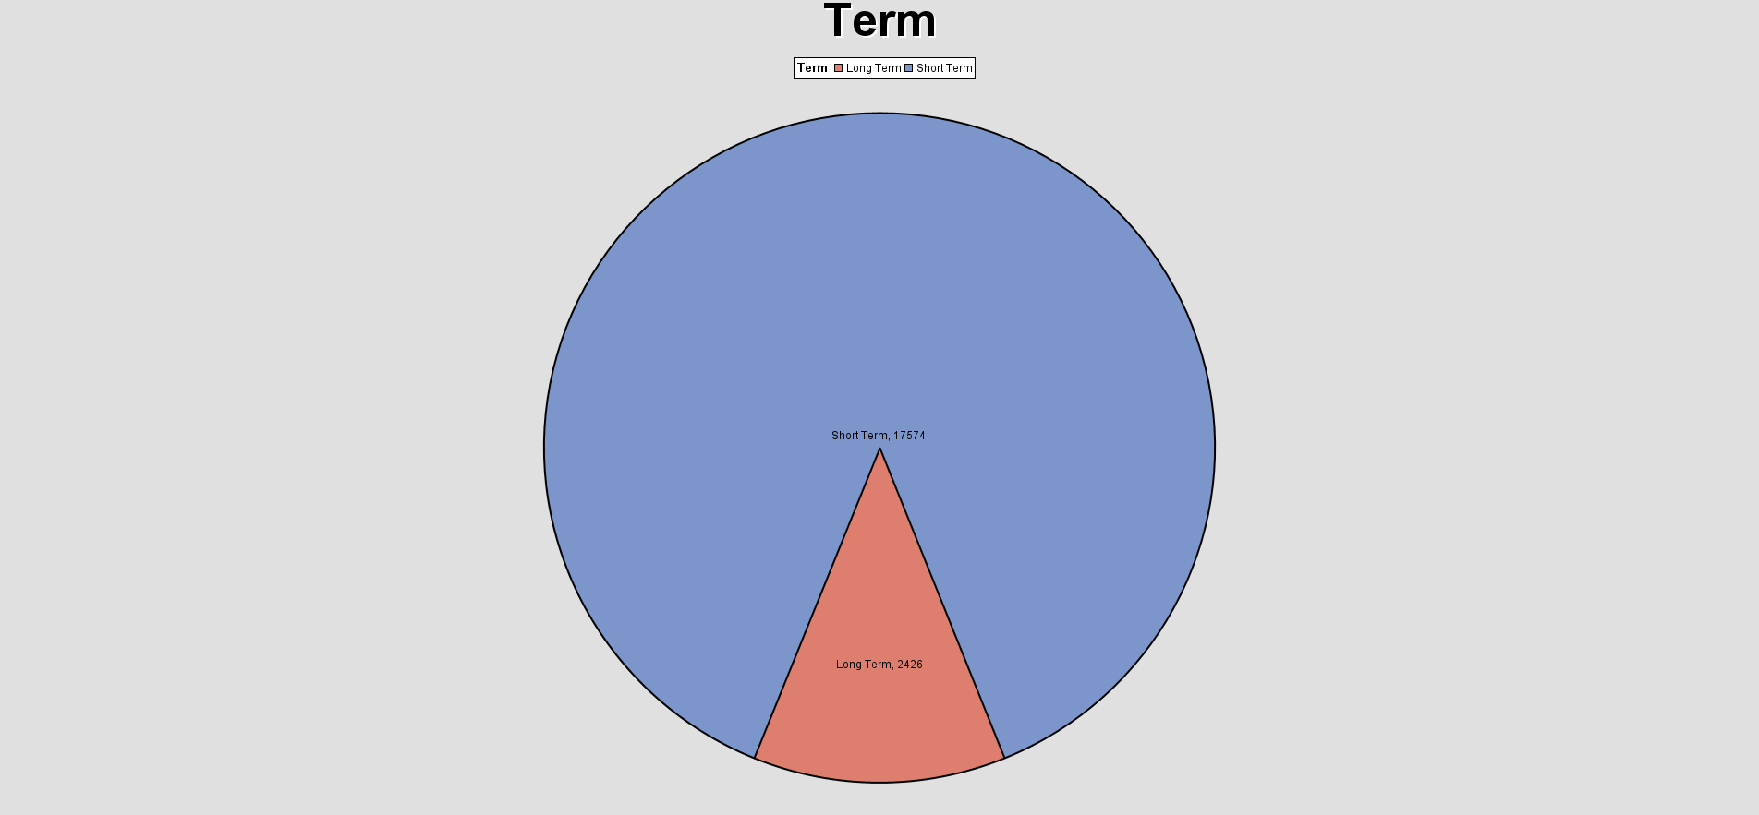

Figure loan term pie chart

The term of the loan determines the timeframe for the bank to get their loan amount back and make a profit. Most of the loans recorded in the dataset are short-term loans while long-term loans occupy less than a quarter.

##### Tax Liens

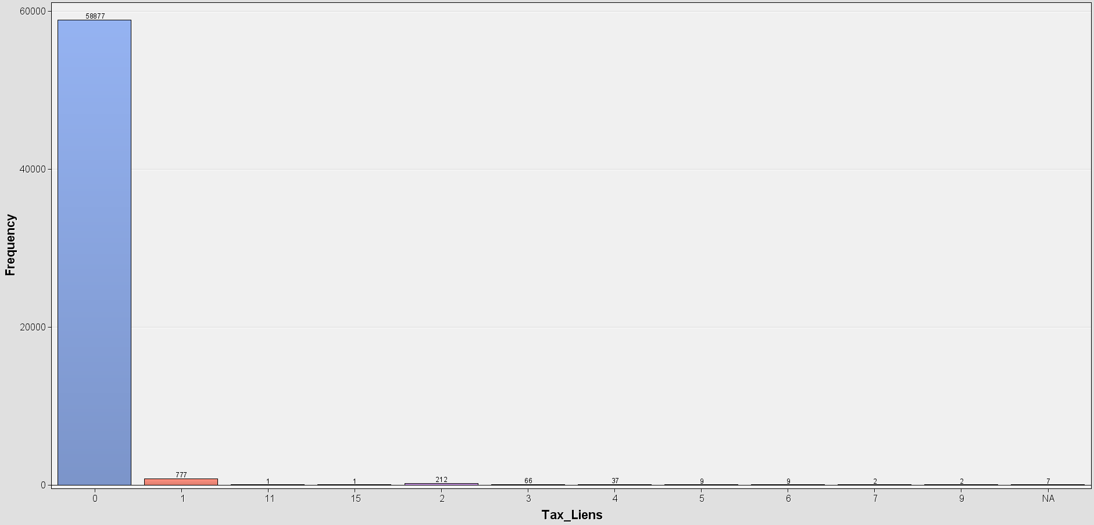

Figure tax liens bar chart

Tax liens are official claims that a government agency has made on a piece of property because of unpaid taxes. The government may file a lien against a person's or company's property as a way of recovering the unpaid tax debt when an individual or business fails to pay their property taxes or other tax obligations. The number of tax liens owned by individuals is 0. On the other hand, 777 people own 1 tax lien while 2 people have the most tax liens (9).

##### Loan Status

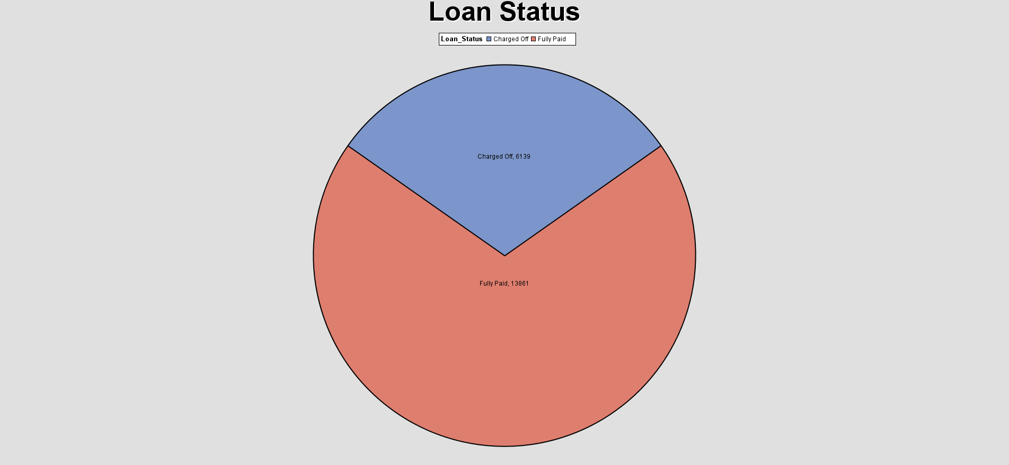

Figure loan status pie chart

Loan status is the target variable for this dataset. Around 14,000 of loans are fully paid whereas 6139 of loans are charged off.

##### Home Ownership with Annual Income

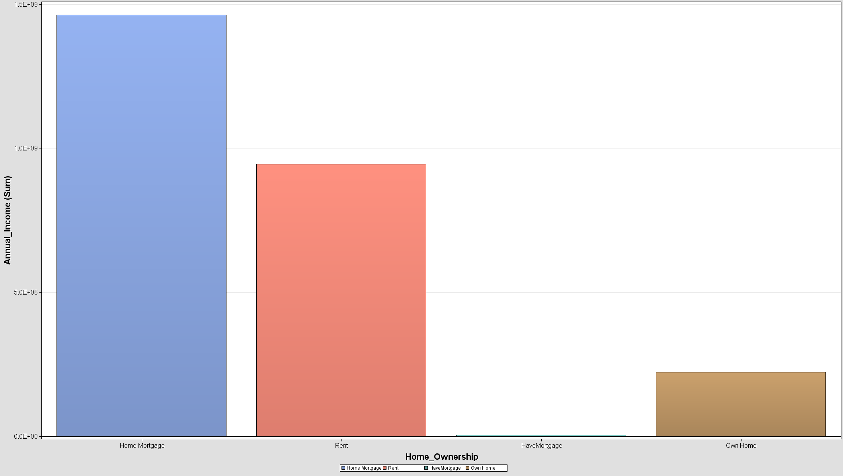 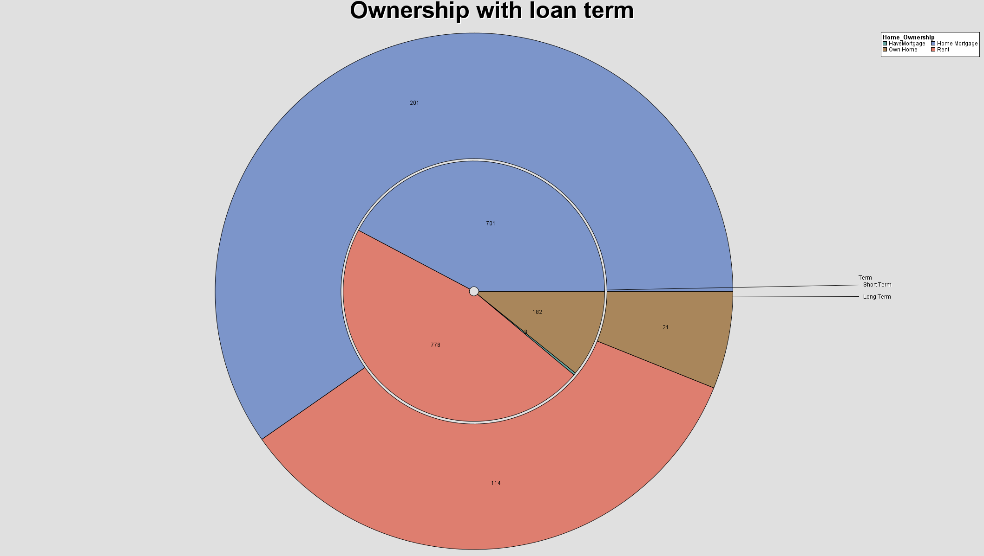

Figure home ownership with annual income and loan term

When applying for a loan, the bank is not only asking the applicants to prove their payability but also to provide their property mortgage so that the bank can ensure they pay the loan installment on time. Most of the people with a home mortgage have higher incomes than other property owners. Meanwhile, the people who are staying in rented houses are having lower annual incomes than the home mortgage people. The ownership of the property also indirectly shows that the people with the short-term loan are mostly renting houses instead of owning their property.

##### Tax Liens with Loan Status

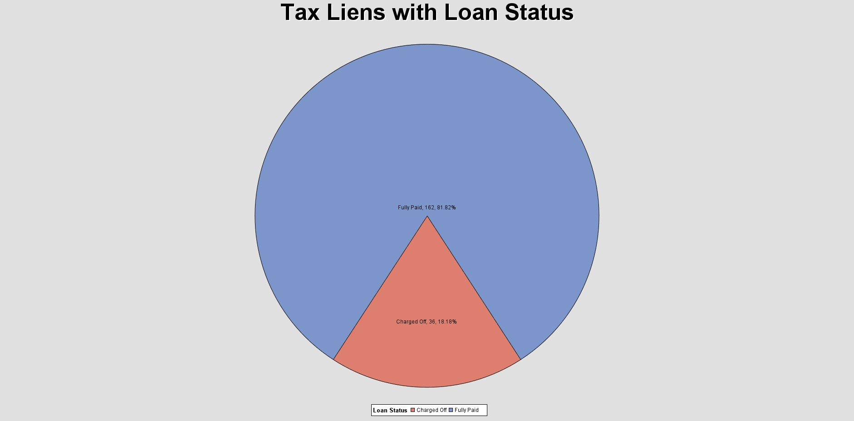

Figure tax liens with ownership pie chart

82% of people successfully pay the loan amount but almost one-fifth of applicants are charged off, which means the liens are unable to fully recover the loan.

##### Monthly Debt with Credit Score

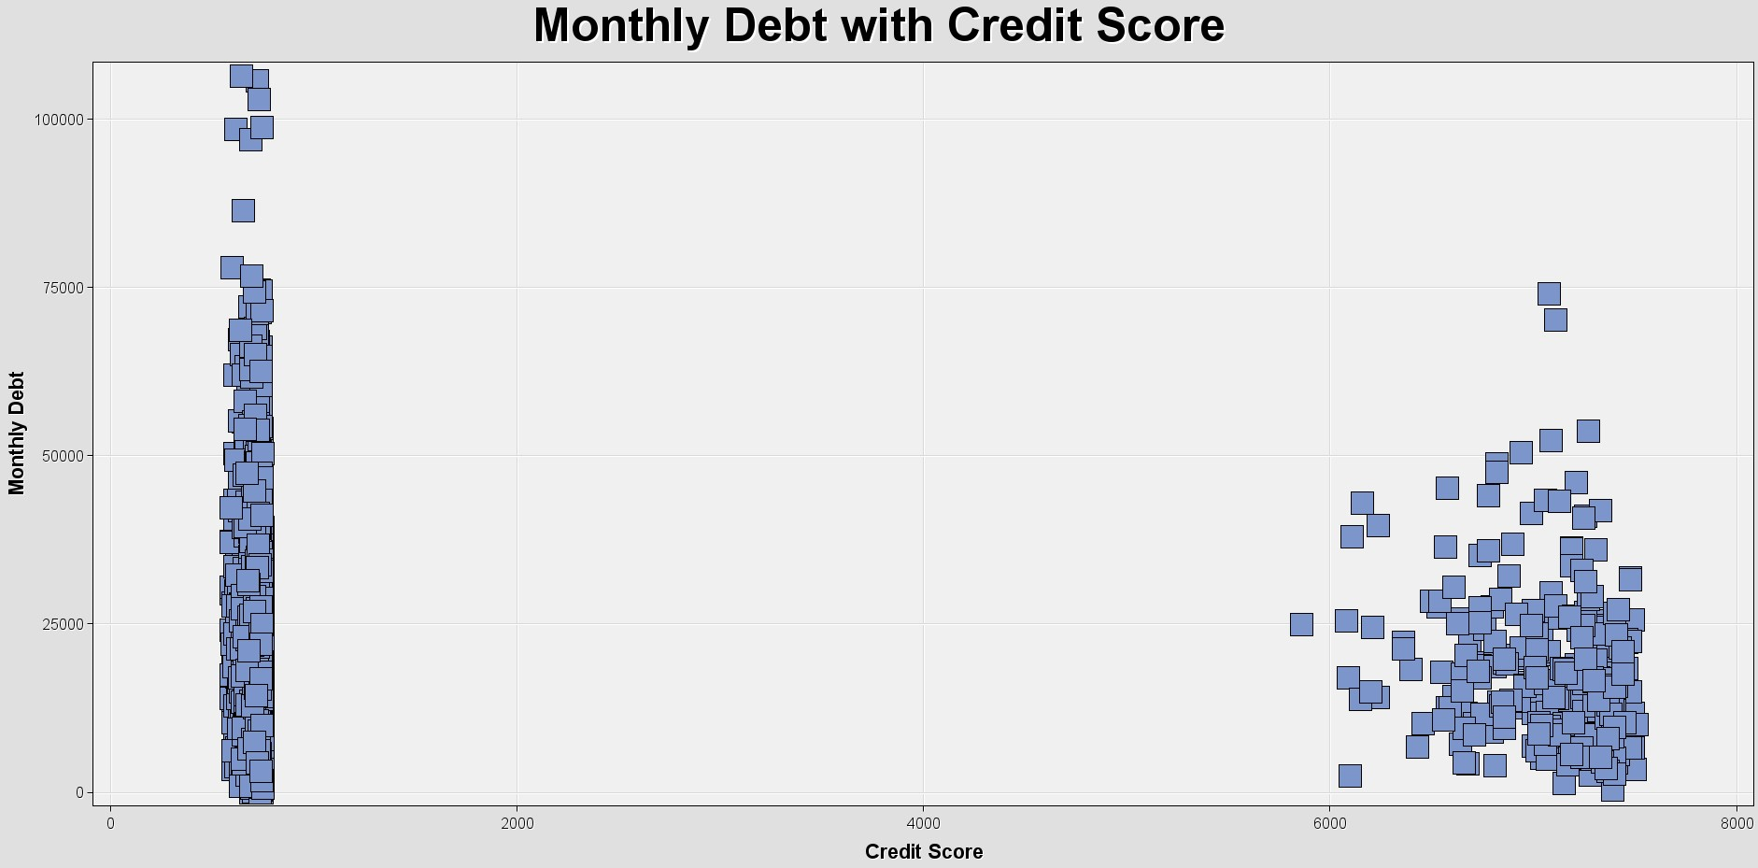

Figure monthly debt with credit score scatter plot

Averagely, people with lower credit score have a higher monthly debt whereas people with higher credit score has less monthly debt to pay. However, this also indicates that the people with higher income have higher credit scores, so the bank is willing to issue the loan to high-income individuals.

## Data Preprocessing

### Data Cleaning

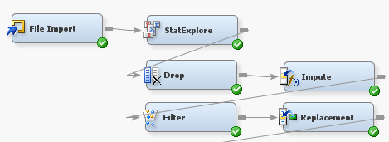

Figure Data Pre-Processing SAS Node

The first stage of obtaining prepared raw data for analysis is data pre-processing. It includes a variety of tasks aimed at improving data quality and preparing it for effective analysis. In this procedure, missing values are dealt with by imputation, unwanted data will be dropped, and Inconsistence data will proceed with replacement editor. Additionally, features could be normalized or scaled to maintain consistency and stop some factors from overpowering others. The result of data pre-processing is to produce a more accurate and efficient dataset that enhances the ability of analytical models and algorithms to produce valuable insights.

Below is the class summary statistic showing the class variables and the related information as numbers of levels, missing data, mode, mode percentage, mode2, and mode2 percentage from the dataset.

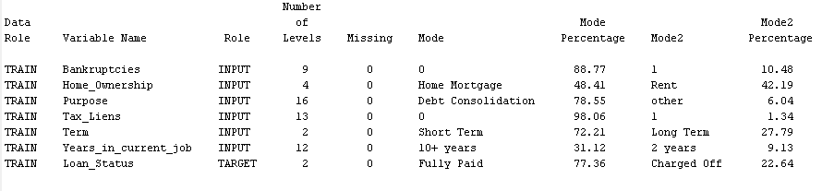

Figure Class Variables Summary Statistic

|  |  |
| --- | --- |
| **Variables** | **Data Exploration/ Understanding/Findings** |
| **Bankruptcies**  **(INPUT):** | * This variable has 9 levels and no missing values. * Mode is ‘0’, which involved 88.77 Mode Percentage * Mode 2 is ‘1’, which occurs 10.48 in Mode2 percentage. |
| **Home_Ownership**  **(INPUT):** | * This variable has 4 levels and no missing values. * Mode is ‘Home Mortgage,’ which involved 48.41 Mode Percentage * Mode 2 is ‘Rent,’ which occurs 42.19 in Mode2 percentage. |
| **Purpose**  **(INPUT):** | * This variable has 16 levels and no missing values. * Mode is ‘Debt Consolidation,’ which involved 78.55 Mode Percentage * Mode 2 is ‘other,’ which occurs 6.04 in Mode2 percentage. |
| **Tax_Liens**  **(INPUT):** | * This variable has 13 levels and no missing values. * Mode is ‘0,’ which involved 98.06 Mode Percentage * Mode 2 is ‘1,’ which occurs 1.34 in Mode2 percentage. |
| **Term**  **(INPUT):** | * This variable has 2 levels and no missing values. * Mode is ‘Short Term,’ which involved 72.21 Mode Percentage * Mode 2 is ‘Long Term,’ which occurs 27.79 in Mode2 percentage. |
| **Years_in_current_job**  **(INPUT):** | * This variable has 12 levels and no missing values. * Mode is ‘10+ years,’ which involved 31.12 Mode Percentage * Mode 2 is ‘2 years,’ which occurs 9.13 in Mode2 percentage. |
| **Loan_Status**  **(TARGET):** | * This variable has 2 levels (binary) and no missing values. * Mode is ‘Fully Paid,’ which involved 77.36 Mode Percentage * Mode 2 is ‘Charged Off,’ which occurs 22.64 in Mode2 percentage. |

Table Data Preprocessing class attributes findings

Besides that, the interval summary statistic indicates all the interval variables and all the related variables’ information from the dataset. For instance, role, mean, standard deviation, missing and non-missing data, minimum, median, maximum, skewness, and kurtosis.

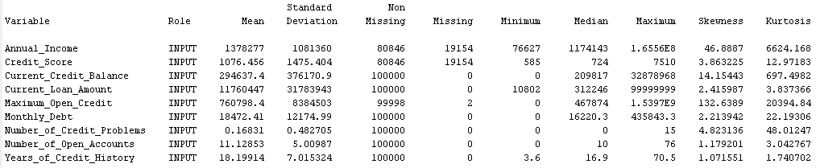

Figure Interval Variables Summary Statistic

|  |  |  |
| --- | --- | --- |
| **Variables** | **Data Exploration/ Understanding/Findings** | **Pre-processing techniques used** |
| **Annual_Income**  **(INPUT):** | * The mean is 1378277, and the standard deviation is 1081360. * There are 80846 non-missing data and exist 19154 missing data. * Its minimum, median, and maximum are 76627, 1174143, and 1.6556E8. * The skewness is positively skewed at 46.8887 and the kurtosis at 6624.168. | IMPUTE +  TRANSFORMATION |
| **Credit_Score**  **(INPUT):** | * The mean is 1076.456, and the standard deviation is 1475.404. * There are 80846 non-missing data and exist 19154 missing data. * Its minimum, median, and maximum are 585, 724, and 7510. * The skewness is positively skewed at 3.863225 and the kurtosis at 112.97183. | IMPUTE |
| **Current_Credit_Balance**  **(INPUT):** | * The mean is 294637.4, and the standard deviation is 376170.9. * There is 100 0000 occurrence data and no missing data. * Its minimum, median, and maximum are 0, 209817, and 32878968. * The skewness is positively skewed at 14.15443 and the kurtosis at 697.4982. | - |
| **Current_Loan_Amount**  **(INPUT):** | * The mean is 11760447, and the standard deviation is 31783943. * There is 100 0000 occurrence data and no missing data. * Its minimum, median, and maximum are 10802, 312246, and 99999999. * The skewness is positively skewed at 2.415987 and the kurtosis at 3.837366. | - |
| **Maximum_Open_Credit**  **(INPUT):** | * The mean is 760798.4, and the standard deviation is 8384503. * There are 99998 non-missing data and exist 2 missing data. * Its minimum, median, and maximum are 0, 467874, and 1.5397E9. * The skewness is positively skewed at 132.6389 and the kurtosis at 20394.84. | IMPUTE +  TRANSFORMATION |
| **Monthly_Debt**  **(INPUT):** | * The mean is 18472.41, and the standard deviation is 12174.99. * There is 100 0000 occurrence data and no missing data. * Its minimum, median, and maximum are 0, 16220.3, and 435843.3. * The skewness is positively skewed at 2.213942 and the kurtosis at 22.19306. | - |
| **Number_of_Credit_Problems**  **(INPUT):** | * The mean is 0.16831, and the standard deviation is 0.482705. * There is 100 0000 occurrence data and no missing data. * Its minimum, median, and maximum are 0, 0, and 15. * The skewness is positively skewed at 4.823136 and the kurtosis at 48.01247. | - |
| **Number_of_Open_Accounts**  **(INPUT):** | * The mean is 11.12853, and the standard deviation is 5.00987. * There is 100 0000 occurrence data and no missing data. * Its minimum, median, and maximum are 0, 10, and 76. * The skewness is positively skewed at 1.179201 and the kurtosis at 3.042767. | - |
| **Years_of_Credit_History**  **(INPUT):** | * The mean is 18.19914, and the standard deviation is 7.015324. * There is 100 0000 occurrence data and no missing data. * Its minimum, median, and maximum are 3.6, 16.9, and 70.5. * The skewness is positively skewed at 1.071551 and the kurtosis at 1.740702. | - |

Table 3 Data Preprocessing class attributes findings

#### Drop

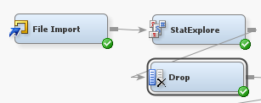

Figure  Drop Method Node in SAS

The "Drop" method removes specified variables or attributes from the dataset. Removing irrelevant or redundant data is applied to speed up the data preprocessing stage. The following analysis is concentrated more when irrelevant variables are removed. The "Drop" method helps to improve the effectiveness of modeling and analytic processes, leading to a more precise and succinct result.

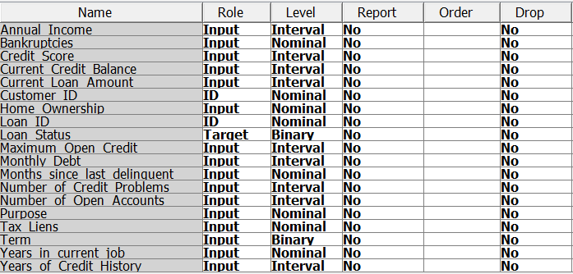

Figure Variable before dropping method.

As the figure indicates above, the raw datasets obtained 19 variables in total before proceeding with the dropping method. Since the result indicates the related variable is not important to the modeling.

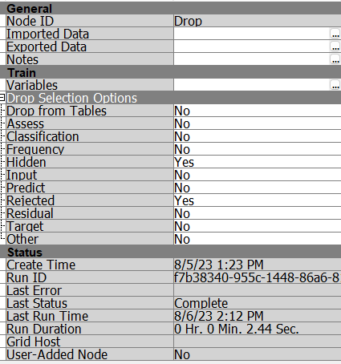 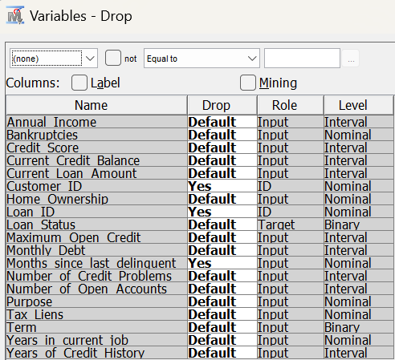



Figure Drop Method Setting

After configuration, we dropped three unnecessary variables: customer ID, loan ID, and Months since the last delinquent. Months since the last delinquent worth rate is 0.001644.

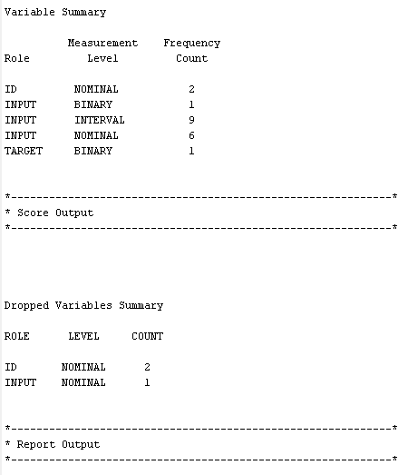



Figure Dropped variables summary.

Three variables had dropped, which included two ID nominal data and one input nominal data variable.

#### Impute

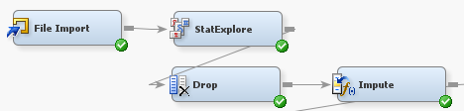

Figure Impute Method Node in SAS

Using the "Impute" approach, the missing values in the dataset are addressed. To estimate and close these gaps, it uses a variety of strategies, such as mean or median replacement. This procedure is vital since incomplete data can hamper inaccurate analysis. The dataset maintains its integrity and is made more dependable for further studies by imputed missing values. The "Impute" method is a crucial phase in the data pretreatment process since it helps produce valuable insights and reliable outcomes.

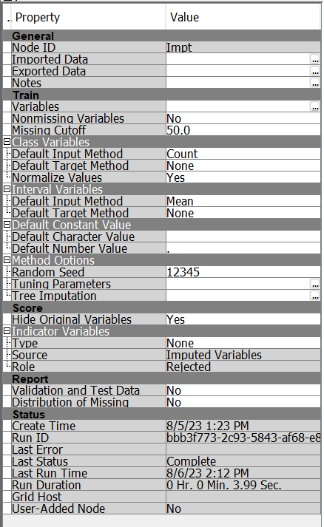 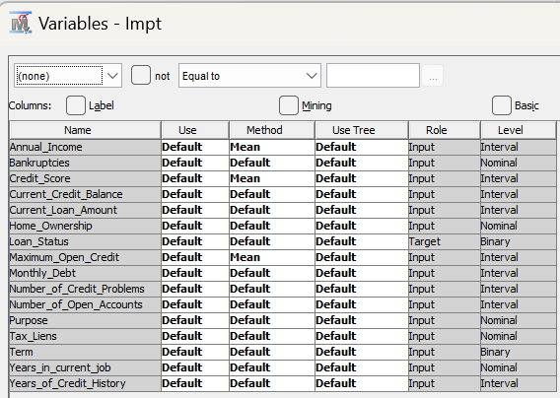



Figure Impute Method Setting

The figure above indicates that three variables had been imputed in the imputing process: Annual income using the mean method, maximum open credit using a mean method, and years in current job applied tree method.





Figure Result Before Impute Process

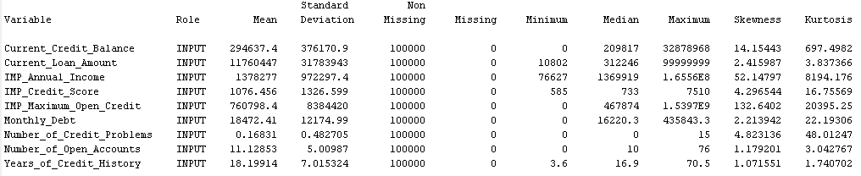

Figure Result After Impute Process

After imputing the missing value with the mean and tree method, all the missing value had solved, and in the current dataset, all data is with value.

|  |  |
| --- | --- |
| Attributes Visualization | Description |
| A screenshot of a computer  Description automatically generated  A screenshot of a computer  Description automatically generated  Figure Before and after imputed attribute Annual_Income | The figure shows the difference between the Annual_Income attribute being imputed its 19,154 missing data and the missing value bins being removed after imputation using the **mean** method. |
| A screenshot of a computer  Description automatically generated  A screenshot of a computer  Description automatically generated  Figure Before and after imputed attribute Credit_Score | The figure shows the difference between the Credit_Score attribute being imputed its 19,154 missing data and the missing value bins being removed after imputation using the **mean** method. |
| A screenshot of a computer  Description automatically generated  A screenshot of a computer  Description automatically generated  Figure Before and after imputed attribute Maximum_Open_Credit | The figure shows the difference between the Maximum_Open_Credit attribute being imputed its two-missing data, and the missing value bins being removed after imputation using the **mean** method. |

#### Replacement

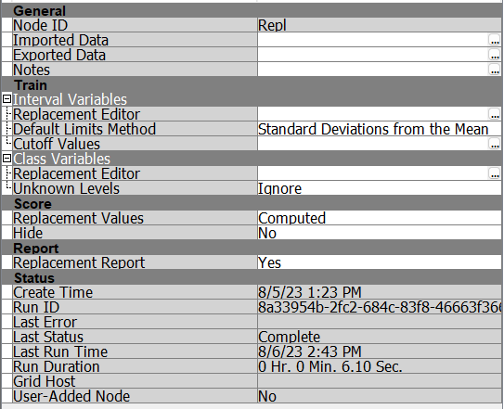

Figure Replacement process' setting

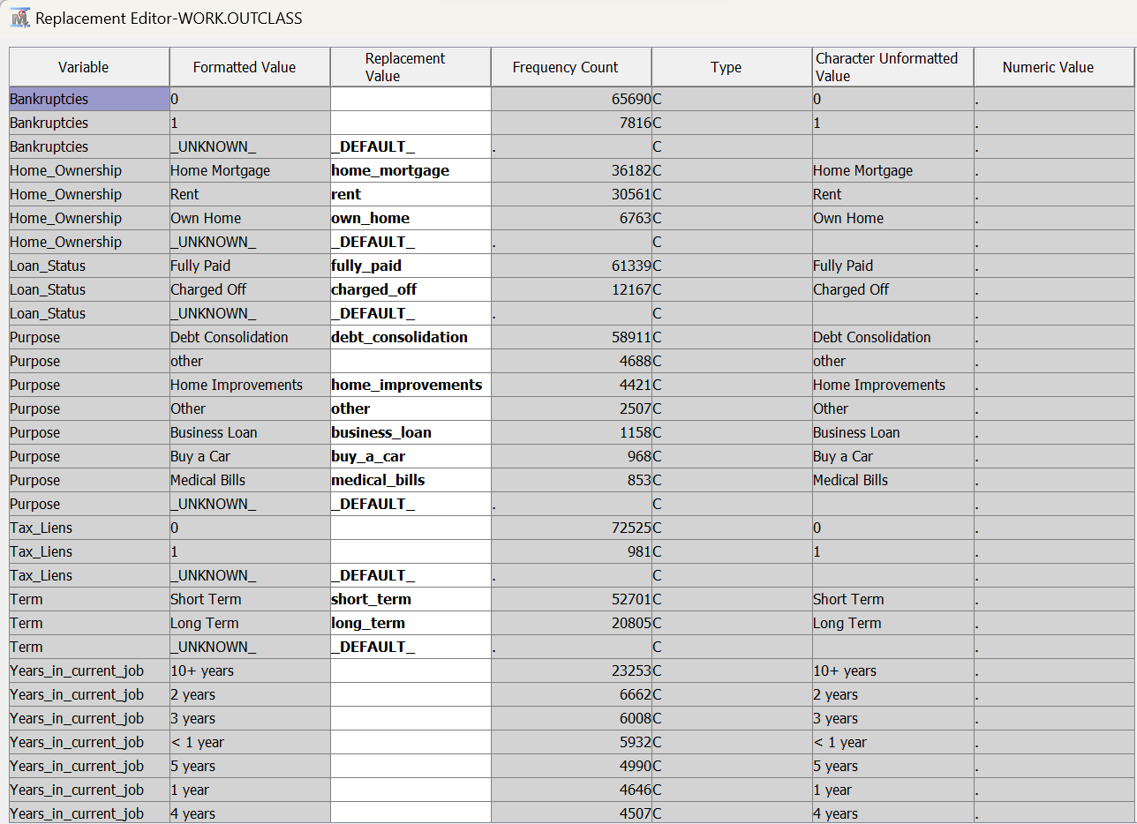

Figure Replace variables in lowercase.

From the figure indicated above, it is the replacement editor in SAS EM. Modifying the variable’s name into lowercase is always suggested for data analytics manners and habits. Hence, we changed all the related variables to lowercase and added an underscore in this case. Below is the table showing that the variable's name has been successfully updated.

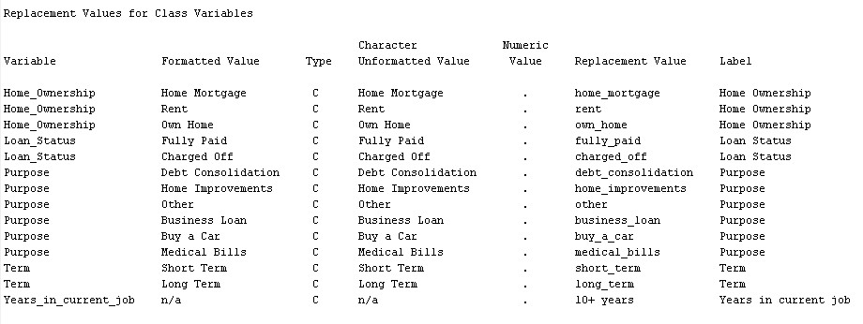

Figure After the replacement process

### Transformation

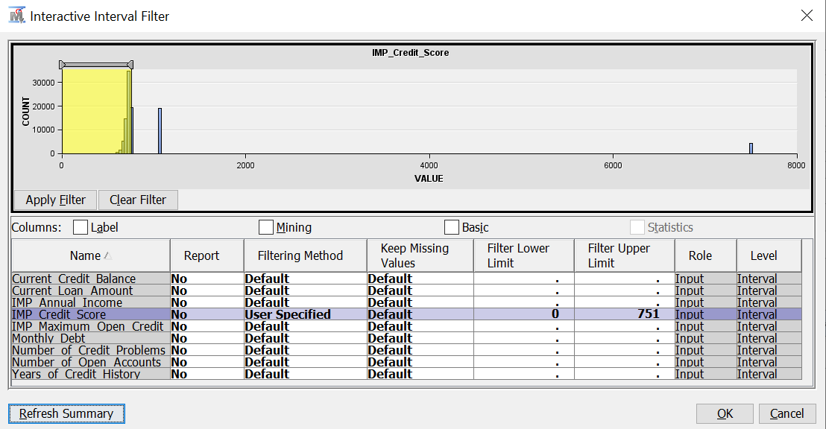

Figure Filter Credit Score

The Credit Score attribute's noisy data is processed using the Filter node. This processed credit score attribute's upper limit to 751, therefore capping the attribute's maximum value at that number. The lower limit of the credit score is currently set to 0. This node makes it easier to clean up data so that credit scores stay within the lower and upper bounds that have been established.

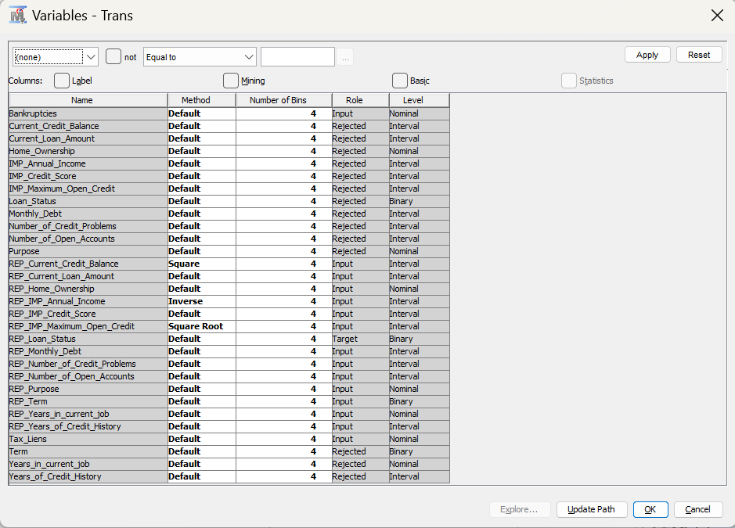

Figure Transformation Variable

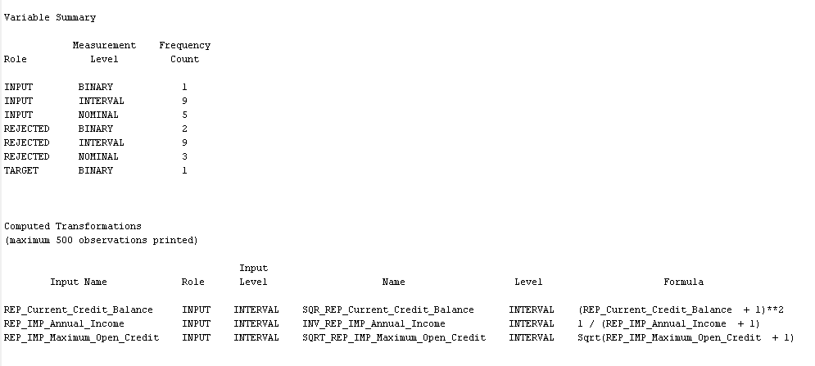

Figure Variable Summary of Transformation

**Before**

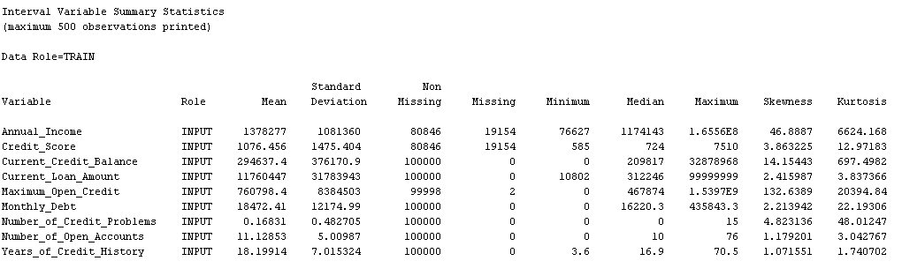

**After**

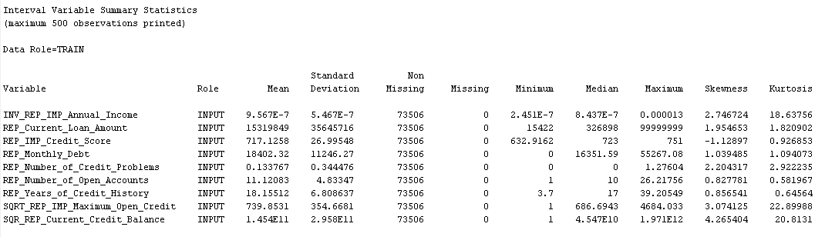

Figure Variables skewness change

|  |  |  |  |
| --- | --- | --- | --- |
| Attribute | Method | Skewness | Interpretation |
| Current Credit Balance | Square | Before: 14.15443  After: 4.265404 | By spreading out extreme values, square transformations can help the distribution become more symmetrical and centered. |
| Annual Income | Inverse | Before: 46.8887  After: 2.746724 | The skewness has significantly decreased because of the inverse. Distributions with big values can be normalized with the use of inverse transforms. |
| Maximum Open Credit | Square Root | Before: 132.6389  After: 3.074125 | Transformations using the square root can mitigate the effects of excessive values. |

Table Variables transformation

In order to better model performance and lower the possibility of bias, transformations are used in the preprocessing of data to align data distributions with the assumptions of statistical models. Bias can be introduced by outliers and skewed data, which excessively affects model results. Outliers are mitigated via transformations, which stop them from having a significant influence on the model. They increase the analysis ability of the data and the reliability of the conclusions drawn from later modelling events.

**Additional Processing For Decision Tree Modeling**

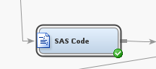 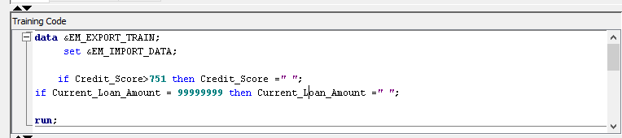

Figure SAS Code Editor

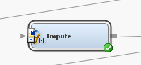 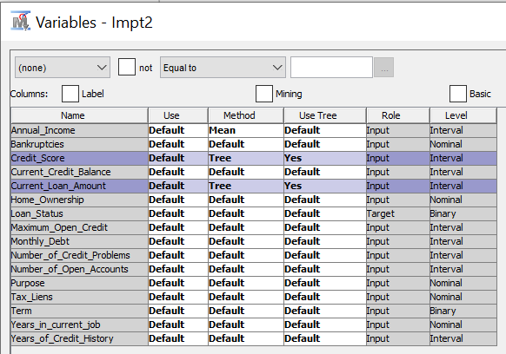

Figure Impute Variable Settings

SAS code is to be pre-processing the attributes in the code editor. There are two conditions of when credit score is more than 751, then set it to blank meaning change it to missing value. Similarly, the current loan amount equal to 99999999 will be converted to missing value as well. Consequently, impute is used to impute missing values and method are changed from ‘Default’ to ‘Tree’ as this method uses decision trees to predict and fill in missing values according to patterns observed in the data provided. However, this data pre-processing only applied when Decision Tree modelling is to be carried out to get a higher accuracy of predicting ‘Fully Paid’ loan status.

### Resampling and data partition

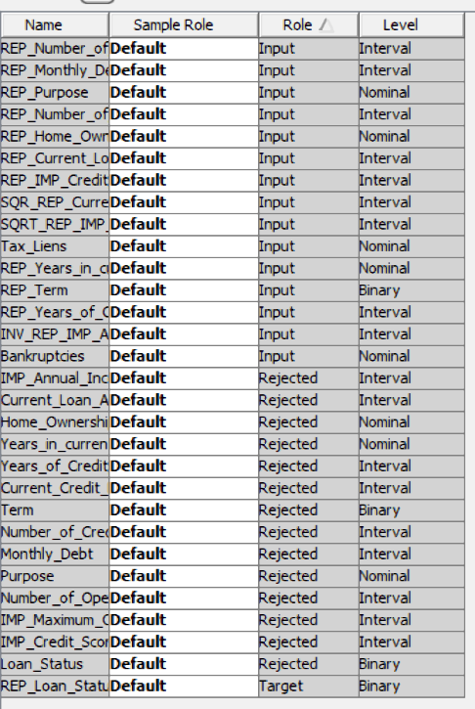

Figure variables status of resampling nodes

Before the data preprocessing, we use the resampling techniques to change the observation number of the target variable so that the outcome model will not have bias during making predictions on the target variable. Before doing the resampling, the target variable distribution is as below:

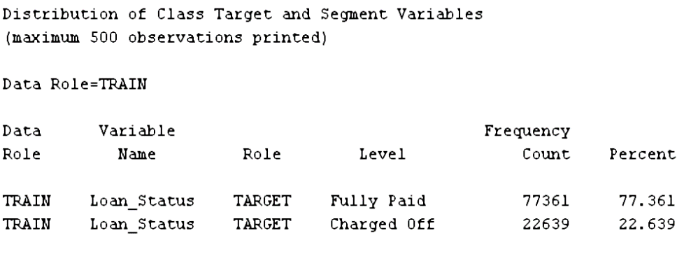

Figure number of observations before resampling

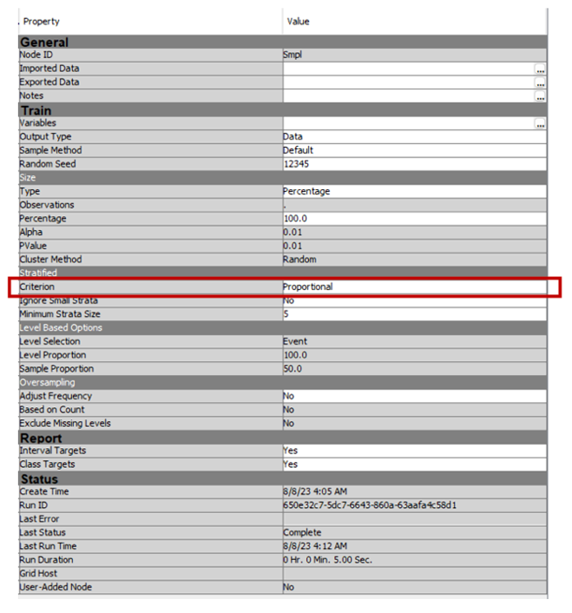

Figure settings of resampling nodes

However, the accuracy of the model we built later is higher when we try on proportional sampling. Henceforth, our sampling method would not be using the equal sampling method and the target variable will be a proportional balance based on the percentage of each class in the target variable.

After the resampling, the observation of each class in the target variables are as below:

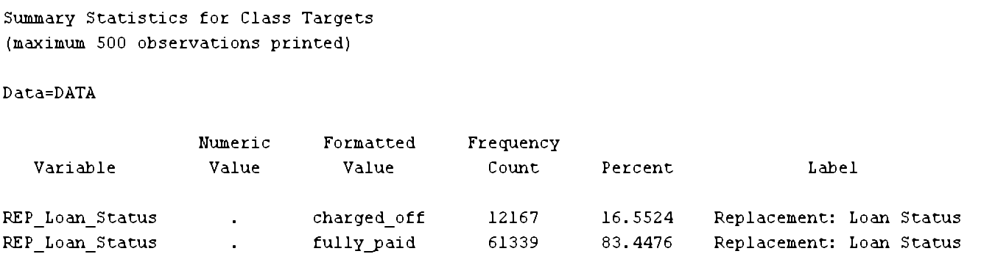

Figure number of observations after resampling

##### Data Partition

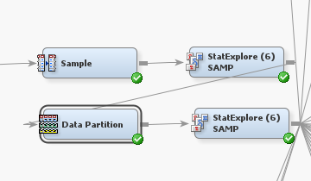 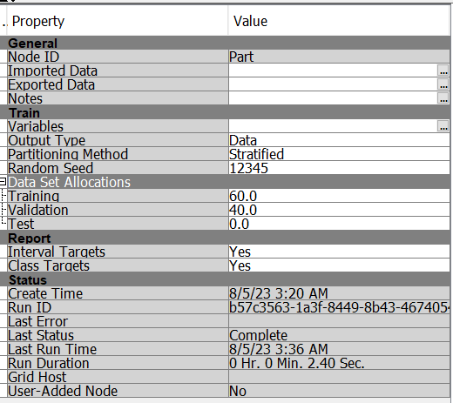

Figure data partition nodes settings

Data partitioning is the allocation of the entire data collection which consists of training, validation, and test data. Generally, only a portion of a large data set is selected for the partitions. Preliminary model fitting is performed using a training data set. Whereas a validation data set is used to compare models and avoid a modeling node from overfitting the training data as well as used for a final model evaluation. In this case, the data partition is split into training and validation data sets of a 60:40 ratio, and perform data modeling according to this partition ratio.

## Model Construction and Optimization

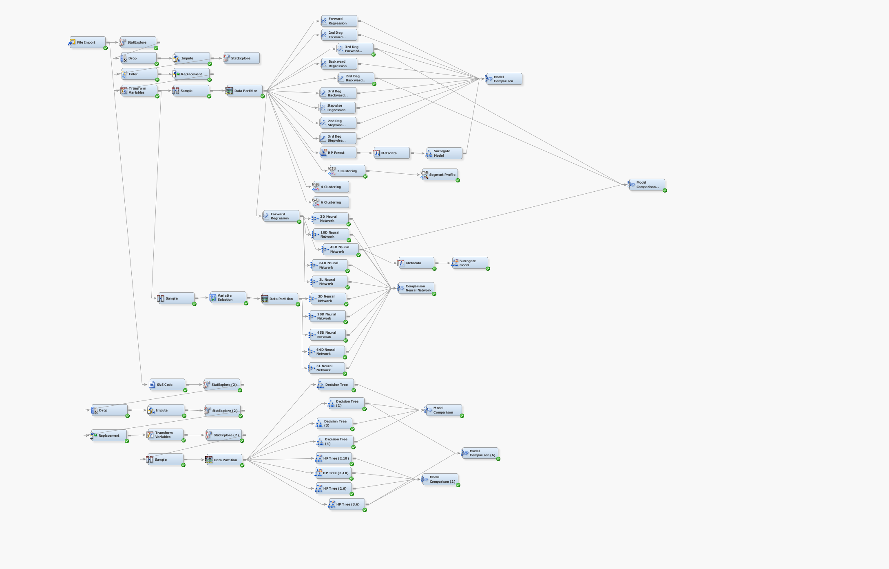

Figure .0. Overview of SAS diagram

### Neural Network – Neaw Aik Ka TP065116

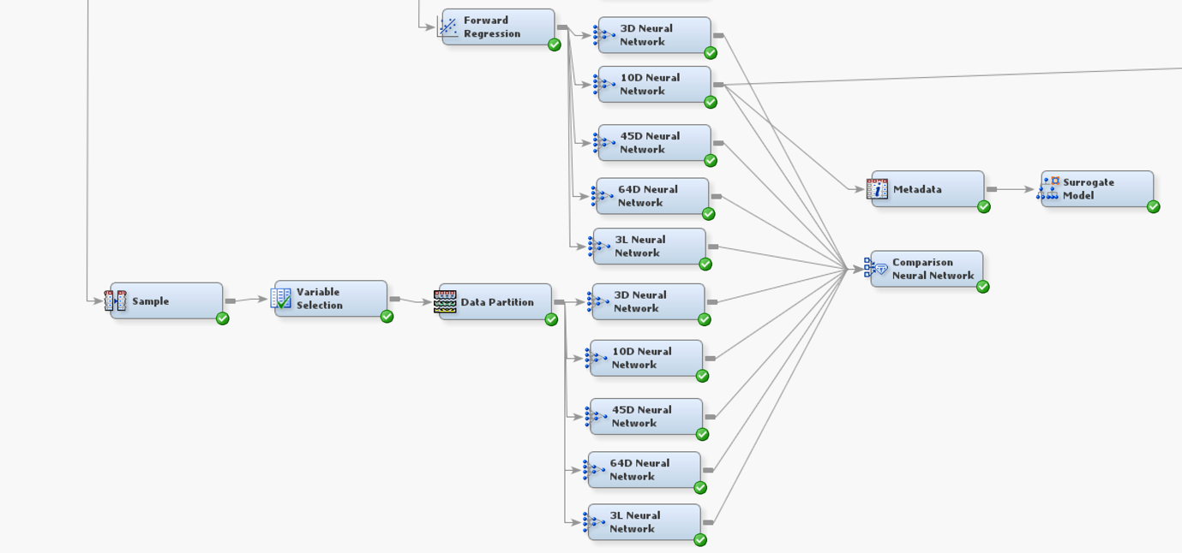

Figure .0. Neural Network

$$Output of neurons=inputs*weights+bias$$

The architecture of the Neural Network is using neurons to connect between input, hidden, and output layers. Through deep learning, it will learn to connect the nodes, bringing up the answer of classification. It is a model that developed from a regression that it has a similarity with regression but has a more outstanding ability to discover the association and relationship among attributes. However, there are few data preparation methods for neural network modeling, here we proposed 2 methods: forward regression and equal sampling with variable selection.

#### Sampling method change

##### Method 1: Regression

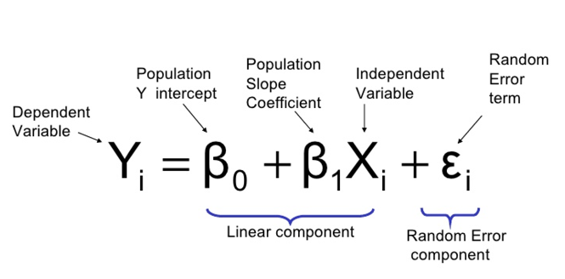

Figure Regression model formula

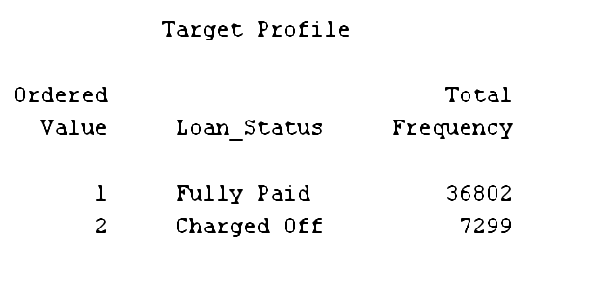

Figure Target variable class size with proportional sampling

For this neural network data preparation method, we deploy the forward regression model for the feature selection. The forward regression model will calculate the p-value of variables and eliminate those with less minimal influence on the target variable. A glance at the size of the target variable class, ‘Fully Paid’ is 36802 while ‘Charged Off’ is 7299.

##### Method 2: Equal Sampling with variable selection

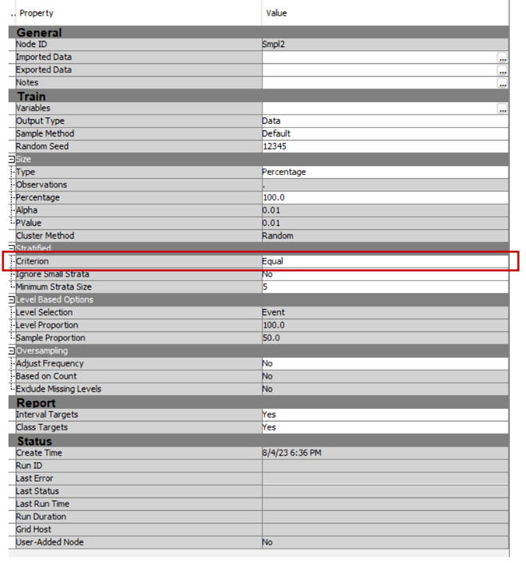

Figure Equal sampling node settings

Another option is that we implement a different sampling method for the neural network’s data preparation. To some extent, the imbalanced dataset might cause the weight algorithm to be dysfunctional. thereby we choose an equal stratified sampling to balance the target variable class. Hence the sampling method applies here is 60:40 of equal under-sampling.

##### Variable selection

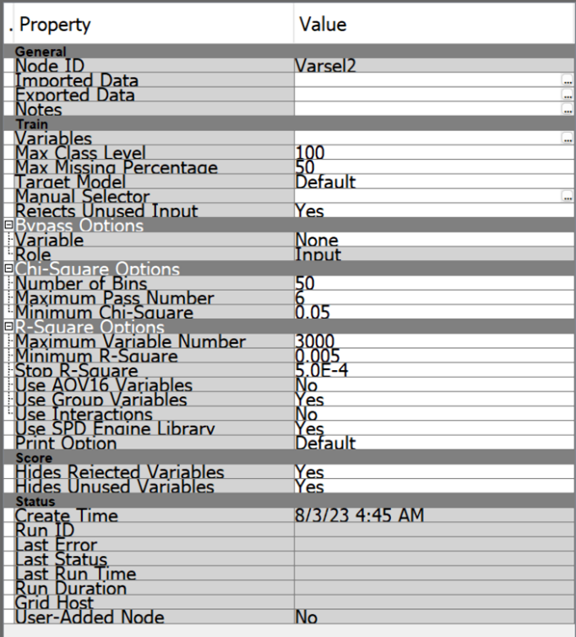

Figure Variables selection nodes setting

$$Degree of freedom=Sample size-1$$

Before the neural network, we also need to make a dimensional reduction using feature selection. According to the settings, the maximum class level allowed in the dataset categorical variables is 100. The max missing percentage of the missing values of the variable is 50%. This sampling method will use the default target model in SAS and reject any unused input in the variable selection process. As the dataset has a degree freedom of more than 4000 and a binary target variable, hence the chi-square will be the indicator for the variable selection. The figure below shows the status of variables in variable selection nodes:

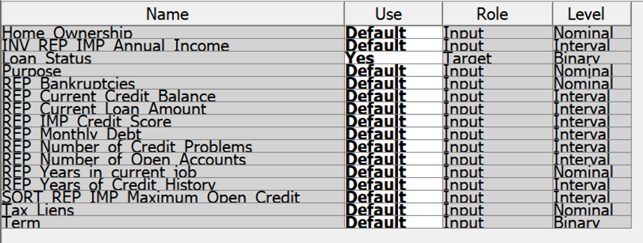

Figure Status of variables in variables selection nodes

##### Data partition

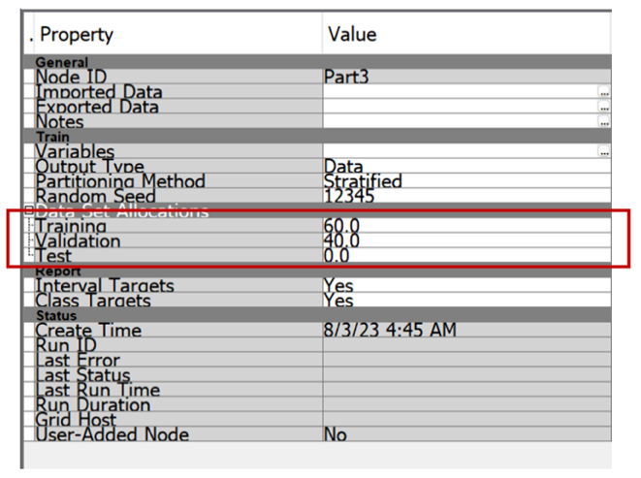

Figure Data Partition nodes settings

The data partition setting for the neural network is the same as other models, using a stratified partitioning method, a ratio of 60:40.

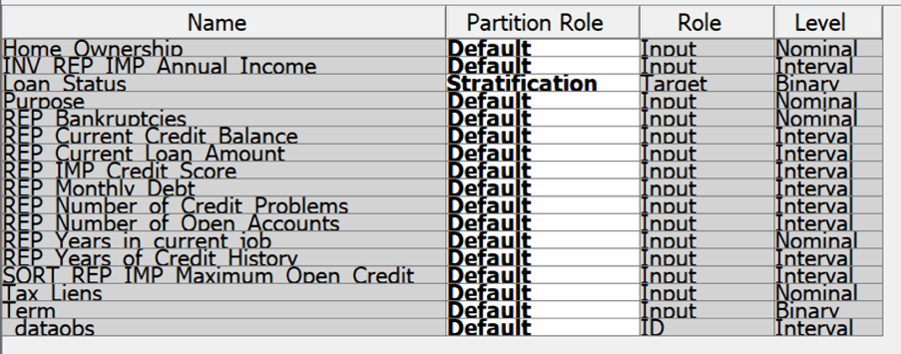

Figure Data Partition variable status settings

After the variable selection, the data partition has been implemented to the dataset for the training and validation process later.

#### Neural Network Comparison

Here, we use the processed dataset to model the neural network with different settings in a number of hidden units and training techniques.

|  |  |  |  |
| --- | --- | --- | --- |
| Data Preparation | Model name | Settings | Results and validation |
| Forward Regression | 3D Neural Network | architecture: Multilayer Perceptron  Hidden Units:3  Training technique: Default  Preliminary Training: Yes | A screen shot of a graph  Description automatically generated  Train MISC:0.165503  Validation MISC: 0.165454 |
| 10D Neural Network | Architecture: Multilayer Perceptron  Hidden Units:10  Training technique: Default  Preliminary Training: Yes | A graph showing a graph  Description automatically generated with medium confidence  Train MISC:0.165525  Validation MISC:0.165522 |
| 45D Neural Network | Architecture: Multilayer Perceptron  Hidden Units:45  Training technique: Default  Preliminary Training: Yes | A graph showing a graph  Description automatically generated with medium confidence  Train MISC:0.165525  Validation MISC:0.165386 |
| 64D Neural Network | Architecture: Multilayer Perceptron  Hidden Units:64  Training technique: Default  Preliminary Training: Yes | A screen shot of a graph  Description automatically generated  Train MISC:0.165525  Validation MISC:0.165488 |
| 3L Neural Network | Architecture: Multilayer Perceptron  Hidden Units:3  Training technique: Levenberg-Marquardt  Preliminary Training: Yes | A screen shot of a graph  Description automatically generated  Train MISC:0.165503  Validation MISC:0.165454 |
| Equal sampling + Variable selection + data partition | 3D Neural Network | Architecture: Multilayer Perceptron  Hidden Units:3  Training technique: Default  Preliminary Training: Yes | A graph on a computer screen  Description automatically generated  Train MISC:0.369203  Validation MISC: 0.378326 |
| 10D Neural Network | Architecture: Multilayer Perceptron  Hidden Units:10  Training technique: Default  Preliminary Training: Yes | A graph showing the growth of a graph  Description automatically generated with medium confidence  Train MISC:0.370916  Validation MISC:0.386235 |
| 45D Neural Network | architecture: Multilayer Perceptron  Hidden Units:45  Training technique: Default  Preliminary Training: Yes | A screen shot of a graph  Description automatically generated  Train MISC:0.386396  Validation MISC:0.399589 |
| 64D Neural Network | architecture: Multilayer Perceptron  Hidden Units:64  Training technique: Default  Preliminary Training: Yes | A graph on a screen  Description automatically generated  Train MISC:0.373039  Validation MISC:0.392296 |
| 3L Neural Network | architecture: Multilayer Perceptron  Hidden Units:3  Training technique: Levenberg-Marquardt  Preliminary Training: Yes | A graph showing a line  Description automatically generated with medium confidence  Train MISC:0.369203  Validation MISC:0.378326 |

Table Neural network comparison table

After comparison, the final model we have chosen is the ‘**45D neural network**’.

Preparation method: forward regression

Architecture: Multilayer Perceptron

Hidden Units:45

Training technique: Default

Preliminary Training: Yes

Train MISC:0.165525

Validation MISC:0.165386

#### Model validation

Weight calculation is essential for the neural network as it helps the model to make predictions based on the relevance of the nodes. Every connection will be given an initial weight during the initial neural network stage. This weight initialization is usually powered by stochastic gradient descent. Then, it will continuously be adjusted by the neural network itself at each time of the training based on the learning rate set. The gap between the predicted and expected output will be drawn as a loss graph using the loss function. The following section will have a more detailed view of the neural network model chosen.

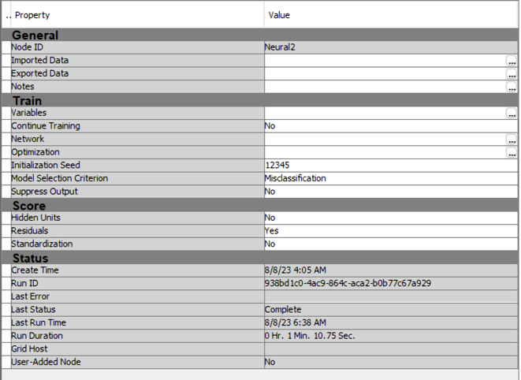

Figure Neural network model settings

In the ‘45D Neural Network’, we set the continued training to ‘NO’, indicating that the neural network is not allowing the input layer neurons to directly connect with the output layers. The model will be selected based on the misclassification rate of the validation dataset. If the validation dataset is available, it will choose using the misclassification rate of the training dataset. For the scoring data, the hidden units and standardization data are set to ‘NO’ for not creating hidden units and standardization scoring data but the residuals variables scoring data will be created.

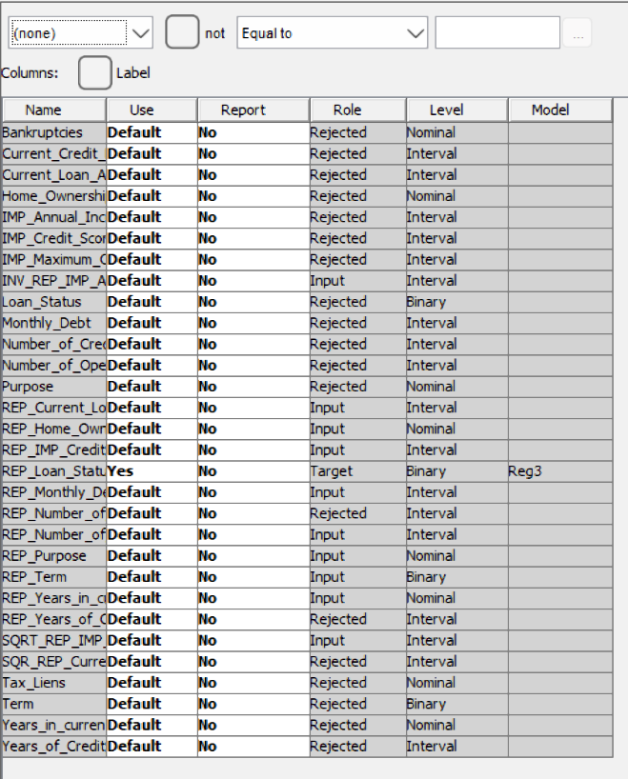

Figure Neural network variables status

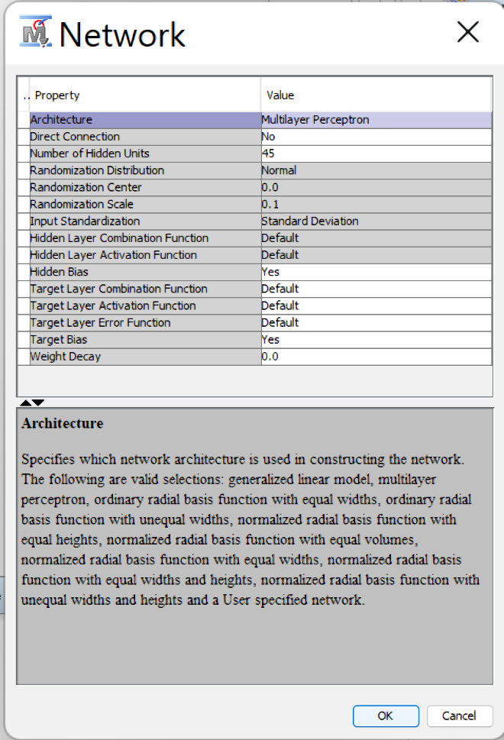

Figure network settings

In the network settings, the architecture is set to multilayer perceptron. The multilayer perceptron is the most common neural network architecture that connects the neurons using activation functions like Tanh and Sigmoid. Here the hidden units specified in the hidden layer are 10. As the bias in the hidden layers of the model might affect its performance, hence the hidden bias is set to ‘YES’. This means that the model allows hidden bias to readjust according to the result of our model predictions, providing better fitting for the dataset and the model. Meanwhile, the target layer combination, activation, and error function all use ‘DEFAULT’.

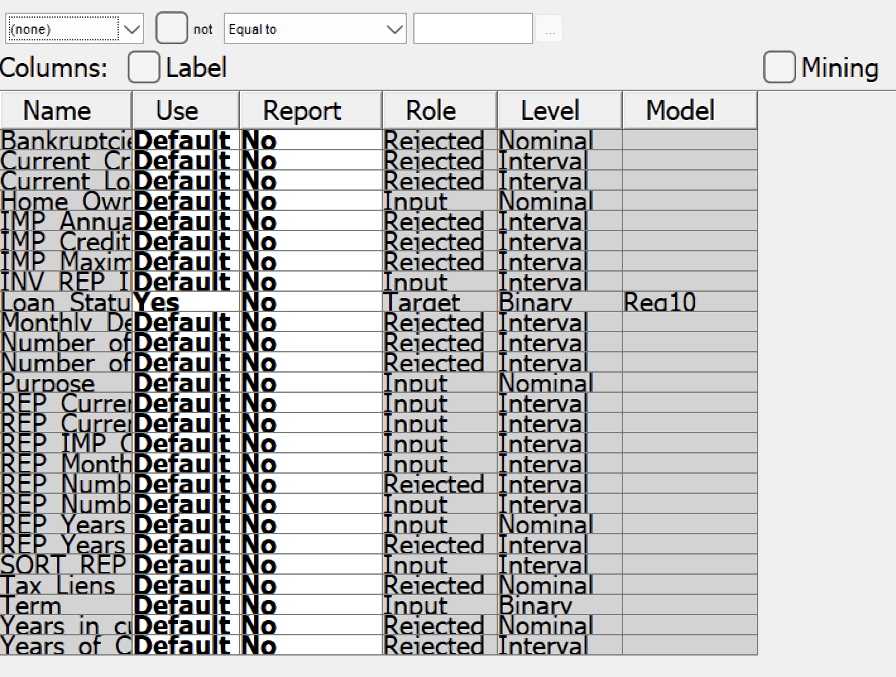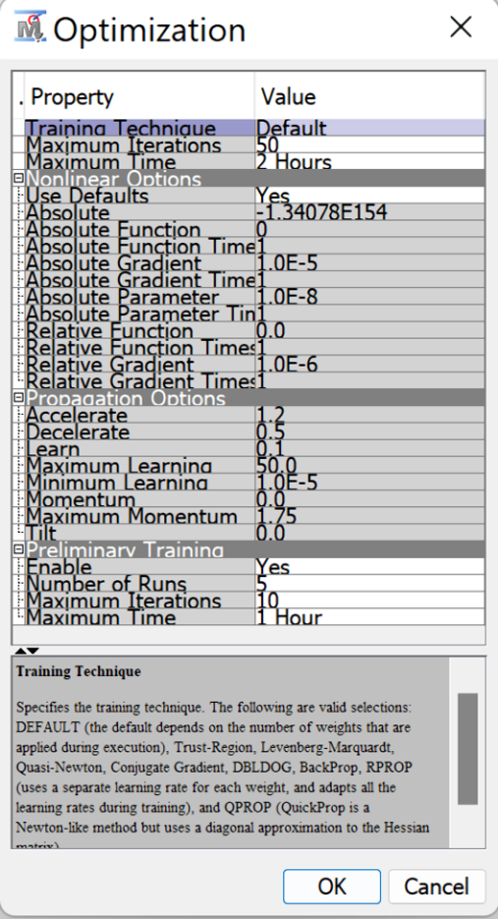

Figure Neural network optimization settings

For the optimization of the neural model, the training technique is using the default. Hence the technique will be chosen at the time it executes based on the weights assigned. The iterations of the training are 50 times with a maximum of 2 hours. The preliminary training is to let the model make some assumptions and try on the initialization weight of the model to have a better picture of the dataset features. The number of runs here is 5 and there will be a maximum of 10 times iterations in 1 hour.

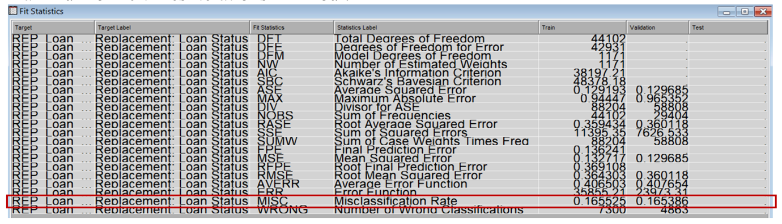

Figure Neural network fit statistics

After training, the neural network MISC result is 0.165525 (train) and 0.165386 (validation).

##### Confusion matrix

|  |  |
| --- | --- |
| A screenshot of a document  Description automatically generated  Figure Neural network classification table | A screenshot of a computer  Description automatically generated  Figure Neural network event classification table |

Based on the prediction result given by the neural network, we calculate some indicators to examine the performance of the model built.

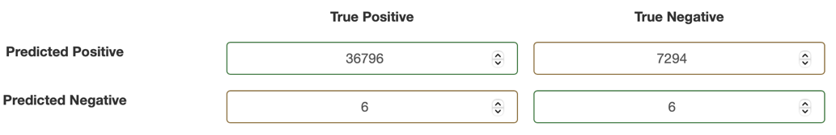

Figure Confusion matrix

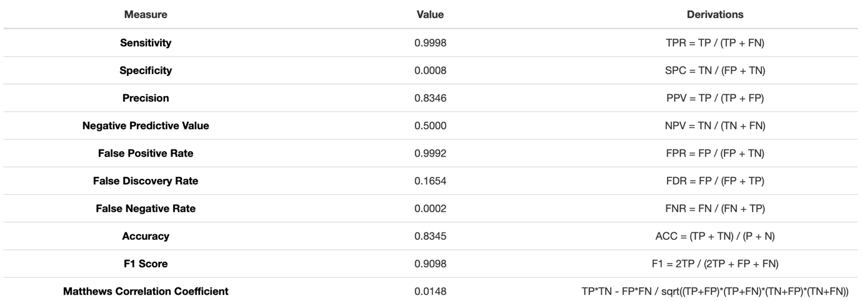

Figure Neural network performance indicators

From the indicators, some of the value is considerably low. The specificity is only 0.0008, meaning that the ability of the model to predict the positive cases is not enough. On the other hand, the false negative rate has merely 0.0002. This shows that the neural network model has an extreme ability to predict the true positive cases in the dataset. The Matthews Correlation Coefficient (MCC) here has a value of 0.0148. It shows that the model is actually not satisfactory even though it has been the best accuracy model in our modeling process. The reason for these disadvantages happening could be due to the proportional sampling during the resampling process.

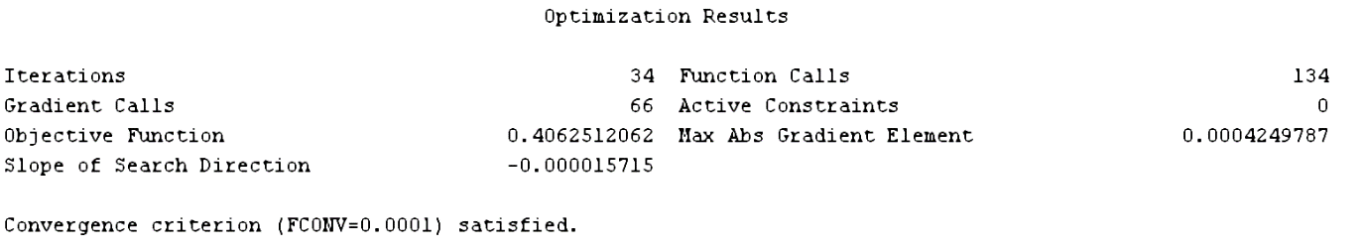

Figure Neural network optimization result

The optimization result above shows the iterations and function calls by the neural network. Notably, the low max abs gradient element value indicates that the neural network is converging well.

#### Critical interpretation of outcomes

In the following section, we will look into the underneath association that is discovered by this neural network. Firstly, we extract the metadata from the neural network model built to feed it into the HP Tree for the interpretation of the result. We reject the Loan Status for the variable status and set the loan prediction result of ‘Fully Paid’ to the new target variable for the Surrogate Model.

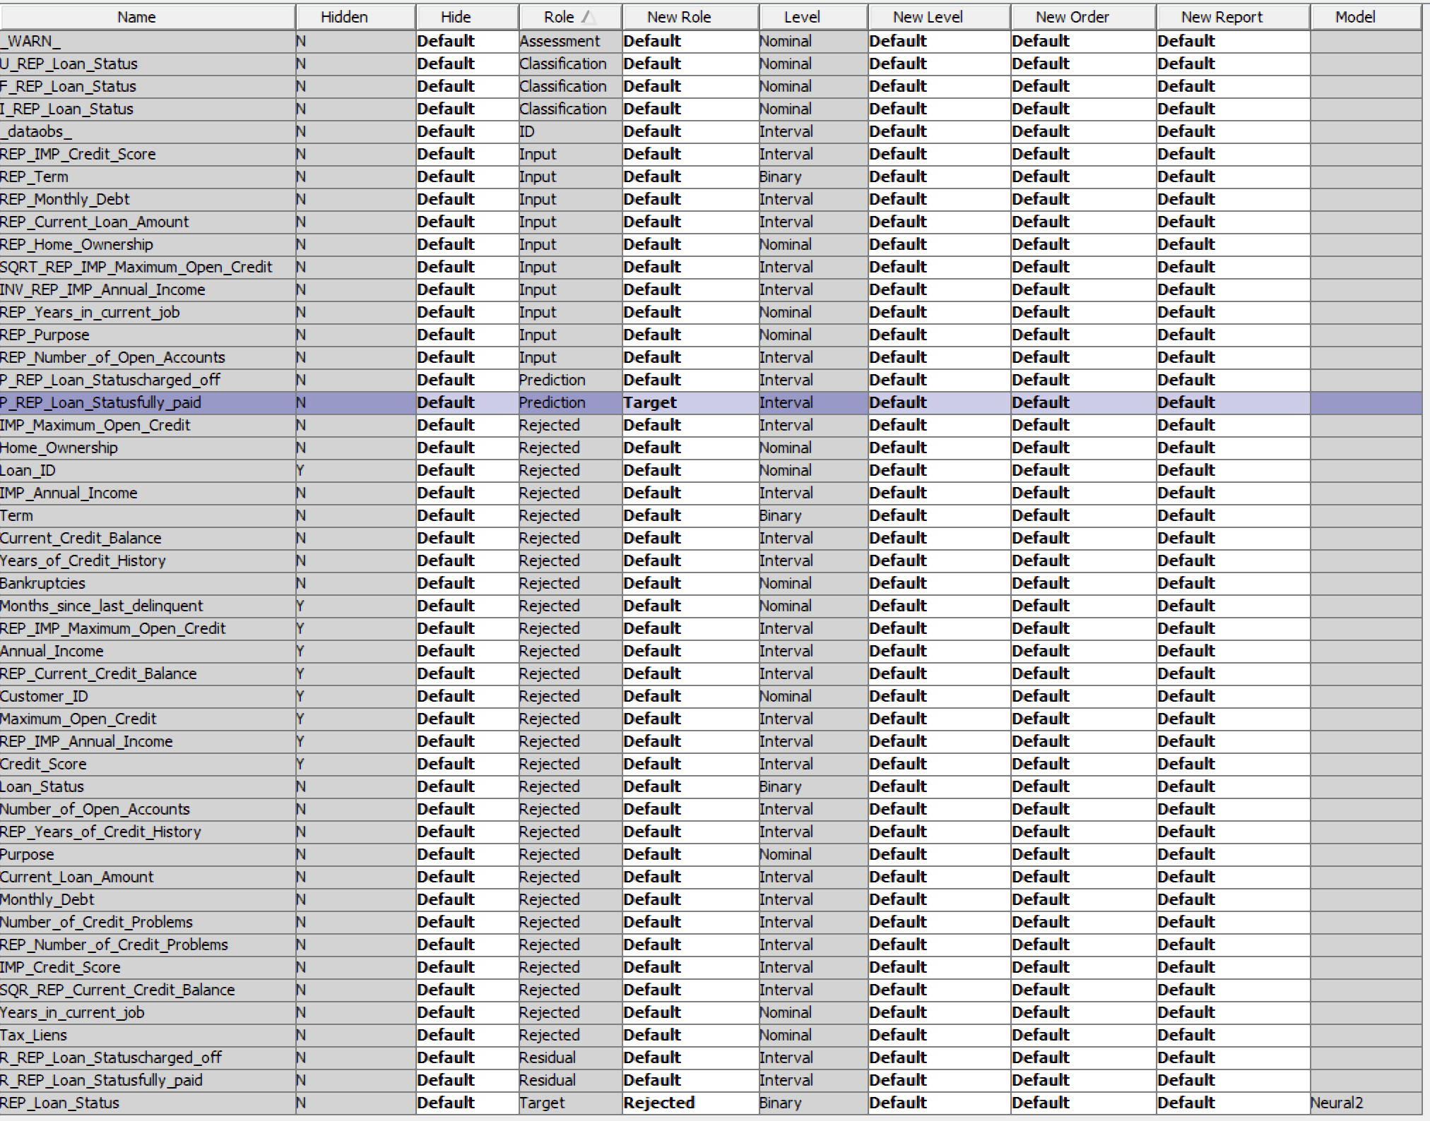

Figure HP Tree Metadata

##### Surrogate Model

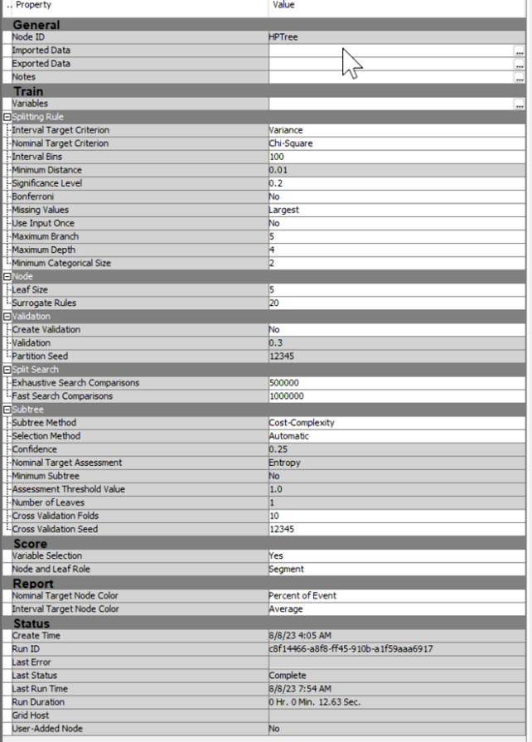

Figure Surrogate model settings

The Surrogate Model references the HP Tree. The splitting rules for interval and nominal variables are variance and chi-square respectively. Every 100-interval variable will be grouped into 1 bin. If any missing value occurs, it will be assigned to the largest branch in the surrogate model. Each of the leaf nodes must have a minimum of 5 training data and only 20 surrogate rules can be generated in non-leaf nodes. For the subtree creation, it will depend on the cost-complexity pruning. The below figure shows the surrogate tree result.

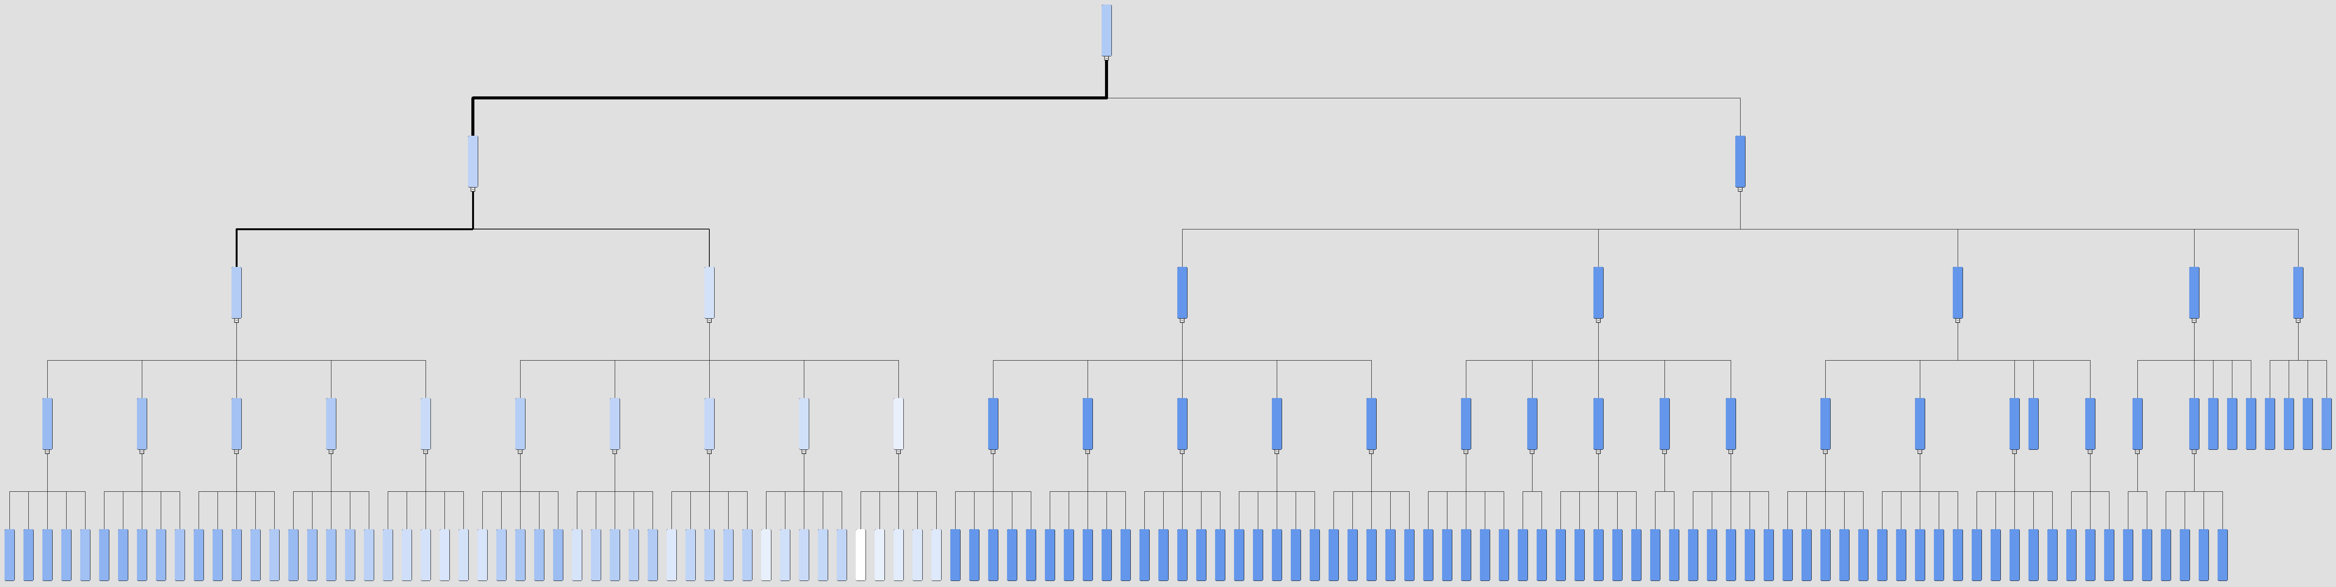

Figure Surrogate tree

##### Node Rules Generated

|  |  |
| --- | --- |
| Condition | Interpretation |
| *--------------------------------------------------*  NODE = 67  *--------------------------------------------------*  ('Transformed: Replacement: Imputed: Annual Income'n >= 1.9097406e-06 AND 'Transformed: Replacement: Imputed: Annual Income'n < 2.9341378e-06)  AND MISSING('Transformed: Replacement: Imputed: Annual Income'n) OR ('Transformed: Replacement: Imputed: Annual Income'n >= 1.1414427e-06)  AND MISSING('Replacement: Term'n) OR ('Replacement: Term'n IS SHORT_TERM)  AND MISSING('Replacement: Current Loan Amount'n) OR ('Replacement: Current Loan Amount'n < 1015267.8)  PREDICTED VALUE IS 0.74373241  Weight = 1508  Variance = 0.0012998 | **Condition 1:** the value of 'Transformed: Replacement: Imputed: Maximum Open Credit' is less than 733.087 or missing.  **Condition 2:** the value of 'Replacement: Monthly Debt' is less than 21463.7 or missing.  **Condition 3:** the value of 'Replacement: Current Credit Balance' is less than 302442 or missing.  When all condition above met, the probability of ‘Fully paid’ has 74.37% |
| *--------------------------------------------------*  NODE = 65  *--------------------------------------------------*  ('Transformed: Replacement: Imputed: Annual Income'n >= 1.5255916e-06 AND 'Transformed: Replacement: Imputed: Annual Income'n < 1.7816909e-06)  AND MISSING('Transformed: Replacement: Imputed: Annual Income'n) OR ('Transformed: Replacement: Imputed: Annual Income'n >= 1.1414427e-06)  AND MISSING('Replacement: Term'n) OR ('Replacement: Term'n IS SHORT_TERM)  AND MISSING('Replacement: Current Loan Amount'n) OR ('Replacement: Current Loan Amount'n < 1015267.8)  PREDICTED VALUE IS 0.76339228  Weight = 1525  Variance = 0.00149947 | **Condition 1:** the value of 'Transformed: Replacement: Imputed: Annual Income' is greater than or equal to 1.5255916e-06 and less than 1.7816909e-06.  **Condition 2:** the value of 'Transformed: Replacement: Imputed: Annual Income' is missing OR if it's greater than or equal to 1.1414427e-06.  **Condition 3:** the value of 'Replacement: Term' is missing OR if it's equal to 'SHORT_TERM'.  **Condition 4:** the value of 'Replacement: Current Loan Amount' is missing OR if it's less than 1015267.8.  When all condition above met, the probability of ‘Fully paid’ has 76.34% |
| *--------------------------------------------------*  NODE = 64  *--------------------------------------------------*  MISSING('Transformed: Replacement: Imputed: Annual Income'n) OR ('Transformed: Replacement: Imputed: Annual Income'n < 1.5255916e-06)  AND MISSING('Transformed: Replacement: Imputed: Annual Income'n) OR ('Transformed: Replacement: Imputed: Annual Income'n >= 1.1414427e-06)  AND MISSING('Replacement: Term'n) OR ('Replacement: Term'n IS SHORT_TERM)  AND MISSING('Replacement: Current Loan Amount'n) OR ('Replacement: Current Loan Amount'n < 1015267.8)  PREDICTED VALUE IS 0.79554214  Weight = 4701  Variance = 0.00166992 | **Condition 1:** the value of 'Transformed: Replacement: Imputed: Annual Income' is missing OR if it's less than 1.5255916e-06.  **Condition 2:** the value of 'Transformed: Replacement: Imputed: Annual Income' is missing OR if it's greater than or equal to 1.1414427e-06.  **Condition 3:** the value of 'Replacement: Term' is missing OR if it's equal to 'SHORT_TERM'.  **Condition 4:** the value of 'Replacement: Current Loan Amount' is missing OR if it's less than 1015267.8.  When all condition above met, the probability of ‘Fully paid’ has 79.55% |
| *--------------------------------------------------*  NODE = 62  *--------------------------------------------------*  ('Replacement: Monthly Debt'n >= 9948.0744 AND 'Replacement: Monthly Debt'n < 17132.795)  AND ('Transformed: Replacement: Imputed: Annual Income'n >= 7.5729375e-07 AND 'Transformed: Replacement: Imputed: Annual Income'n < 1.1414427e-06)  AND MISSING('Replacement: Term'n) OR ('Replacement: Term'n IS SHORT_TERM)  AND MISSING('Replacement: Current Loan Amount'n) OR ('Replacement: Current Loan Amount'n < 1015267.8)  PREDICTED VALUE IS 0.84064475  Weight = 2860  Variance = 0.000940986 | **Condition 1:** the value of 'Replacement: Monthly Debt' is greater than or equal to 9948.0744 AND less than 17132.795.  **Condition 2:** the value of 'Transformed: Replacement: Imputed: Annual Income' is greater than or equal to 7.5729375e-07 AND less than 1.1414427e-06.  **Condition 3:** the value of 'Replacement: Term' is missing OR if it's equal to 'SHORT_TERM'.  **Condition 4:** the value of 'Replacement: Current Loan Amount' is missing OR if it's less than 1015267.8.  When all condition above met, the probability of ‘Fully paid’ has 84.06% |
| *--------------------------------------------------*  NODE = 57  *--------------------------------------------------*  ('Replacement: Monthly Debt'n >= 14922.112 AND 'Replacement: Monthly Debt'n < 22659.503)  AND ('Transformed: Replacement: Imputed: Annual Income'n >= 5.0119445e-07 AND 'Transformed: Replacement: Imputed: Annual Income'n < 7.5729375e-07)  AND MISSING('Replacement: Term'n) OR ('Replacement: Term'n IS SHORT_TERM)  AND MISSING('Replacement: Current Loan Amount'n) OR ('Replacement: Current Loan Amount'n < 1015267.8)  PREDICTED VALUE IS 0.86596002  Weight = 1808  Variance = 0.000700325 | **Condition 1:** the value of 'Replacement: Monthly Debt' is greater than or equal to 14922.112 AND less than 22659.503.  **Condition 2:** the value of 'Transformed: Replacement: Imputed: Annual Income' is greater than or equal to 5.0119445e-07 AND less than 7.5729375e-07.  **Condition 3:** the value of 'Replacement: Term' is missing OR if it's equal to 'SHORT_TERM'.  **Condition 4:** the value of 'Replacement: Current Loan Amount' is missing OR if it's less than 1015267.8.  When all condition above met, the probability of ‘Fully paid’ has 86.6% |
| *--------------------------------------------------*  NODE = 63  *--------------------------------------------------*  MISSING('Replacement: Monthly Debt'n) OR ('Replacement: Monthly Debt'n >= 17132.795)  AND ('Transformed: Replacement: Imputed: Annual Income'n >= 7.5729375e-07 AND 'Transformed: Replacement: Imputed: Annual Income'n < 1.1414427e-06)  AND MISSING('Replacement: Term'n) OR ('Replacement: Term'n IS SHORT_TERM)  AND MISSING('Replacement: Current Loan Amount'n) OR ('Replacement: Current Loan Amount'n < 1015267.8)  PREDICTED VALUE IS 0.80743786  Weight = 3331  Variance = 0.00142805 | **Condition 1:** 'Replacement: Monthly Debt' is missing OR greater than or equal to 17132.795.  **Condition 2:** the value of 'Transformed: Replacement: Imputed: Annual Income' is greater than or equal to 7.5729375e-07 AND less than 1.1414427e-06.  **Condition 3:** 'Replacement: Term' is missing OR if it's equal to 'SHORT_TERM'.  **Condition 4:**  'Replacement: Current Loan Amount' is missing OR if it's less than 1015267.8.  When all condition above met, the probability of ‘Fully paid’ has 80.74% |
| *--------------------------------------------------*  NODE = 58  *--------------------------------------------------*  MISSING('Replacement: Monthly Debt'n) OR ('Replacement: Monthly Debt'n >= 22659.503)  AND ('Transformed: Replacement: Imputed: Annual Income'n >= 5.0119445e-07 AND 'Transformed: Replacement: Imputed: Annual Income'n < 7.5729375e-07)  AND MISSING('Replacement: Term'n) OR ('Replacement: Term'n IS SHORT_TERM)  AND MISSING('Replacement: Current Loan Amount'n) OR ('Replacement: Current Loan Amount'n < 1015267.8)  PREDICTED VALUE IS 0.83205759  Weight = 2712  Variance = 0.00140782 | **Condition 1:** 'Replacement: Monthly Debt' is missing OR greater than or equal to 22659.503.  **Condition 2:** the value of 'Transformed: Replacement: Imputed: Annual Income' is greater than or equal to 5.0119445e-07 AND less than 7.5729375e-07.  **Condition 3:** 'Replacement: Term' is missing OR if it's equal to 'SHORT_TERM'.  If 'Replacement: Current Loan Amount' is missing OR if it's less than 1015267.8.  When all condition above met, the probability of ‘Fully paid’ has 83.21% |

### Clustering analysis – Neaw Aik Ka TP065116

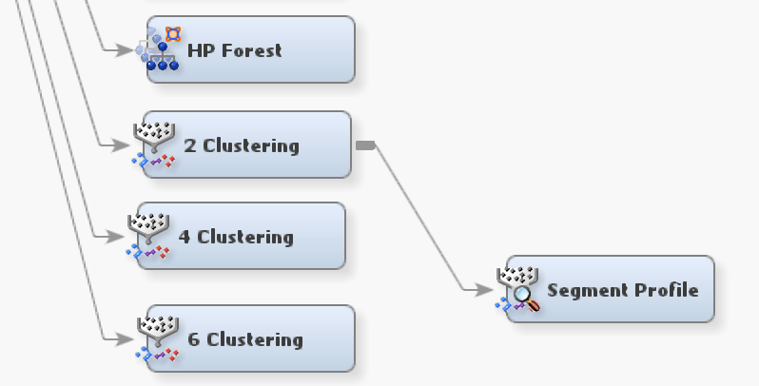

Figure .0. Clustering analysis

Clustering is one of the unsupervised learning that extracts the similarity within the data group by classifying the data into clusters without using the predefined class label. Hence the clustering analysis performance measurement is based on the distance between clusters in the result. To know how much clustering the best can be to cluster the data features, we tried on 2, 4, and 6 clusters.

#### Clustering Model Comparison

|  |  |  |
| --- | --- | --- |
| Model Name | Settings | Results and validation |
| 2 Clustering | Maximum number of clusters: 2 | A blue and red circle  Description automatically generated  Distance between segments 1 and 2:  2.96 x 1011 |
| 4 Clustering | Maximum number of clusters: 4 |  |
| 6 Clustering | Maximum number of clusters: 6 | A diagram with different colored circles  Description automatically generated with medium confidence  A graph with numbers and a number on it  Description automatically generated  A screenshot of a computer  Description automatically generated |

Table Clustering analysis comparison table

According to the cluster distance graph, the 2 clusters get comparatively more ideal results than the 4 clusters and 6 clusters. Starting from 4 clusters, the cluster distance plot shows that the clusters found are not distant and it means that those near neighbor clusters might not be necessary.

#### Model Validation

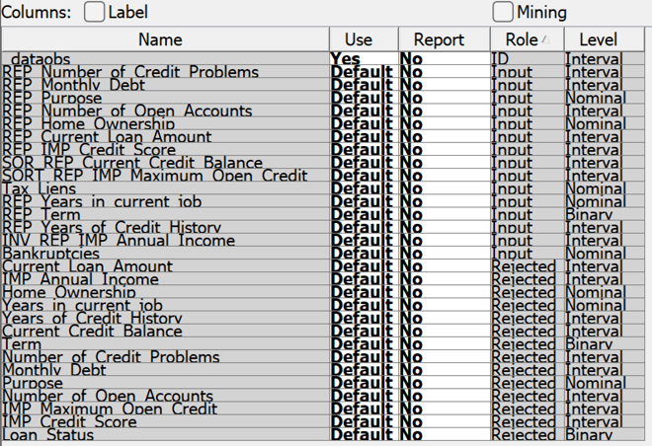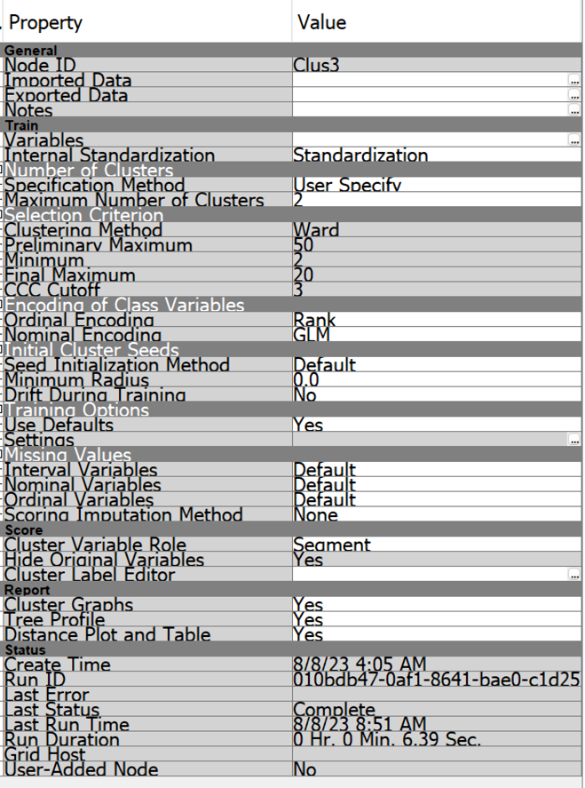

Figure Clusterning analysis node settings

The cluster Tree below shows the clustering rules of the clustering analysis using the tree.

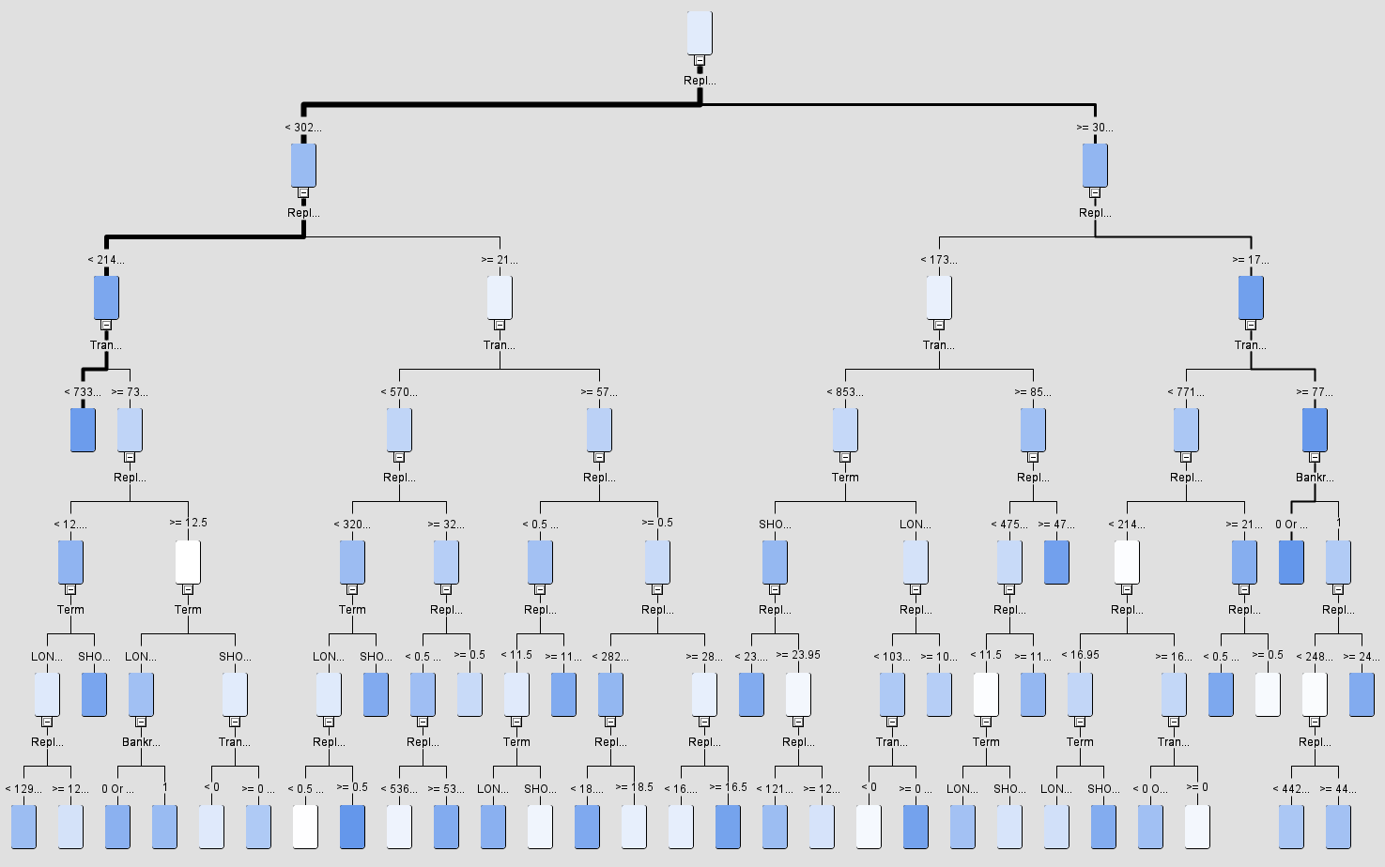

Figure cluster tree

##### Variable Importance

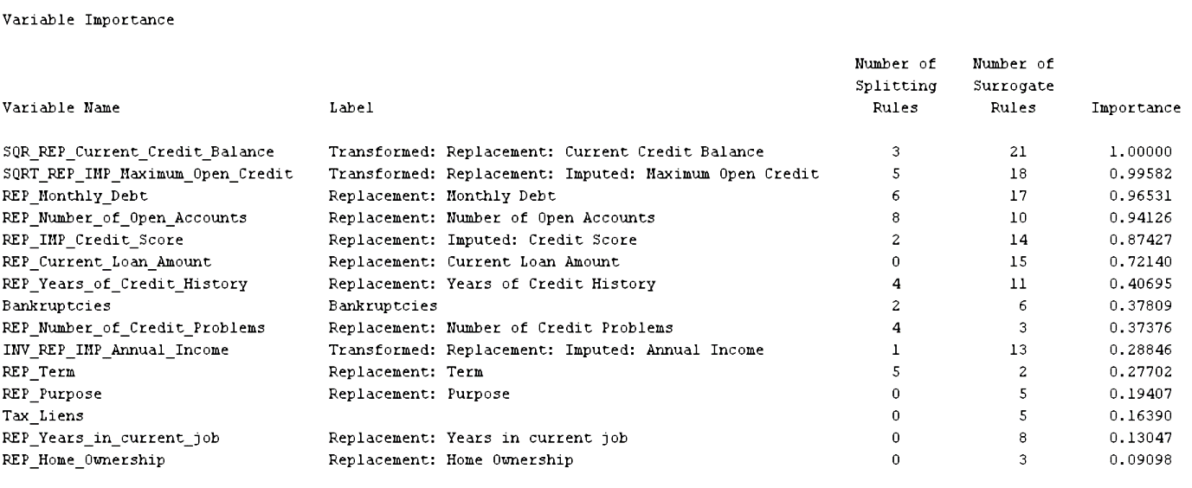

Figure Clustering variable importance

Through clustering analysis, the algorithm lists out the importance of the attributes provided in the dataset during clustering analysis. The first 3 most important variables are Current credit balance, maximum open credit, and monthly debt.

#### Critical Interpretation of Outcomes

In the following section, we look into the node rules generated during the clustering analysis. Then, we use the segment profile nodes to examine the worth of each attribute and have a look at the key factors that is used in clustering analysis.

##### Clustering node rules

|  |  |
| --- | --- |
| Condition | Interpretation |
| *--------------------------------------------------*  Node = 15  *--------------------------------------------------*  if Transformed: Replacement: Imputed: Maximum Open Credit >= 709.022 or MISSING  AND Replacement: Monthly Debt >= 20943.4  AND Bankruptcies IS ONE OF: 0 or MISSING  then  Tree Node Identifier = 15  Number of Observations = 9933  Predicted: _SEGMENT_=2 = 0.05  Predicted: _SEGMENT_=1 = 0.95 | **Condition 1:** the value of 'Transformed: Replacement: Imputed: Maximum Open Credit' is greater than or equal to 709.022 or it's missing.  **Condition 2:** the value of 'Replacement: Monthly Debt' is greater than or equal to 20943.4.  **Condition 3:** the value of 'Bankruptcies' can be either 0 or missing.  When the conditions above are met, the data is likely to belong to segment 1 with 95% of probability. |
| *--------------------------------------------------*  Node = 23  *--------------------------------------------------*  if Transformed: Replacement: Imputed: Maximum Open Credit >= 935.095 or MISSING  AND Replacement: Monthly Debt < 20943.4 AND Replacement: Monthly Debt >= 12878.1 or MISSING  then  Tree Node Identifier = 23  Number of Observations = 2181  Predicted: _SEGMENT_=2 = 0.14  Predicted: _SEGMENT_=1 = 0.86 | **Condition 1:** the value of 'Transformed: Replacement: Imputed: Maximum Open Credit' is greater than or equal to 935.095, or it's missing.  **Condition 2:** the value of 'Replacement: Monthly Debt' is less than 20943.4 and greater than or equal to 12878.1, or it's missing.  When the conditions above are met, the data is likely to belong to segment 1 with 86% of probability. |
| *--------------------------------------------------*  Node = 32  *--------------------------------------------------*  if Transformed: Replacement: Imputed: Maximum Open Credit < 833.173 or MISSING  AND Transformed: Replacement: Current Credit Balance < 1.33E11 or MISSING  AND Replacement: Term IS ONE OF: LONG_TERM  AND Replacement: Number of Open Accounts < 10.5 or MISSING  AND Replacement: Monthly Debt < 20943.4 or MISSING  then  Tree Node Identifier = 32  Number of Observations = 3092  Predicted: _SEGMENT_=2 = 0.91  Predicted: _SEGMENT_=1 = 0.09 | **Condition 1:** the value of 'Transformed: Replacement: Imputed: Maximum Open Credit' is less than 833.173 or it's missing.  **Condition 2:** the value of 'Transformed: Replacement: Current Credit Balance' is less than 1.33E11 or it's missing.  **Condition 3:** the value of 'Replacement: Term' is marked as 'LONG_TERM'.  **Condition 4:** the value of 'Replacement: Number of Open Accounts' is less than 10.5 or it's missing.  **Condition 5:** the value of 'Replacement: Monthly Debt' is less than 20943.4 or it's missing.  When the conditions above are met, the data is likely to belong to segment 2 with 91% of probability. |
| *--------------------------------------------------*  Node = 36  *--------------------------------------------------*  if Transformed: Replacement: Imputed: Maximum Open Credit < 833.173 or MISSING  AND Replacement: Years of Credit History < 30.35 or MISSING  AND Replacement: Term IS ONE OF: SHORT_TERM or MISSING  AND Replacement: Number of Open Accounts < 17.5 or MISSING  AND Replacement: Monthly Debt < 20943.4 or MISSING  then  Tree Node Identifier = 36  Number of Observations = 16705  Predicted: _SEGMENT_=2 = 0.98  Predicted: _SEGMENT_=1 = 0.02 | **Condition 1:** the value of 'Transformed: Replacement: Imputed: Maximum Open Credit' is less than 833.173 or it's missing.  **Condition 2:** the value of 'Replacement: Years of Credit History' is less than 30.35 or it's missing.  **Condition 3:** the value of 'Replacement: Term' is marked as 'SHORT_TERM' or it's missing.  **Condition 4:** the value of 'Replacement: Number of Open Accounts' is less than 17.5 or it's missing.  **Condition 5:** the value of 'Replacement: Monthly Debt' is less than 20943.4 or it's missing.  When the conditions above are met, the data is likely to belong to segment 2 with 98% of probability. |

Table Clustering analysis node rules table

##### Segment profile

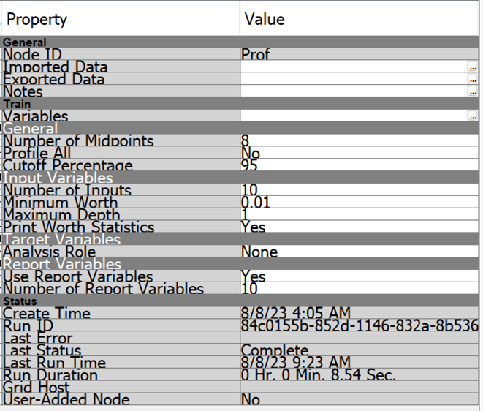

Figure Segment profile node settings

For the number of midpoints, we set the value to 8, meaning that all of the distribution diagrams drawn will have 8 midpoints. To not draw irrelevant diagrams, we combine them into _OTHER_ by setting the profile all to NO. The combining will only be executed once the cutoff percentage reaches 95%. There will be 10 inputs with all their worth more than or equal to 0.01. Besides, we set the maximum depth to 1 so that the algorithm will use the log worth value to identify the importance of the variables. The worth values of attributes will be displayed in the segment profile node results.

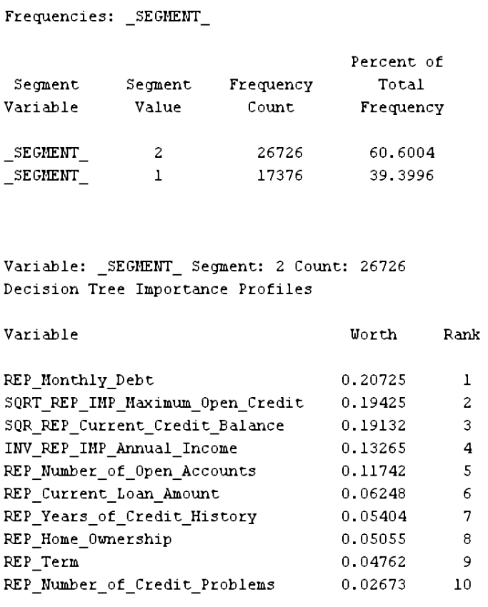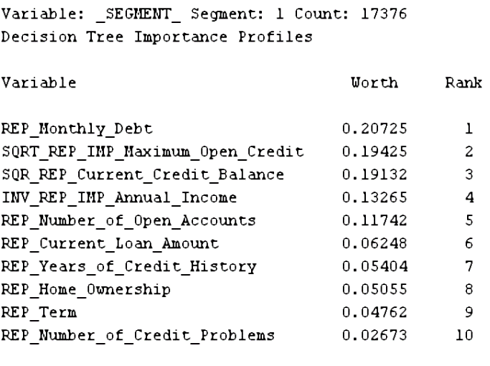

Figure Importance profiles

There are 26726 observations (60.6%) has been grouped into Segment 2 while the rest (17376, 39.4%) go to Segment 1. The calculation also ranked the variables that are the most relevant to segment formation. For both of the segments, monthly debt, maximum open credit, and current credit balance are ranked as the top 3 in this list.

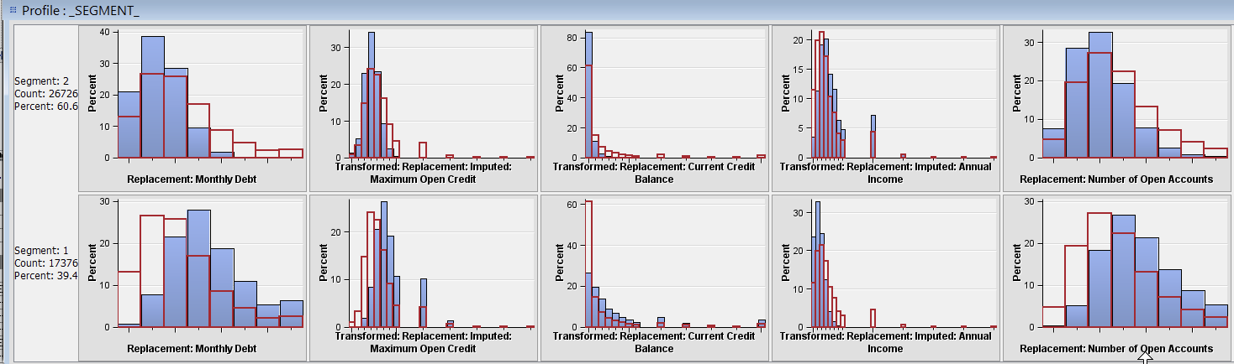

­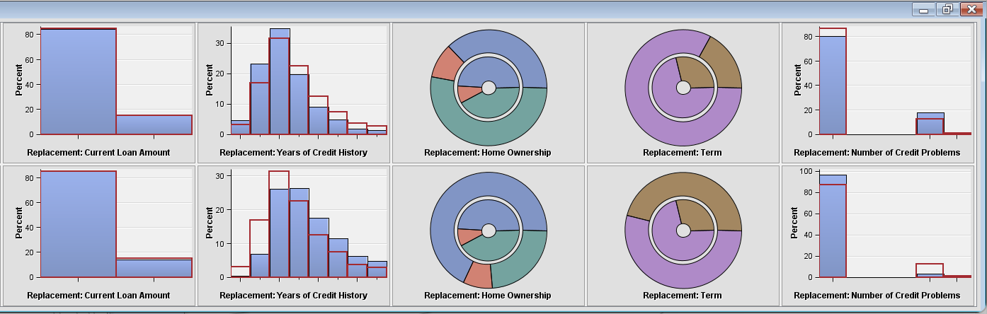

Figure Segment profile graphs

The graphs above show the profile for each of the segments in the dataset. In segment 2, the monthly debt, maximum open credit, current credit balance, number of open accounts, and years of credit history are lower than the average level. Meanwhile, annual income and the number of credit problems are slightly higher than the average number recorded.

In Segment 1, the monthly debt, maximum open credit, current credit balance, number of open accounts, and years of credit history are higher than the average value. On the other hand, annual income and number of credit problem are not hit the average expectation.

For the current loan amount, both segments have the same level of record as the average.

In terms of the categorical variable, the long-term loan (brown color) in segment 2 is lower than the overall average in the dataset while segment 1’s long-term loan is higher than the average. In the pie chart of home ownership, the red color indicates the own_home, the blue color indicates the home_mortgage and the green color indicates rent. The home_mortagage and own_home are less than the average number in segment 2 while the situation in segment 1 is totally inverse.

### 3rd Degree Forward Polynomial Regression – Tai Rui Xian TP060922

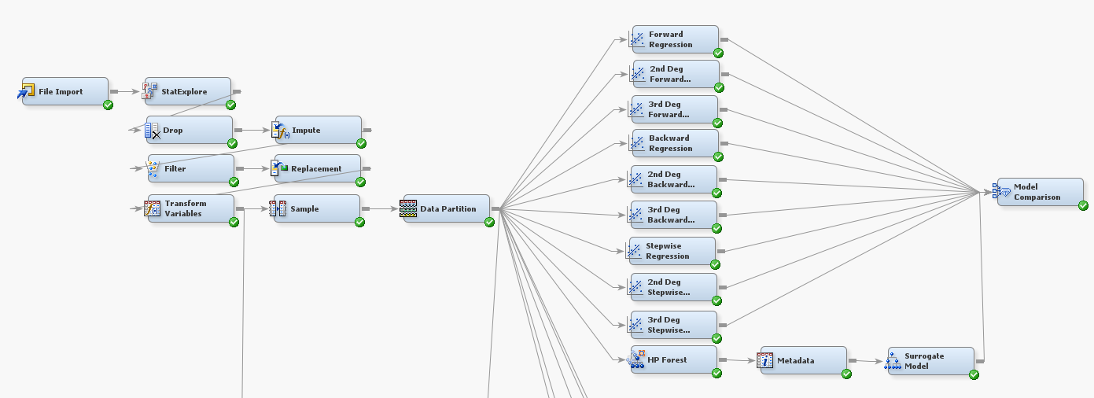

Figure .0. All related regression model node

In statistical modeling, the stepwise variable selection method of forward regression is employed. It begins with an empty model and progressively adds predictor variables that, according to a specified criterion, frequently an F-test or a p-value, contribute the most to the model's performance. With this approach, a predictive model is built by gradually adding predictors that improve its explanatory ability. This method extends to polynomial regression models of the corresponding degrees using second- and third-degree forward polynomial regressions. When dealing with complex interactions between variables, such as in nonlinear datasets, these strategies are especially helpful. They aid in locating important predictors and capturing higher-order interactions, which may result in more accurate forecasts. Forward regression, which provides an automated method to generate interpretable models by gradually integrating relevant variables, is frequently used in domains like machine learning, economics, and social sciences. This increases the interpretability and predictive accuracy of the models.

#### Model Construction & Optimization (Forward & Stepwise Regression)

|  |  |
| --- | --- |
| **Model Option and Setting** | **Results and Validation** |
| Model 1: Forward Regression  A screenshot of a computer  Description automatically generated  Figure Forward regression setting |   Figure Forward regression MISC graph  **MISC Train: 0.165525**  **MISC Valid: 0.165522** |
| Model 2: 2nd Degree Forward Polynomial Regression  A screenshot of a computer  Description automatically generated  Figure 2nd Degree Forward Polynomial Regression setting | A graph with red and blue lines  Description automatically generated  Figure 2nd Degree Forward Polynomial Regression MISC graph  **MISC Train: 0.165571**  **MISC Valid: 0.16542** |
| Model 3: 3rd Degree Forward Polynomial Regression  A screenshot of a computer  Description automatically generated  Figure Model 2: 3rd Degree Forward Polynomial Regression setting | A graph of a step number  Description automatically generated  Figure 3rd Degree Forward Polynomial Regression  **MISC Train: 0.165525**  **MISC Valid: 0.165284** |
| Model 4: Stepwise Regression  A screenshot of a computer  Description automatically generated  Figure Stepwise regression setting | A graph showing a line graph  Description automatically generated with medium confidence  Figure Stepwise Regression MISC graph  **MISC Train: 0.166364**  **MISC Valid: 0.166576** |
| Model 5: 2nd Degree Stepwise Polynomial Regression  A screenshot of a computer  Description automatically generated  Figure 2nd Degree Stepwise Polynomial Regression setting | A graph showing a graph of a model selection  Description automatically generated  Figure 2nd Degree Stepwise Polynomial Regression MISC graph  **MISC Train: 0.165525**  **MISC Valid: 0.165522** |
| Model 6: 3rd Degree Stepwise Polynomial Regression  A screenshot of a computer  Description automatically generated  Figure 3rd Degree Stepwise Polynomial Regression | A graph of a model selection step number  Description automatically generated  Figure 3rd Degree Stepwise Polynomial Regression MISC graph  **MISC Train: 0.165525**  **MISC Valid: 0.165522** |

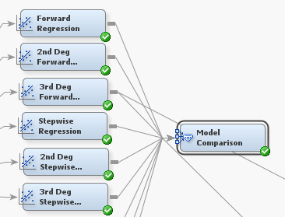

Figure Model comparison node

In case to compare all the MISC rates within the few models and find out the lowest MISC rate model, a model comparison node is placed in SAS EM.

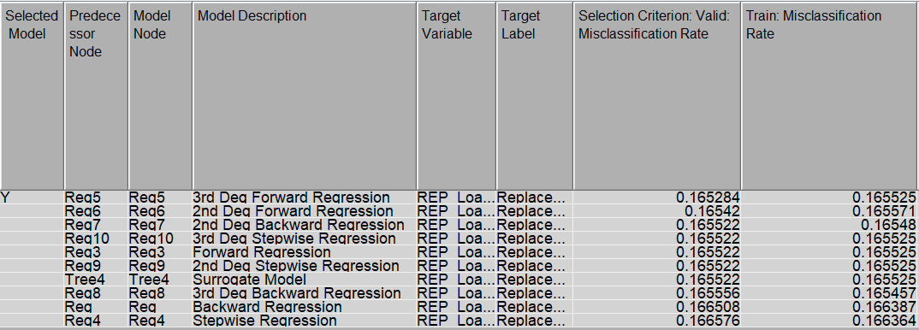

Figure Model comparison table

According to the result from the table, the 3rd degree forward polynomial regression model has the lowest MISC rate within the 10 models which include MISC train 0.165284 and MISC validation 0.165525. Hence, from the above table, I can finalize that 3rd-degree forward polynomial regression is the most accurate model within them to train the dataset.

#### Model Validation

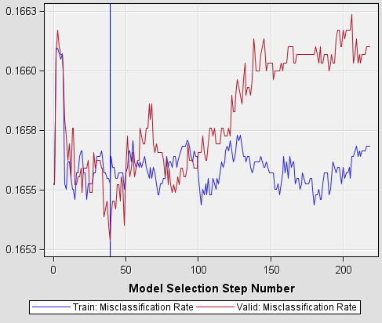

Figure Iteration plot (MISC)

Graph above indicates the misclassification rate of model 3rd-degree forward polynomial regression. Red line represents the valid misclassification rate and blue line represents to train misclassification rate. From the graph, we can notify both intercepted intercept with each other, the valid red line is increase, and the MISC line is plot at the lowest rate which lowest than 0.1655. From all the aspects shown, the graph indicates better modeling performance, representing that the model is training the dataset appropriately and no overfitting.

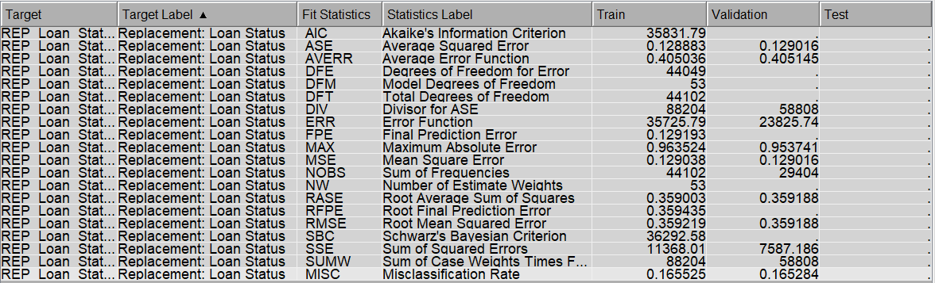



Figure Model 3 Fit Statistic table

According to the fit statistic table above, the misclassification rate for the training data is 0.165525, which means that approximately 16.55% of the cases in the training set were classified incorrectly by the model. As for the validation data, the misclassification rate is 0.165284, indicating that around 16.53% of the cases in the validation set were misclassified. Better predictive performance is indicating by the lower misclassification rate from the result; the outcome from the finding is that there is 83.47% accuracy for the model to train the loan status correctly.

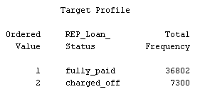

Figure Model 3's target profile

From the target profile showing, in the training process, it is implementing 36802 fully_paid and 7300 charged_off rows for the output.

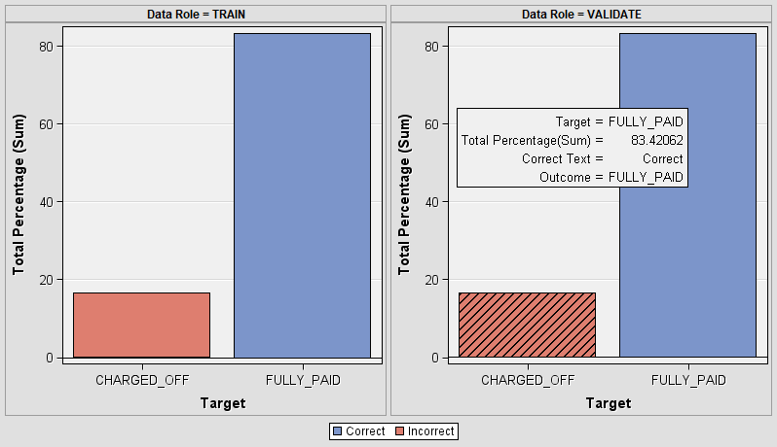

Figure Classification chart

Based on the chart above showing, it is the classification chart which indicates the performance evaluation of classification models. It provides a visual on how well a classification model has predicted the different classes within the dataset. In this case, in validation data, the target fully_paid can predict correctly with the total of percentage on 83.42% and incorrect total percentage on 16.50%. As in train data, the target fully_paid can predict correctly with the total percentage on 83.42% and incorrect total percentage on 16.53%.

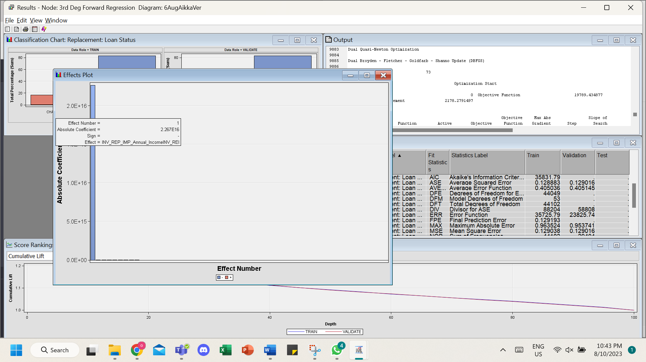

Figure Effect Number graph

According to the effect number graph above, it is the graph to visualize the effect number in regression. It is shown in bar charts and representing the absolute coefficients of the model effects. The higher the value in the section, the higher the influence on the target variables. The absolute coefficient values in the graph represent the degree of influence of each variable in the regression model. The plot assists in visualizing the correlation coefficients of the variables in a chart format, allowing us to understand the strength and direction of the relationships between the variables and the regression model. In this case, the highest effect number ‘1’ involved the absolute coefficient of 2.267E16. The Annual Income variable affects transformation, replacement, and impute.

#### Critical Interpretation of Outcome

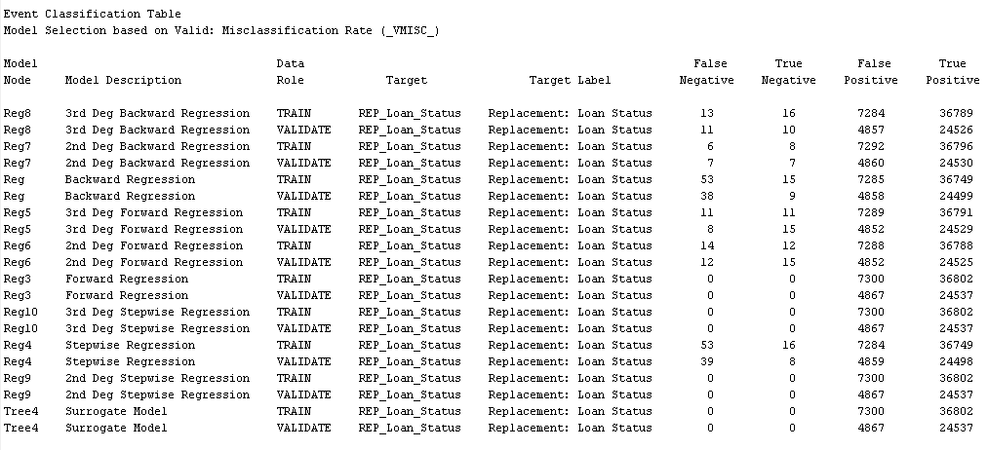

Figure Event Classification Table

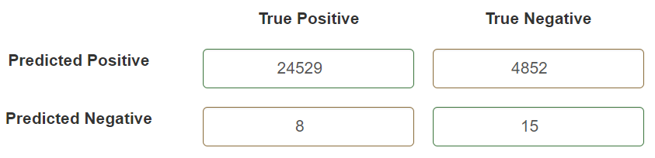

Figure 3rd Degree Forward Polynomial Regression Confusion Matrix

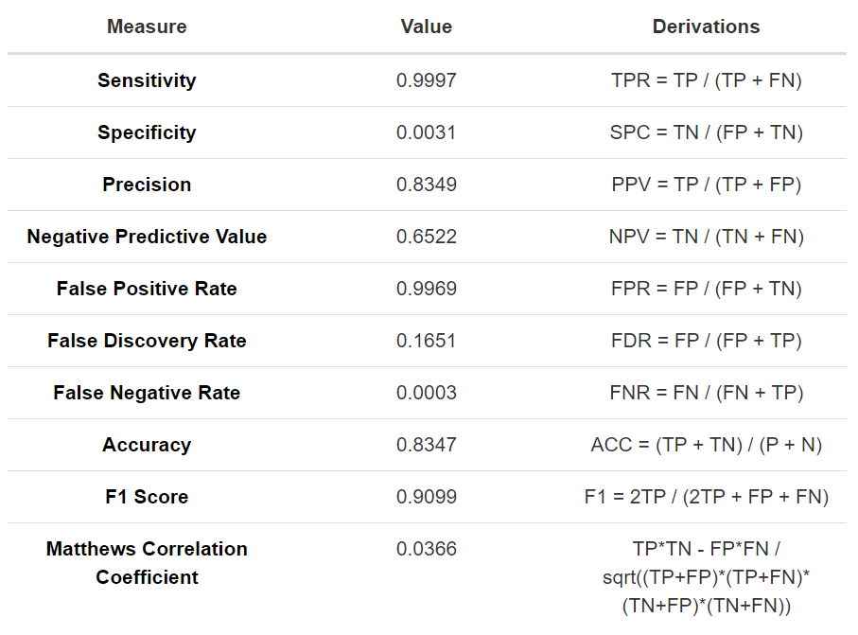

Figure Confusion Matrix Measures

The classification model's performance metrics reveal its effectiveness in predicting classes. The model exhibits high sensitivity (0.9997), accurately identifying most positive cases, but low specificity (0.0031), indicating challenges in predicting negatives. While the precision (0.8349) and negative predictive value (0.6522) reflect reasonably accurate positive and negative predictions, respectively, the model's false positive rate (0.9969) and false discovery rate (0.1651) highlight a considerable number of false positives. Conversely, the false negative rate is very low (0.0003), and the accuracy (0.8347) reflects an overall acceptable level of correctness. The F1 score (0.9099) suggests a balanced trade-off between precision and recall, while the Matthews correlation coefficient (0.0366) implies a relatively weak correlation between predicted and actual outcomes. The provided counts of true positives (TP), false positives (FP), false negatives (FN), and true negatives (TN) contribute to these insights, emphasizing the model's strengths in identifying positive cases but revealing room for improvement in reducing false positives.

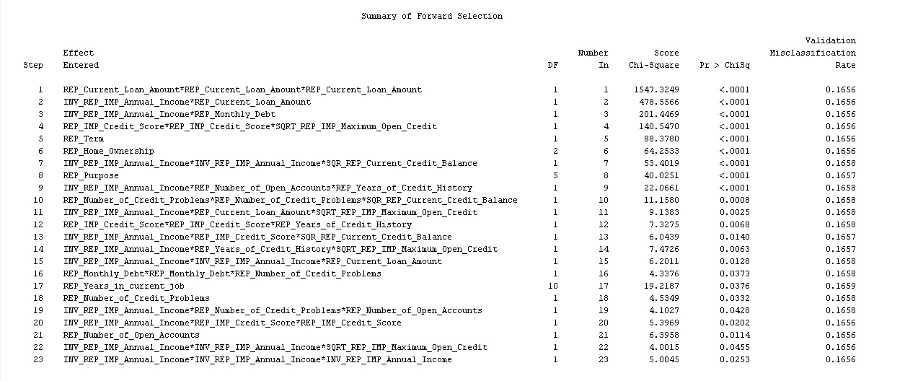

Figure Summary of Forward Selection

The summary of forward selection outlines the steps of adding predictors to the model. Each step introduces new variables based on their significance. Starting with the most influential variable "REP_Current_Loan_Amount*REP_Current_Loan_Amount*REP_Current_Loan_Amount," the process adds variables like income, purpose, homeownership, and others to improve model fit. Variables' chi-square values indicate their significance, with smaller values indicating better fit. This iterative process helps identify relevant features while refining the model's predictive accuracy.

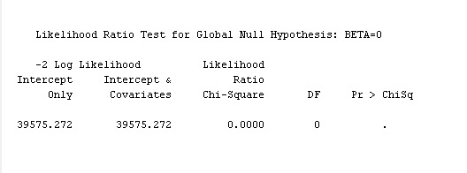

Figure Likelihood Ratio Test for Global Null Hypothesis

The "Intercept Only" model has a log likelihood of 39575.272. When adding covariates, the log likelihood remains the same, indicating that the additional covariates do not significantly improve the model fit. The Chi-Square value of 0 and the p-value of "." (not significant) suggest that the added covariates don't contribute to the model's explanation of the data.



Figure Analysis of Maximum Likelihood Estimates

The intercept parameter has an estimated value of 1.6178 with a standard error of 0.0128. The Wald Chi-Square value is 15942.04, indicating that the intercept's effect is highly significant (p-value < 0.0001). The standardized estimate is 5.042, suggesting a substantial impact of the intercept on the model's outcome.

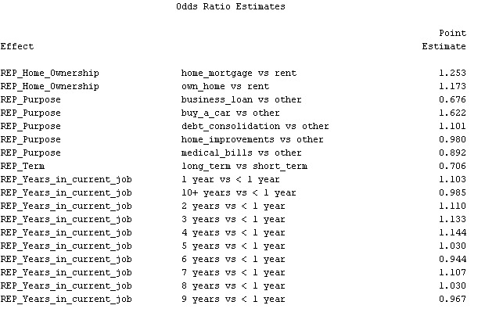

Figure Odds Ratio Estimates

The odds ratio estimates indicate the impact of various factors on the likelihood of a target event. Home ownership (mortgage vs. rent) has a 1.253 odds ratio, suggesting higher odds of the event. Similarly, owning a home (vs. renting) and certain loan purposes like buying a car (1.173 and 1.622 odds ratios) also influence higher odds. However, getting a business loan (0.676 odds ratio) or choosing home improvements (0.980 odds ratio) might lower odds. Different job years have varying effects, with longer durations generally associated with increased odds.

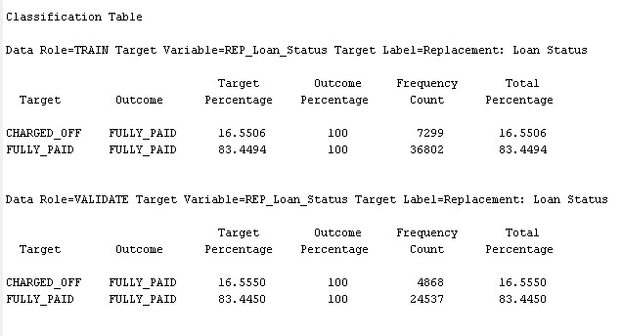

Figure Classification Table

The "Classification Table" provides a breakdown of the predicted outcomes compared to the actual outcomes for both the training and validation datasets. In the training dataset, for the "CHARGED_OFF" target, the model correctly predicted "FULLY_PAID" 16.5506% of the time, while for the "FULLY_PAID" target, the model correctly predicted "FULLY_PAID" 83.4494% of the time. Similarly, in the validation dataset, the model's predictions were similar, with 16.5550% accuracy for "CHARGED_OFF" and 83.4450% accuracy for "FULLY_PAID."

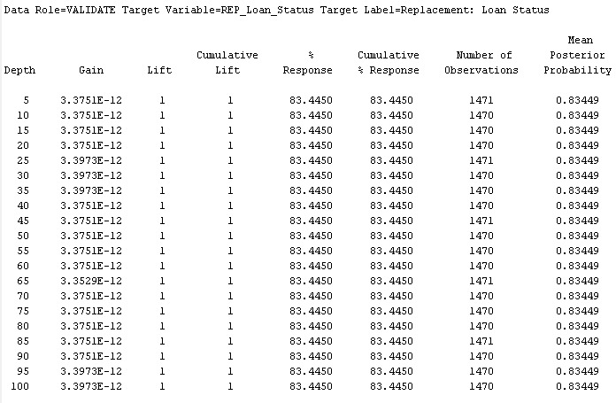

Figure Assessment Score Rankings

The model's performance remains consistent across different assessment depths, with a cumulative gain and lift both equal to 1, indicating 100% capture of positive outcomes ("FULLY_PAID"). The mean posterior probability of positive outcomes remains steady at around 0.83449, showing consistent predictions regardless of assessment depth.

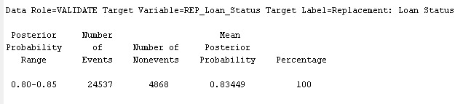

Figure Assessment Score Distribution

In the validation dataset, when the posterior probability range of 0.80-0.85 is considered, there are 24,537 events (positive outcomes) and 4,868 non-events (negative outcomes). The mean posterior probability within this range is 0.83449, indicating that the model predicts a positive outcome with an approximately 83.449% probability for these instances. This probability range captures all events in the validation data.

### 2nd Degree Backward Polynomial Regression – Tai Rui Xian TP060922



Figure .0. All regression model node

Regression analysis uses the statistical method of backward regression to choose the variables. It entails starting with a model that includes all predictors and gradually eliminates those with higher p-values. (Simplilearn, 2023) However, a variation of this approach applied exclusively to polynomial regression models in which higher-order elements are progressively eliminated according to their significance is known as second-degree backward polynomial regression. These methods are useful for working with datasets that contain many predictors. They seek to improve the models while maintaining their predictive power. (S, 2022) Less important variables are removed, making the resulting models easier to understand and less prone to overfitting. The third-degree backward polynomial regression applies the elimination approach exclusively to polynomial regression models with third-degree elements. Widely used in situations with numerous predictors or high-dimensional data, these techniques aid in creating interpretable models with improved generalization, reducing the risk of overfitting. By gradually excluding less relevant variables based on their significance, these approaches offer a resource-efficient means to construct effective polynomial models that balance complexity and performance. (S, 2022)

A forest comprises many decision trees that are unique from one another in two respects. First, a sample without replacement from all available observations serves as the training data for a tree. Second, random selection is used to choose which input variables are considered when dividing a node. The trees in a forest are taught similarly to regular trees in different ways.

#### Model Construction & Optimization (Backward Regression & HP forest)

|  |  |
| --- | --- |
| **Model Option and Setting** | **Results and Validation** |
| Model 1: Backward Regression  A screenshot of a computer  Description automatically generated  Figure Backward regression setting | A graph of a model selection step number  Description automatically generated  Figure Backward regression MISC graph  **MISC Train: 0.166387**  **MISC Valid: 0.166508** |
| Model 2: 2nd Degree Backward Polynomial Regression  A screenshot of a computer  Description automatically generated  Figure 2nd Degree Backward Polynomial Regression setting | A graph showing a number of steps  Description automatically generated  Figure 2nd Degree Backward Polynomial Regression MISC graph  **MISC Train: 0.16548**  **MISC Valid: 0.165522** |
| Model 3: 3rd Degree Backward Polynomial Regression Figure Model 2: 3rd Degree Backward Polynomial Regression setting | A graph showing a number of steps  Description automatically generated  Figure 3rd Degree Backward Polynomial Regression  **MISC Train: 0.165457**  **MISC Valid: 0.165556** |
| Model 4: HP Forest  A screenshot of a computer  Description automatically generated  Figure HP Forest setting | A graph showing a number of trees  Description automatically generated  Figure HP Forest MISC graph  **MISC Train: 0.165525**  **MISC Valid: 0.165522** |

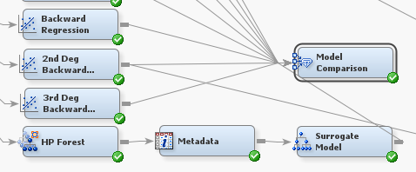

Figure Model Comparison Node

In case to compare all the MISC rate within the few models and find out the lowest MISC rate model, a model comparison node is placed in SAS EM.

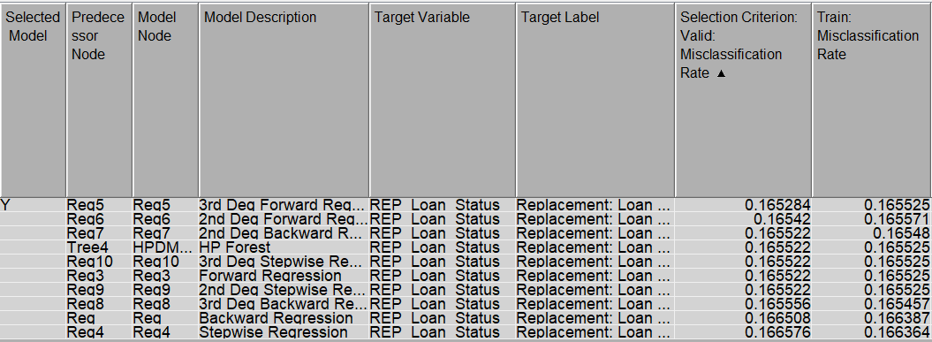

Figure Model comparison table

According to the result from the table, the 2nd degree backward polynomial regression model has the third lowest MISC rate within the 10 models which include MISC train 0.16548 and MISC validation 0.165522. Hence, from the above table, I can finalize that 2nd degree backward polynomial regression is also the most accurate model within them to train the dataset.

#### Model Validation

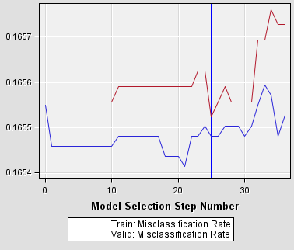

Figure Iteration Plot (MISC)

The graph shows the relationship between the train misclassification rate and the valid misclassification rate. The graph shows that the train misclassification rate decreases as the model selection step number increases. This is because the model is becoming more complex as more terms are added to the polynomial. A more complex model can fit the training data more closely, which leads to a lower misclassification rate. However, the valid misclassification rate does not decrease as quickly as the train misclassification rate. This is because the model is also becoming more complex, which makes it more likely to overfit the training data. The optimal model selection step number is where the train misclassification rate and the valid misclassification rate are closest. In this case, the optimal model selection step number is around 25. A 2nd-degree backward polynomial regression model is a good choice for this data set because it can fit the data well without overfitting. The optimal model selection step 20 ensures that the model is not too complex and will generalize well to new data.

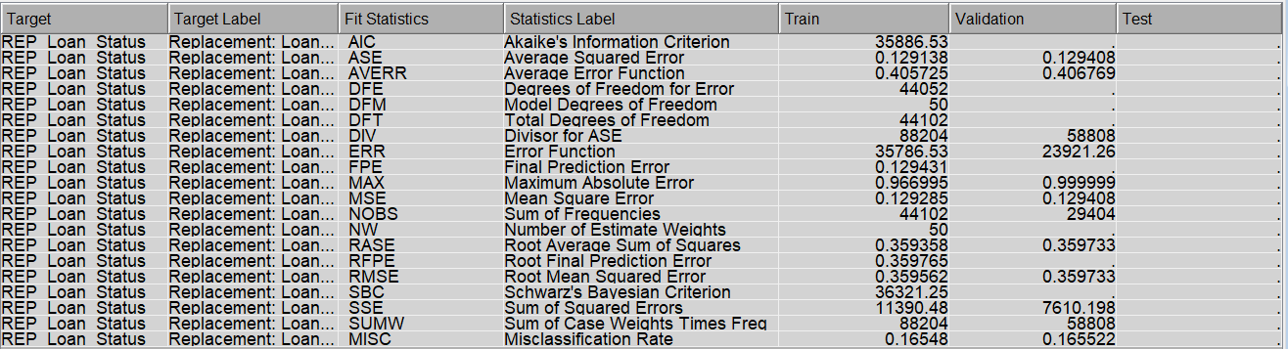



Figure Model 3 Fit Statistic table

According to the fit statistic table above, the misclassification rate for the training data is 0.16548, which means that approximately 16.55% of the cases in the training set were classified incorrectly by the model. As for the validation data, the misclassification rate is 0.165522, indicating that around 16.55% of the cases in the validation set were misclassified. Better predictive performance is indicating by the lower misclassification rate from the result; the outcome from the finding is that there is 83.45% accuracy for the model to train the loan status correctly.

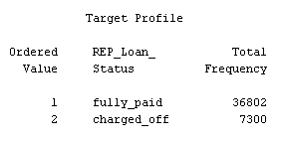

Figure Model 2's target profile

From the target profile showing, in the training process, it is implementing 36802 fully_paid and 7300 charged_off data row for the output.

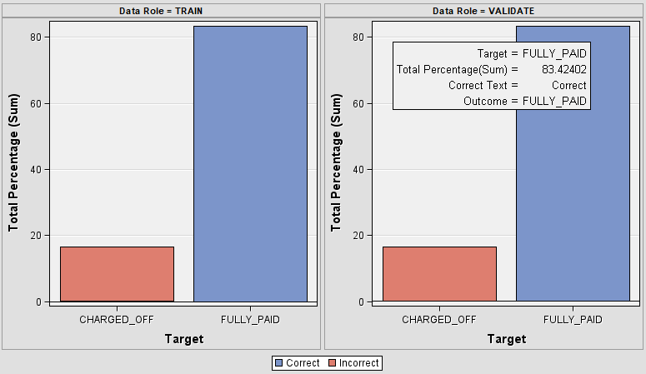

Figure Classification chart

Based on the chart above showing, it is the classification chart which indicates the performance evaluation of classification models. It provides a visual on how well a classification model has predicted the different classes within the dataset. In this case, in validation data, the target fully_paid can predict correctly with the total percentage on 83.42% and incorrect total percentage on 16.53%. As in train data, the target fully_paid can predict correctly with the total percentage on 83.43% and incorrect total percentage on 16.53%.

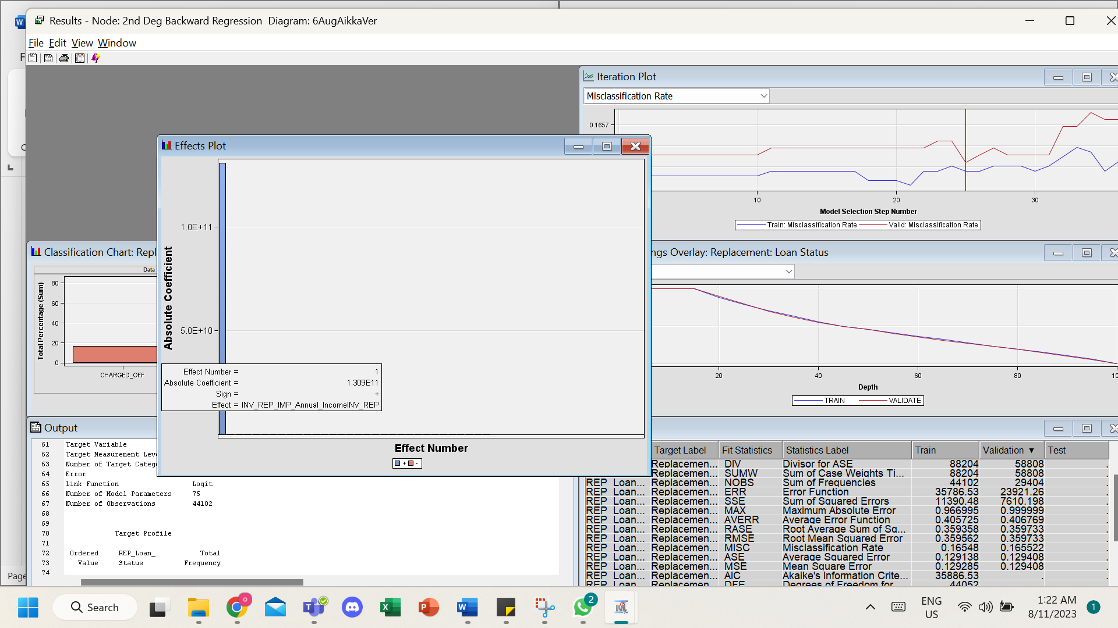

Figure Effect number graph

The effect number graph for the 2nd degree backward polynomial regression model shows the relationship between the absolute value of the coefficient and the effect number for each predictor variable. In the image, the predictor variable with the largest absolute value of the coefficient is NV REP IMP_Annual Income. This means that NV REP IMP_Annual Income has the strongest relationship with the dependent variable. The effect number for NV REP IMP_Annual Income is also relatively high, which means that it is an important predictor variable in the model. The effect number graph shows that NV REP IMP_Annual Income is the most important predictor variable in the 2nd degree backward polynomial regression model. The other predictor variables are also important but not as important as NV REP IMP_Annual Income. In this case, the highest effect number ‘1’ involved the absolute coefficient of 1.309E11. The Annual Income variable affects transformation, replacement, and impute.

#### Critical Interpretation of Outcome



Figure Event Classification Table

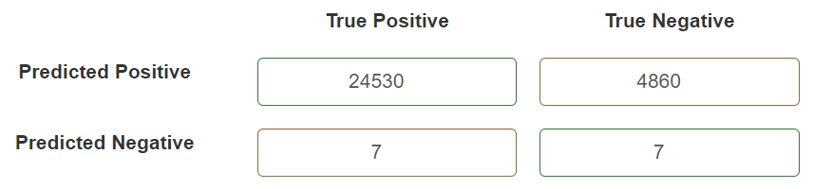

Figure 2nd Degree Backward Polynomial regression Confusion Matrix

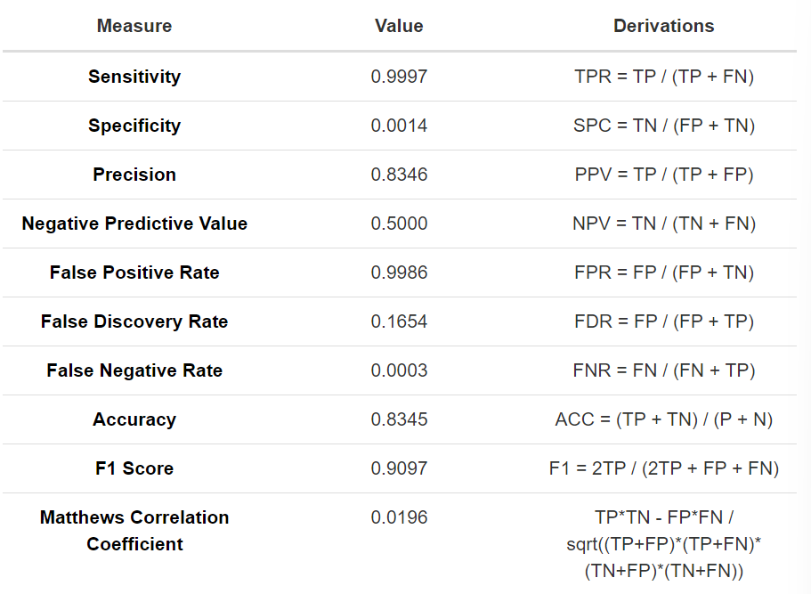

Figure Confusion Matrix Measures

The classification model's performance metrics reveal its high sensitivity (0.9997) in correctly identifying positive cases and reasonable precision (0.8346) in positive predictions. However, it struggles with specificity (0.0014) and negative predictive value (0.5000), leading to challenges in distinguishing true negatives. The model's false positive rate (0.9986) and false discovery rate (0.1654) indicate a notable number of false positive predictions. Conversely, the false negative rate is very low (0.0003), and accuracy (0.8345) reflects an acceptable level of overall correctness. The F1 score (0.9097) indicates a balanced trade-off between precision and recall, while the Matthews correlation coefficient (0.0196) suggests a weak correlation between predicted and actual outcomes. The provided true positive (TP), false positive (FP), false negative (FN), and true negative (TN) counts contribute to these insights, highlighting the model's capability in identifying positive cases but the need for improvements in reducing false positives and enhancing overall performance.

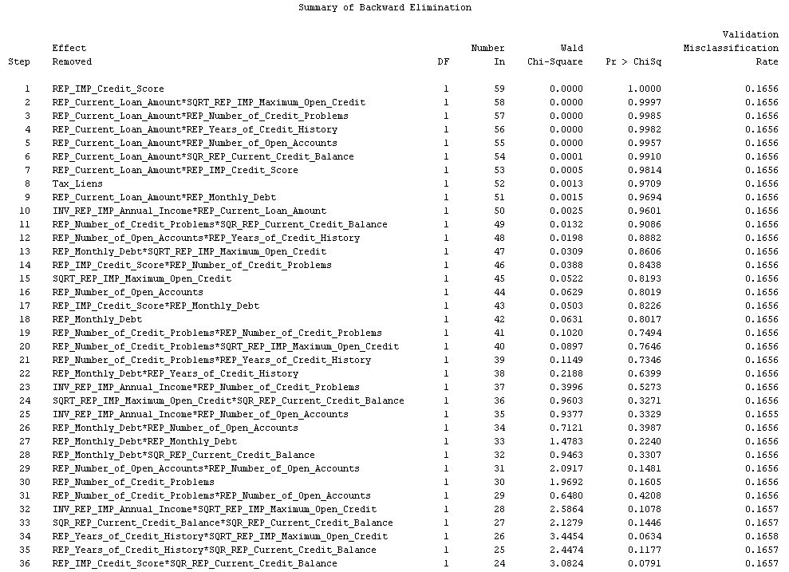

Figure Summary of Backward Elimination

The summary of backward elimination showcases the gradual removal of predictor variables based on their significance. As variables are eliminated, the impact on various metrics is tracked. From the summary of backward elimination, it's apparent that the removal of predictor variables does not significantly affect the misclassification rate, which remains relatively constant at around 16.5%. This could imply that certain variables might not be contributing substantially to the model's predictive power, and their removal doesn't significantly impact its performance in terms of misclassification.

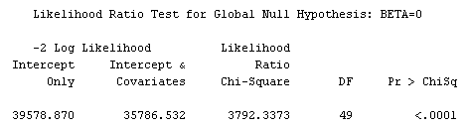

Figure Likelihood Ratio Test for Global Null Hypothesis

The -2 Log Likelihood values represent the model's goodness of fit, where the lower the value, the better the fit. The calculated Chi-Square statistic (3792.3373) with 49 degrees of freedom (DF) indicates that the model with predictor variables significantly improves the model fit compared to the intercept-only model. The p-value (<.0001) further supports this, suggesting that the model's predictors collectively contribute to explaining the variation in the response variable. Therefore, the null hypothesis that all predictor coefficients are zero (BETA=0) is rejected, and the model with predictor variables is statistically significant in explaining the variability in the data.

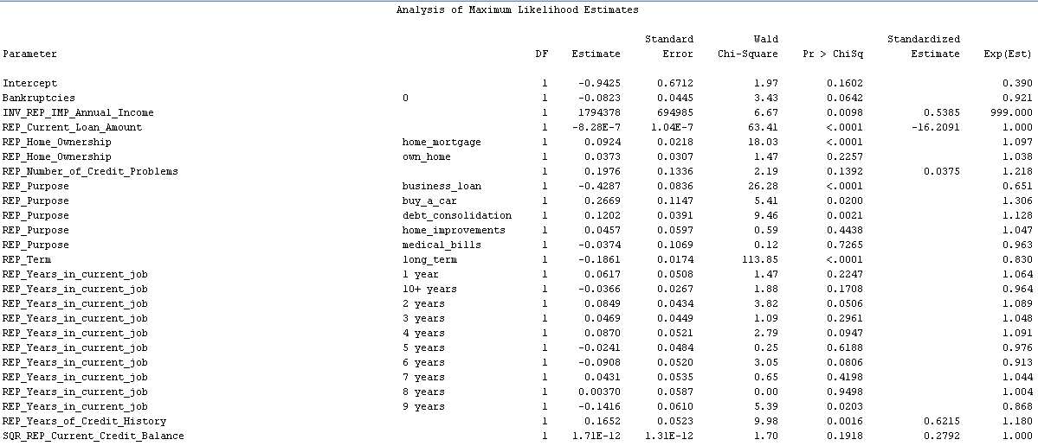

Figure Analysis of Maximum Likelihood Estimates

Notably, the intercept's estimate indicates a negative influence, but it's not statistically significant. Variables like "Annual_Income"" Current_Loan_Amount,"" Home_Ownership,"" Purpose,""Term,""Years_in_current_job,"and" Years_of_Credit_History" show statistically significant effects based on their p-values (< 0.05). These variables have positive or negative influences on the response. Additionally, some variables' effects appear not to be statistically significant due to their higher p-values, like "Bankruptcies" and "Years_in_current_job." The "Current_Credit_Balance" variable has an estimate close to zero, suggesting limited influence. Standardized estimates reflect the relative importance of variables in the model.

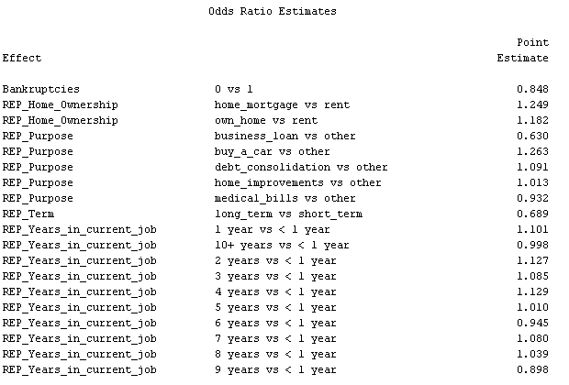

Figure Odds Ratio Estimates

An odds ratio greater than 1 indicates a higher likelihood of the event occurring, while an odds ratio less than 1 suggests a lower likelihood. For instance, variables like "Bankruptcies," "Home Ownership," "Purpose," "Term," and "Years in Current Job" are assessed against specific reference categories. "Bankruptcies" at 0 vs 1 has an odds ratio of 0.848, implying a reduced likelihood of an event happening when "Bankruptcies" is 0 compared to 1. "Home Ownership" and "Purpose" variations also show their impact on the odds of different outcomes. Similarly, "Term" indicates that a "long term" loan has lower odds compared to a "short term" loan. "Years in Current Job" variations relative to "< 1 year" or "10+ years" affect odds, suggesting insights into the relationships between variables and outcomes.

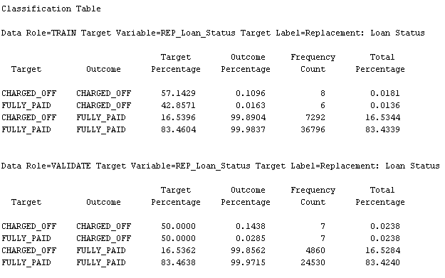

Figure Classification Table

The classification table compares model predictions with actual outcomes for "Loan Status." It indicates that the model accurately predicted 50% of "CHARGED_OFF" cases and 83.46% of "FULLY_PAID" cases. However, misclassifications occurred: 50% of "CHARGED_OFF" were wrongly labeled "FULLY_PAID," and 16.54% of "FULLY_PAID" were inaccurately classified as "CHARGED_OFF."

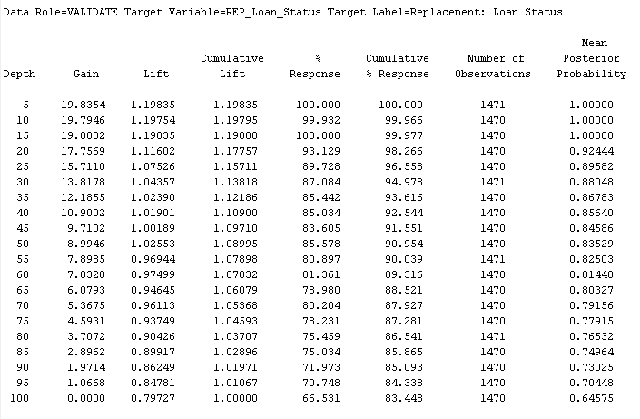

Figure Assessment Score Rankings

The assessment score ranking illustrates how performance metrics like gain, lift, and response change with varying decision tree depths. A depth of 5 yields the highest gain (19.8354) and lift (1.19835), indicating superior model performance. This helps in selecting the best tree depth for predictive accuracy.

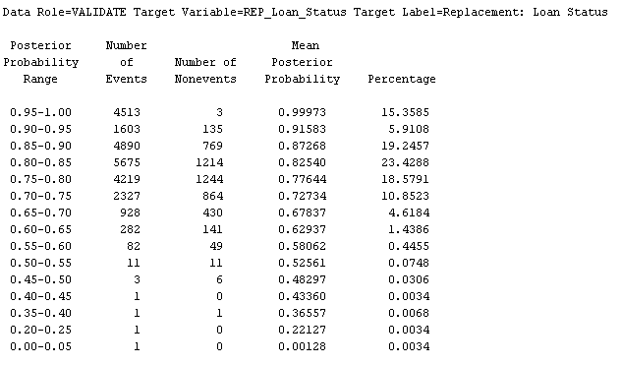

Figure Assessment Score Distribution

The assessment score distribution segments "Loan Status" posterior probabilities into ranges. Each range includes event and nonevent counts, along with the mean posterior probability. For instance, in the range "0.95-1.00," there are 4513 events and 3 nonevents, with a mean probability of 0.99973. This distribution reveals how the model assigns probabilities to predicted outcomes, aiding evaluation.

### Decision Tree – Chin Min Hwei TP061818

The decision tree algorithm is widely used in supervised learning for both regression and classification tasks due to its popularity and ease of interpretation. It aims to build a model based on training data, allowing it to predict the target variable's class or value by learning straightforward decision rules from previous data. The decision tree visualizes all potential solutions in a tree-like structure, resembling human decision-making processes. It starts from the root node, comparing attributes to the dataset, and follows branches until reaching leaf nodes where the final prediction is made. Consequently, the decision tree outcomes offer a clear graphical visual, facilitating comprehension and understanding of the underlying logic behind the predictions.

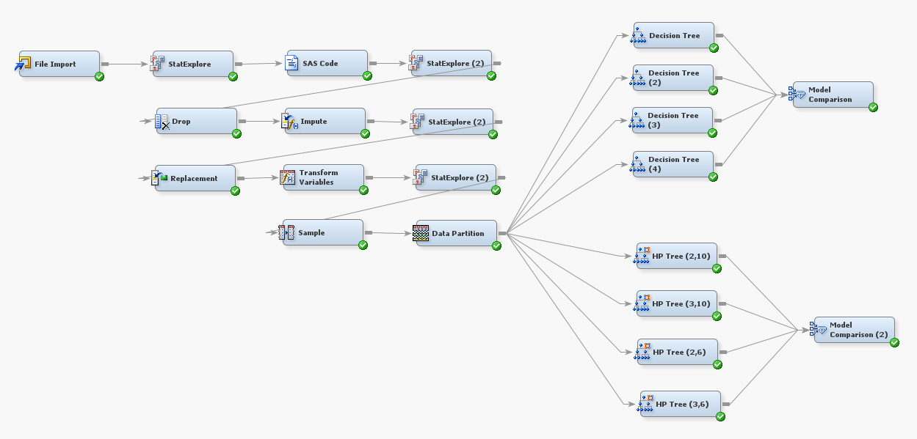

Figure Predictive Modeling

#### Model Construction and Optimization

|  |  |
| --- | --- |
| **Properties Setting** | **Output** |
|  **|   **MISC Train: 0.214907**  **MISC Validation: 0.216489** |
|  **|   **MISC Train: 0.19304**  **MISC Validation: 0.19429** |
|  **|   **MISC Train: 0.192856**  **MISC Validation: 0.19534** |
|  |   **MISC Train: 0.199107**  **MISC Validation: 0.201665** |

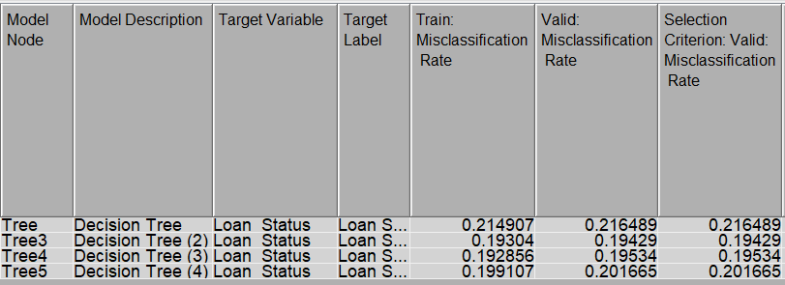

Figure Decision Tree Model Comparison

Based on the comparison outcomes above, **Model 2** has the lowest MISC value for valid data (0.19429) where train data is the second lowest of 0.19304. A lower MISC rate in the training data indicates effective performance of the model in accurately classifying instances on data trained. It also means the model's capacity to get patterns and correlations within the train dataset. Lower valid MISC rate implies model is well performed on unseen data which was not directly trained on. This signifies no overfitting the training data and precise predictions on instances. We can conclude that Decision Tree of **Model 2** is the best model among the four options when considering training and validation performance to improve generalization. .

#### Model Validation

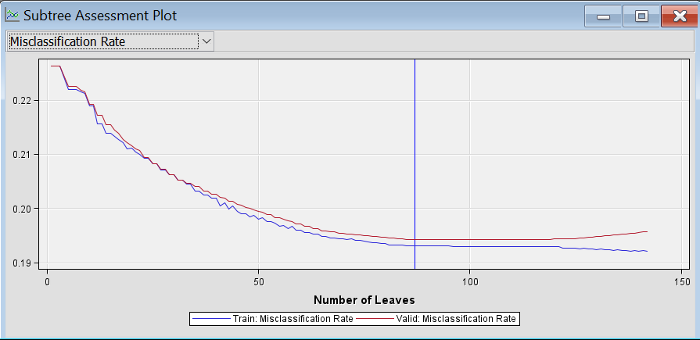

Figure Subtree Assessment Plot MISC

The subtree assessment plot above shows the data stop training at leaves 87, giving a misclassification rate of 0.19304 and 0.19429 for train and validation data respectively.

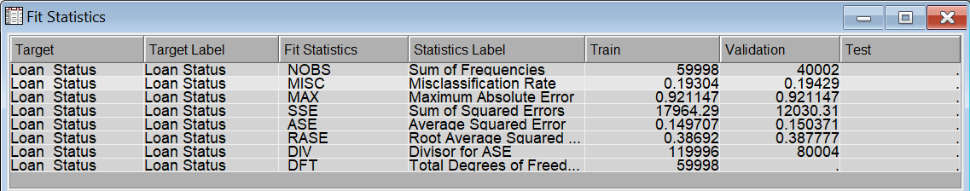

Figure Fit Statistics

Fit statistics table illustrates the target variable of “Loan Status” to evaluate the model’s performance in train and validation data. Based on the statistics, there are 19.3% incorrect for train data, which also means 81.7% prediction accuracy. Meanwhile, validation data has 19.43% of predictions are inaccurate, representing 80.57% accuracy.

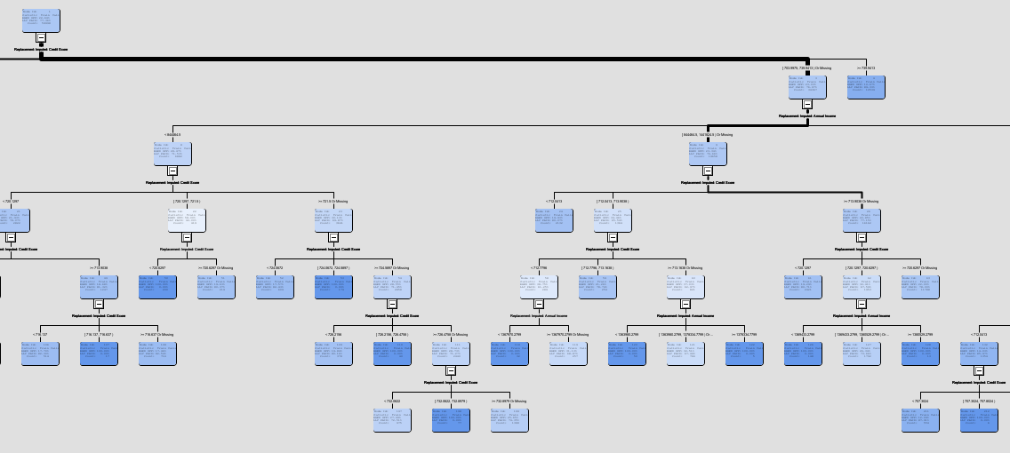

Figure Decision Tree View

The diagram above shows a part of Decision Tree with maximum 3 branches and 6 maximum depth using Assessment subtree method with misclassification measure.

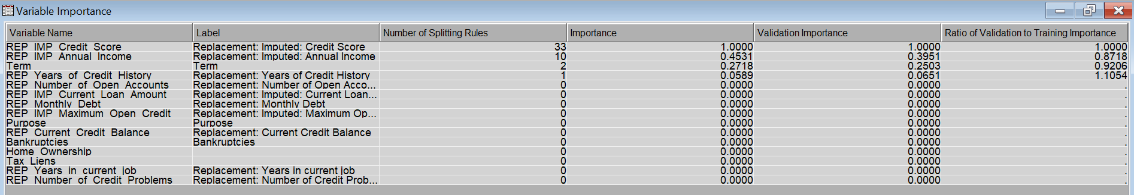

Figure Variable Importance

Variable importance shows the impact or importance of each input variable on the predictive model’s performance. It illustrates which variables contribute substantially to the model's predictions and performance. In this case, REP IMP Credit Score has an important value of 1.0, meaning that it is highly relevant to the model and following by REP IMP Annual Income with second highest of 0.4531 value. Other variables give a 0.0 value demonstrating that there are less important to the model.

#### Critical Interpretation of Outcomes

Summarize how each method performed on the testing data by classifying loan status into two classes such as fully paid and charged off.

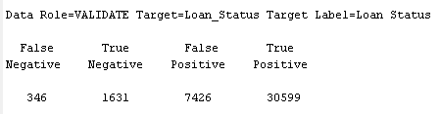

Figure Event Classification Table

|  |  |  |  |
| --- | --- | --- | --- |
| **Actual** | | | |
| **Predicted** | **Loan Status** | **POSITIVE**  *Fully Paid* | **NEGATIVE**  *Charged Off* |
| **POSITIVE**  *Fully Paid* | **True Positive: 30,599**  The number of cases where the model correctly predicted Loan Status is Fully Paid. There are 30,599customers where loan status is fully paid that were correctly predicted. | **False Positive: 7,426**  The model incorrectly predicted "Fully Paid" when the actual result was "Charged Off" which means there are 7,426 instances where the model incorrectly predicted a positive outcome when the actual is negative. |
| **NEGATIVE**  *Charged Off* | **False Negative: 346**  There are 346 cases where the model predicted wrongly to “Charged Off” when the actual outcome should be “Fully Paid”. This means that 346 customers actually fully paid off the loan but it was predicted negatively. | **True Negative: 1,631**  This section is where the model predicts negative loan status correctly. There are 1,631 cases where the model correctly predicted customer loan status as charged off. |

**Node Rules Interpretation**

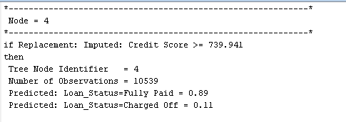

Node 4 shows that a total of 10539 observations where customers with credit score greater than or equal to 739.941 will have a high probability of 0.89 that customer will fully pay on the loan applied. From this node rule, this indicates this particular segment of borrowers who are more likely to fully pay their loans. Customers with these conditions are more likely to fully paid is because they have a strong credit profile and management, reflecting good financial discipline and a positive track record of repaying debts on time.

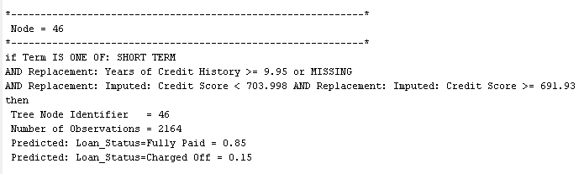

This node represents a subset of 2164 customers that meet the conditions such as credit score range is from 691.93 to 703.998 and years of credit history is at least 9.95 along with short term loan applied. The model predicts that these customers have an 85% probability that their loan status will be Fully Paid. This is because customers applying for short-term loans could have specific intentions for borrowing, like purchases or investments and their well management of financial, resulting them the ability to loan repayable responsible. Also, longer credit history indicates that customers can manage credit obligations constantly, which increases the chance that they will return loans.

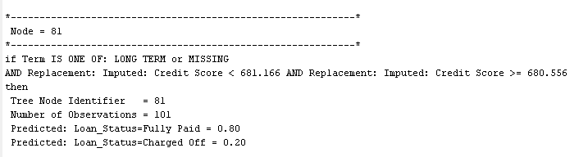

The conditions of credit score range from 680.556 to 681.166 and loan term is long will have 80% probability out of 101 observations are most likely to repay their loans. This implies a diverse group in terms of credit scores and loan term. The 20% predicted probability of being "Charged Off" suggests a moderate risk for these groups. The output shows that even if there is a risk, it is not extremely high. In brief, the different probabilities assigned to each loan status show that the model is reasonably confident in its predictions for this node.

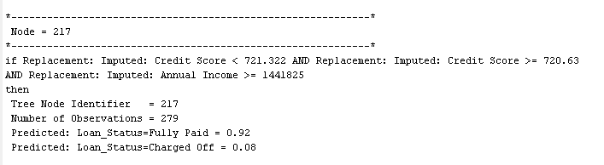

If conditions like credit score range between 720.63 and 721.322 together with annual income at least 1441825 are met, then 92% of a total of 279 number of observations loan status will be ‘Fully Paid’. This may be due to a high financial creditworthiness and constant source of income from stable employment exhibit the capability to pay off the loan applied from bank.

### HP Tree – Chin Min Hwei TP061818

The HP Tree node is tailored for high-performance data mining, offering tree model creation, visualization, and input variable importance determination. It mirrors the features of the HP Tree node, encompassing tools and outcomes such as the tree diagram, treemap, leaf statistics, subtree assessment plot, and Node Rules (SAS, 2017). Validation of the model is also supported by the HP Tree node. It employs its dedicated validation dataset for pruning the tree, producing model statistics, and enhancing overall performance.

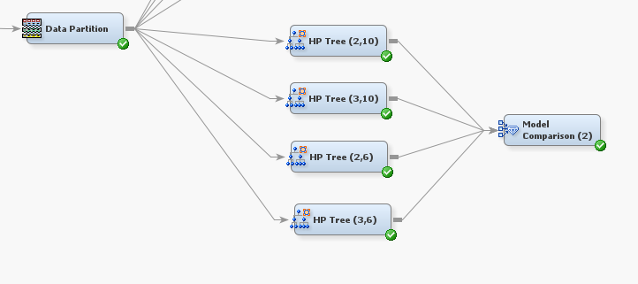

Figure HP Tree Nodes

#### Model Construction and Optimization

|  |  |
| --- | --- |
| **Properties Setting** | **Output** |
|  |   **MISC Train: 0.21034**  **MISC Validation: 0.222389** |
|  |   MISC Train: 0.171606**  **MISC Validation: 0.219989**  MISC plot above shown overfitting of 4.8%, thus this model is not acceptable. |
|  |   MISC Train: 0.223107**  **MISC Validation: 0.223539** |
|  |   **MISC Train: 0.209907**  **MISC Validation: 0.213314** |

To compare MISC for train and valid data set from different property settings of each model, Model Comparison node is used to give an overview of misclassification rate in respective model:

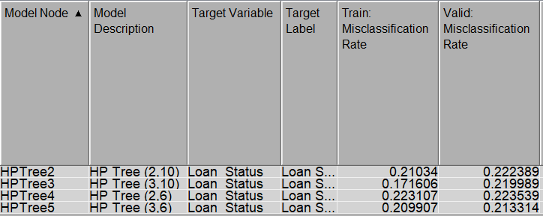

Figure Model Comparison

From the outcomes above, Model 2 has the lowest MISC value of 0.171606 for train data but Model 4 gives the lowest MISC validation of 0.213314 rate. Model 2 is not under consideration as train data is significantly lower than the valid data with 4.8% overfitting occurring. As a result, we can conclude that HP Tree **Model 4** is the best model among the options with lowest valid error when considering training and validation performance and striving for improved generalization.

#### Model Validation

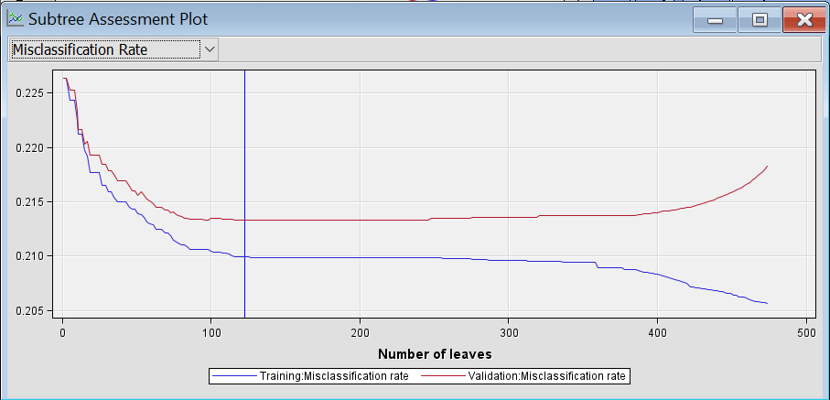

Figure Subtree Assessment Plot MISC

The misclassification rate of training and validation data is shown in the Subtree Assessment Plot above. The plot with 123 number of leaves in blue vertical line identify the optimal subtree size based on misclassification rate evaluation. The train data MISC is 0.209907, where valid data is 0.213314 at the same leaves. The vertical line stopped at the lowest point of validation data to avoid overfitting.

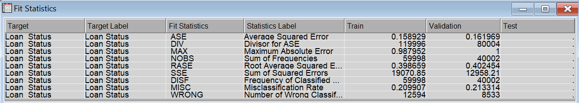

Figure Fit Statistics

MISC indicates the rates that were incorrectly predicted and misclassified cases by the model. Train data gives an accuracy percentage of 79%. Whereas validation data gives 78.67% of accuracy. In short, a lower MISC rate, symbolize a higher accuracy of model performance in predicting the bank loan status.

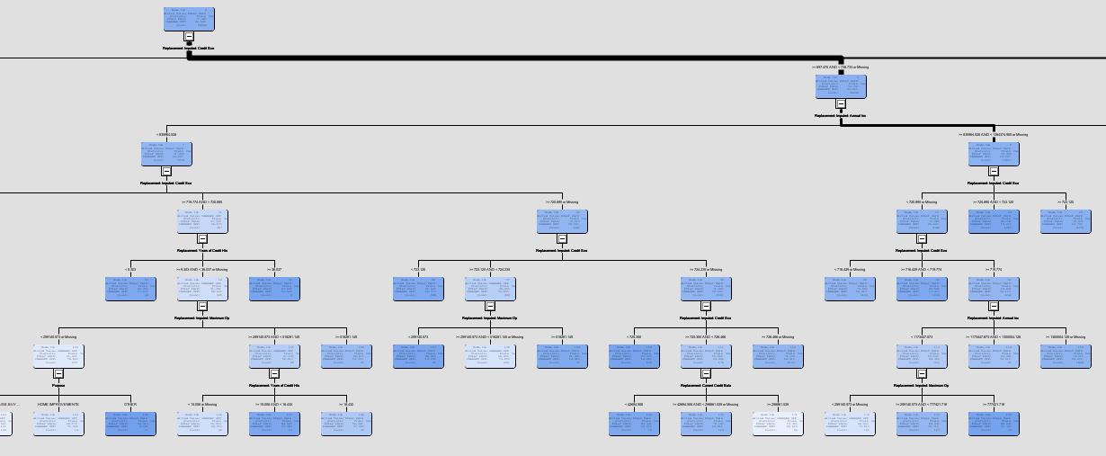

Figure HP Tree View

Tree diagram above displayed a HP Tree with maximum 3 branches and maximum depth of 6 using Assessment subtree method, Automatic selection method with misclassification nominal target assessment property settings.

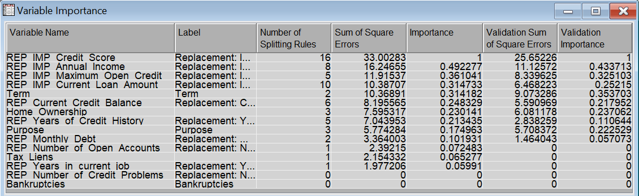

Figure Variable Importance

Credit score variable has the highest importance value followed by annual income. Variables like maximum open credit, current loan amount, loan term, current credit balance, etc will be slightly relevant to the model but not as important as credit score in predicting the result.

#### Critical Interpretation of Outcomes

Summarize how each method performed on the testing data by classifying loan status into two classes such as fully paid and charged off.

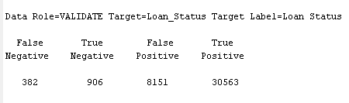

Figure Event Classification Table

|  |  |  |  |
| --- | --- | --- | --- |
| **Actual** | | | |
| **Predicted** | **Loan Status** | **POSITIVE**  *Fully Paid* | **NEGATIVE**  *Charged Off* |
| **POSITIVE**  *Fully Paid* | **True Positive: 30,563**  There are 30,563 cases where loan status is fully paid that were correctly predicted by the model. | **False Positive: 8,151**  There are 8,151 cases where the model incorrectly predicted “Fully Paid” when the actual is “Charges Off”. |
| **NEGATIVE**  *Charged Off* | **False Negative: 382**  The model predicted wrongly where 382 customers loan status actually “Fully Paid” but it was predicted as “Charged Off”. | **True Negative: 906**  This is where the model predicts loan status as “Charged Off” is same as the actual result. |

**Node Rules Interpretation**

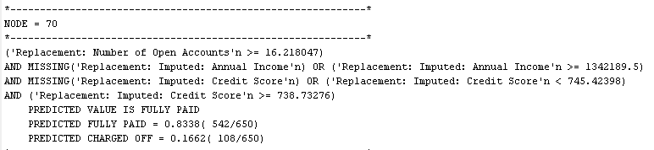

The node rule shows that customers with annual income at least 1342189.5, number of open accounts more than 16.218047 and credit score range between 738.73276 and 745.42398 are predicted “Fully Paid” with a high probability of 0.8338 (542 out of 650 cases). Customers with these conditions have the loan repayment ability mostly because of annual income at least 1342189.5 shows a strong financial competence to converge loan commitments. Also, the high number of open accounts of 16 or more denotes that the customer has diversify financial responsibilities which financial position is stable and well managed. Customers that show these criteria may be more cautious while borrowing a loan which they are able to pay back, increasing the chance of successful loan repayment.

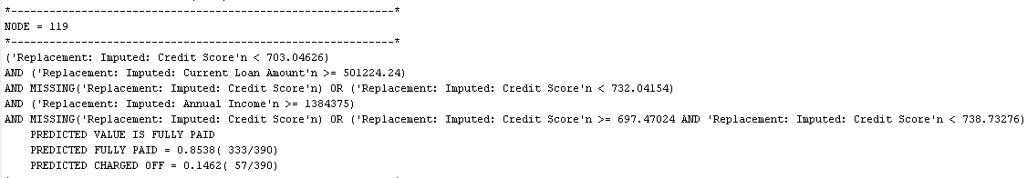

This set of conditions define a rule-based classification model. The model predicts that the loan is "Fully Paid” with a probability of 0. 8538 (333 out of 390 cases) if the customer satisfied conditions stated in the node rule. The conditions are based on certain factors, credit score, current loan amount and annual income. Several assumptions are made understanding why customers with these circumstances may pay their entire loans. For example, customers with a credit score range of 697.47024 to 738.73276 may prove a stable credit management history. Besides, customers with stable employment provides a secure income stream, achieving it more likely to make loan payments. The model's rules provide boundaries for debt, income, and creditworthiness degrees, uncovering a cautious attitude to loan approval. Customers that justify these conditions may be deemed as low-risk applicants.

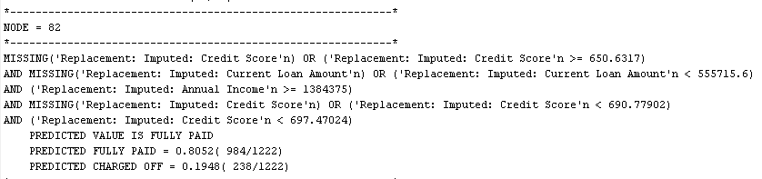

If the customer financial data met the conditions of annual income at least 1384375, credit score from 650.6317 to 697.47024 as well as current loan amount less than 555715.6. The model predicts that the loan will be "Fully Paid” with a probability of 0. 8052 (984 out of 1222 cases) and “Charged Off” 0. 1948 (238 out of 1222 cases). Based on the criteria, some assumptions are made to determine why customers with these conditions can fully pay their loans. For instance, customers fulfilling these measures likely have a strong financial profile characterized by a combination of higher income, positive credit history, and affordable loan amount. Annual income and credit score ranges indicate customers with stable employment and reliable credit behaviour. Hence, people with this financial information will probably fully paid their loan with high chances of 80.52 percent.

# Model Comparison

As per the requirements, we have built 6 models in this data analysis process, and we made a model comparison at the end of the analysis. As there are 2 different preprocessing methods utilized for the decision tree and HP Tree model in our analysis, therefore we will review these models independently by using two model comparison nodes.

In the first preprocessing process we used, we compared 2nd-degree backward regression, 3rd-degree forward regression, and 45D neural networks. Among these 3 models, the 3rd-degree forward regression gets the best result in terms of the ROC curve below.

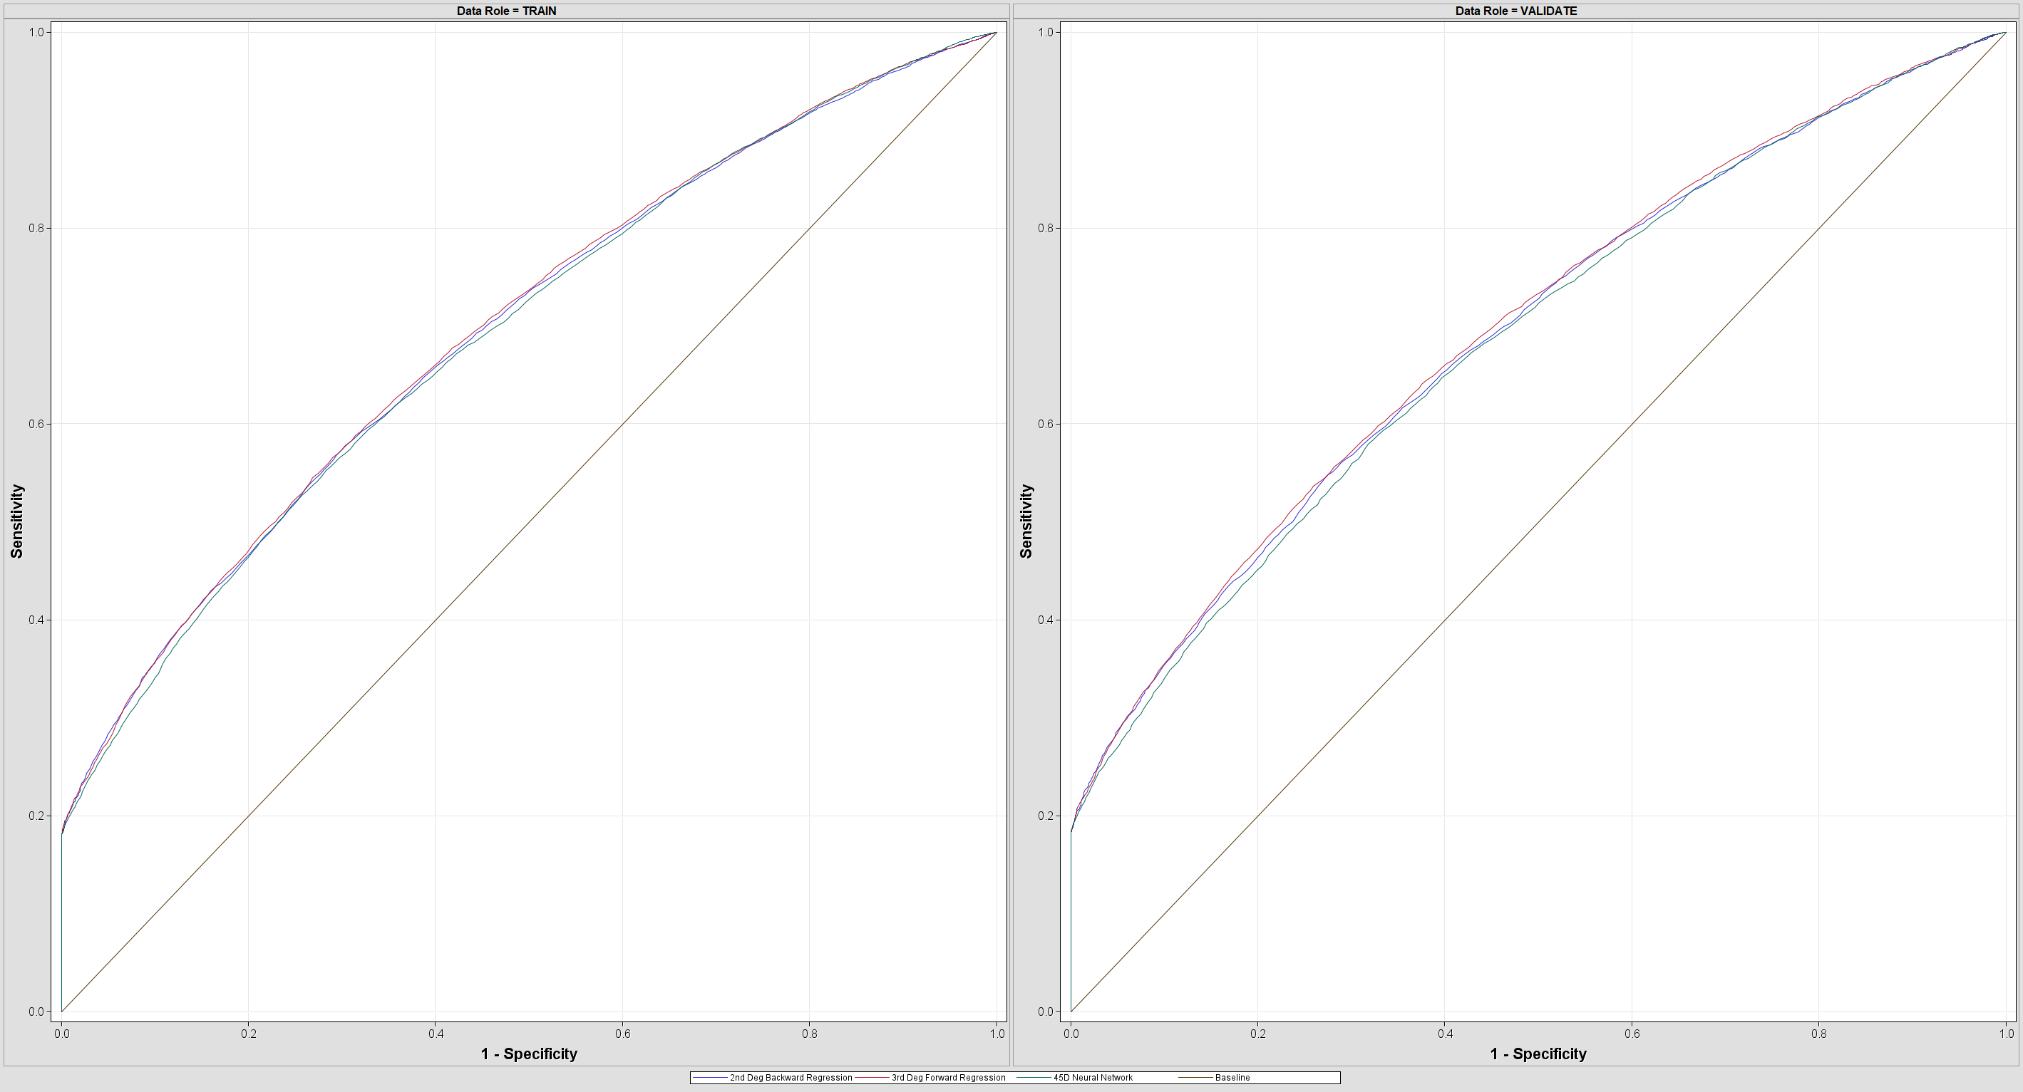

Figure ROC curve 1

Following that, we check on the misclassification chart of 3 models, due to the proportional resampling used in preprocessing, the models here have a higher bias in the prediction that it can predict the ‘Fully paid’ class accurately but it is terrible in predicting the ‘charged off’ class.

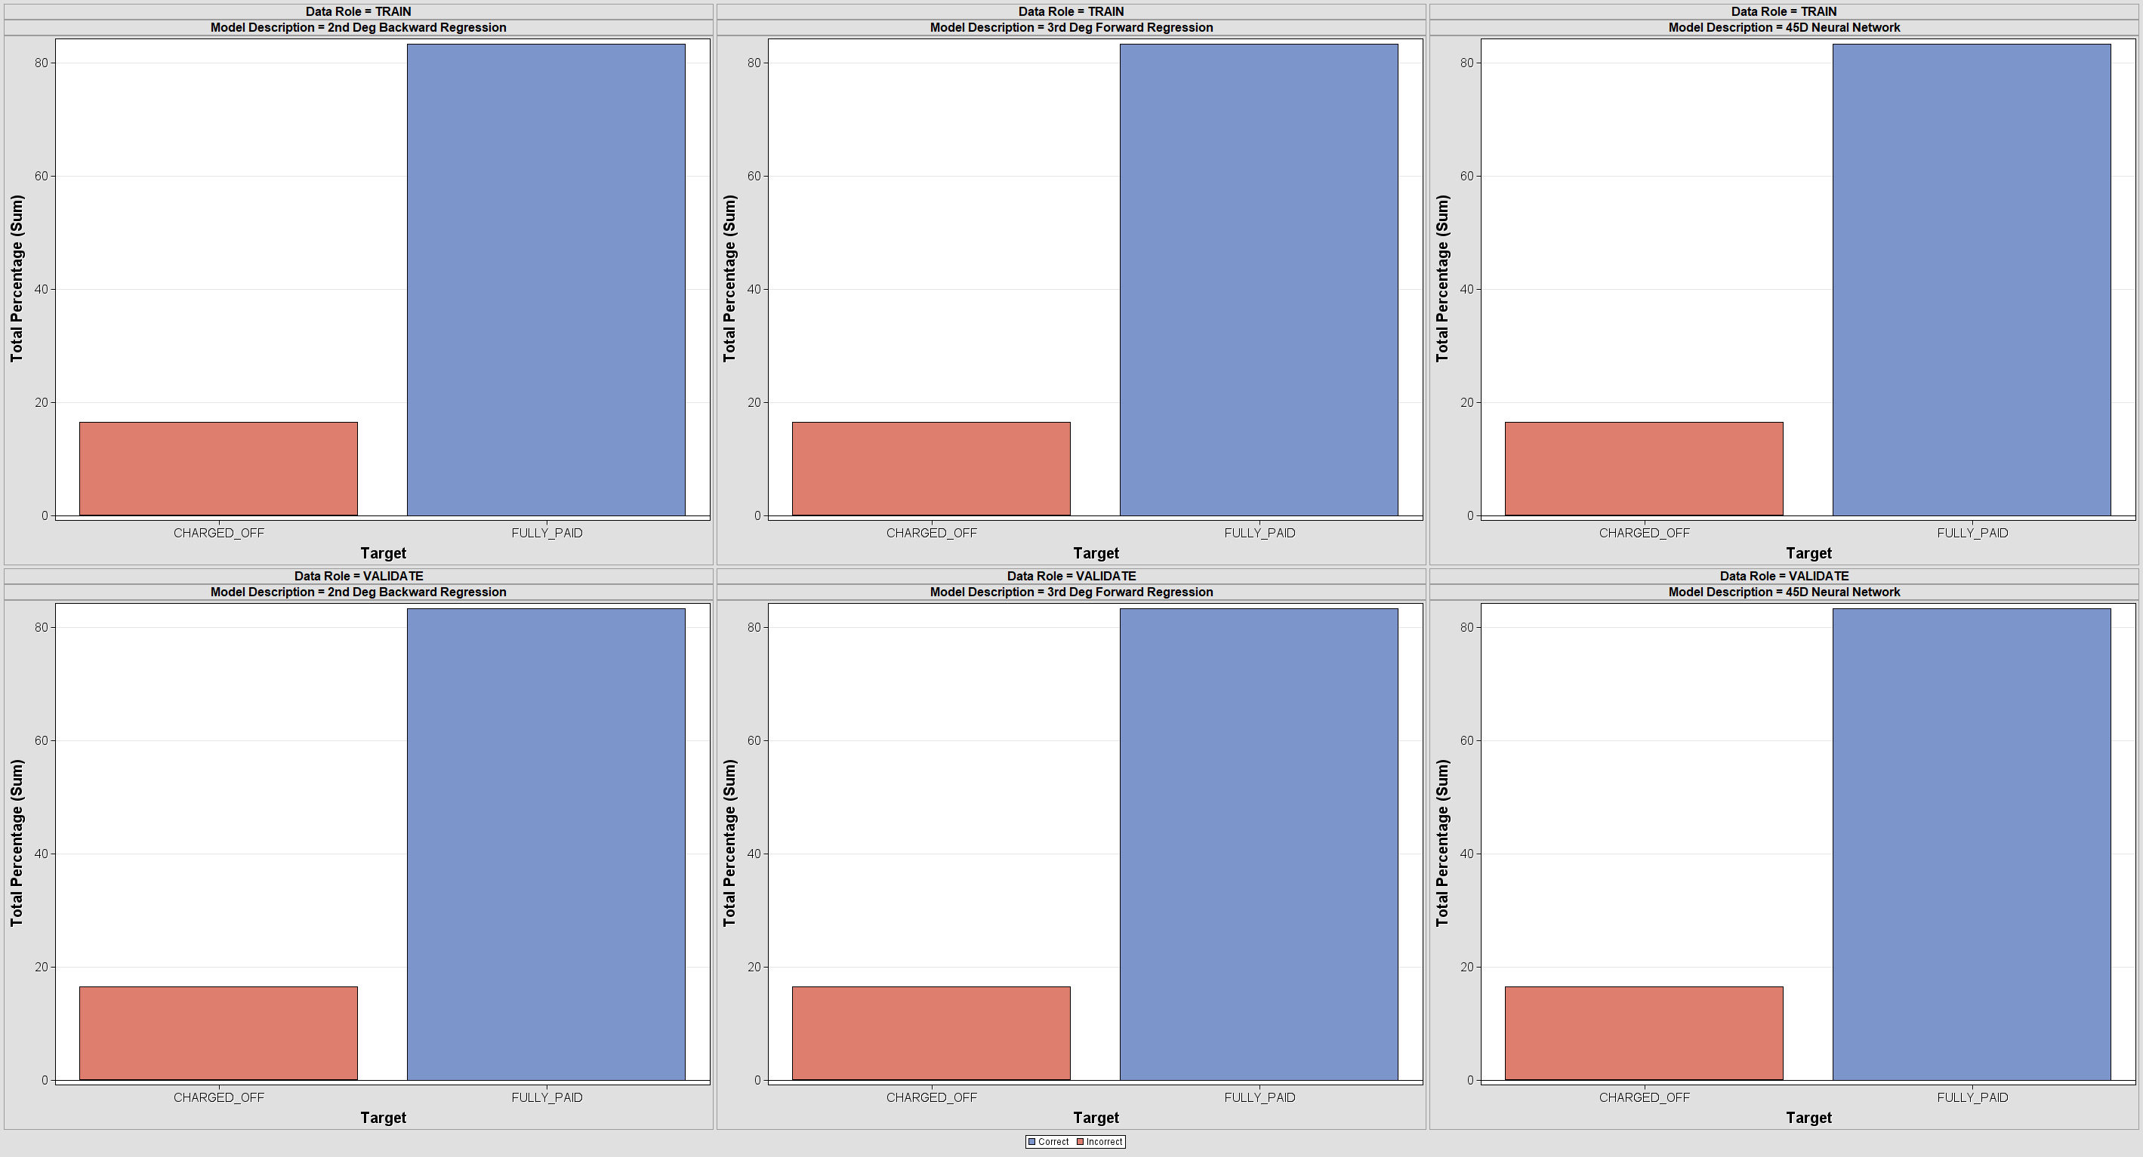

Figure Misclassification Chart 1

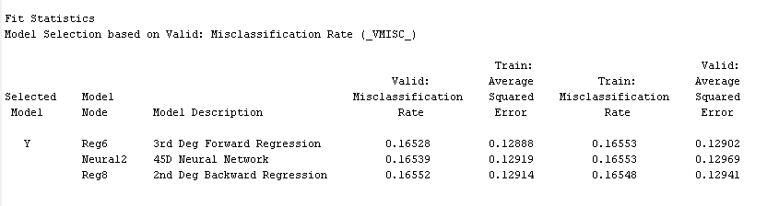

Figure models fit statistics 1

In terms of the comparison of validation misclassification rate, 3rd-degree forward regression gets the best result of 0.16528 as well.

For the decision tree and HP Tree, there are some differences in terms of missing values imputation and data transformation. Using different preprocessing has successfully built the most optimized decision tree and HP Tree model in the data analysis. We also tried to connect the other model to this processed data here, but the models only gain less accuracy. Therefore, this customized data preprocessing best fits with the decision tree and HP Tree models made.

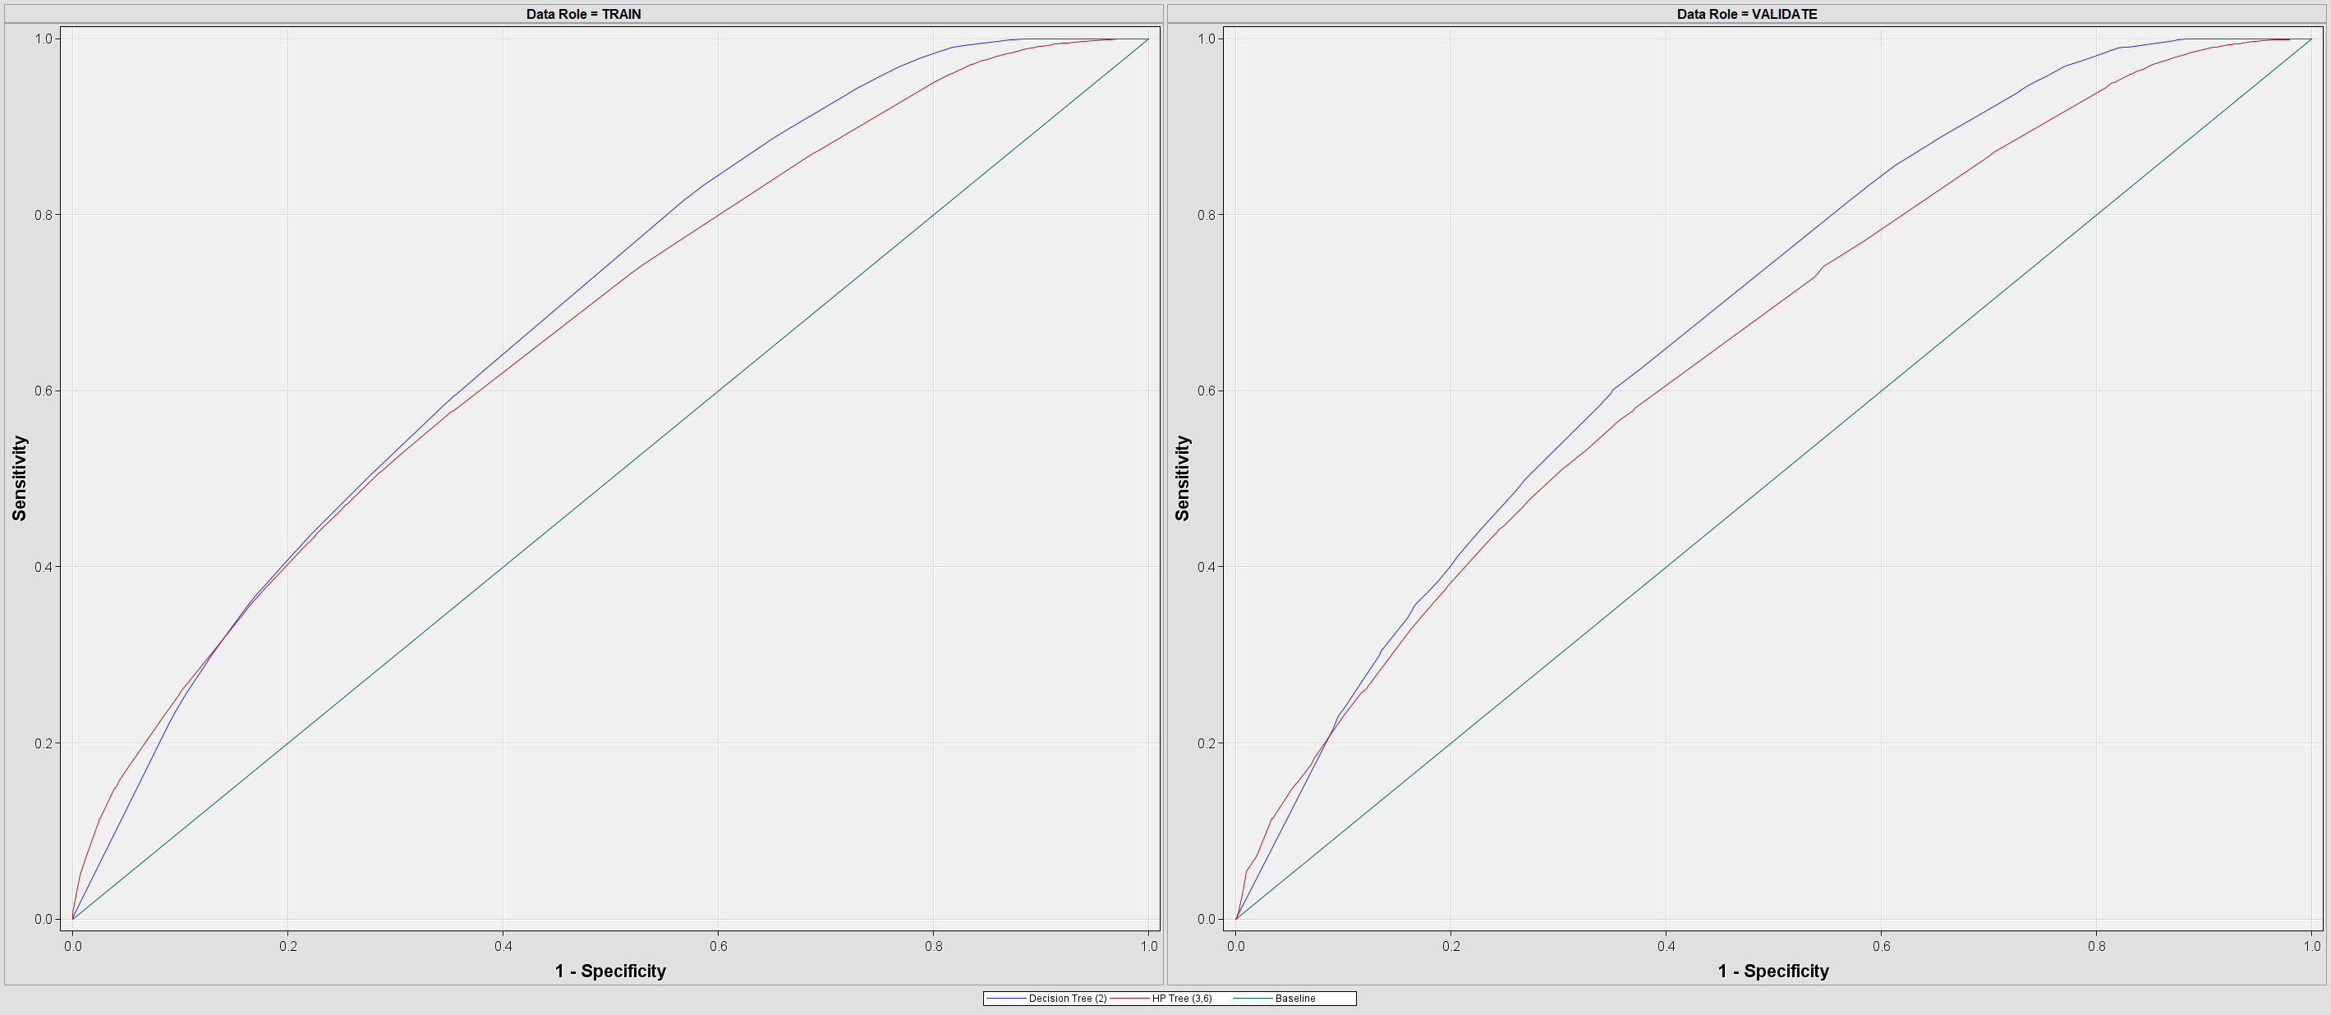

Figure ROC curve 2

In this preprocessing method, the ROC chart shows that the decision tree has a better prediction result than HP Tree in the validation data.

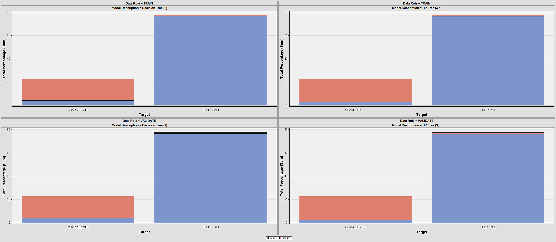

Figure Classification chart 2

For the misclassification data, the bar chart shows that the decision tree is superior to HP Tree in predicting the ‘Fully Paid’ class as it has less incorrectness in the graph.

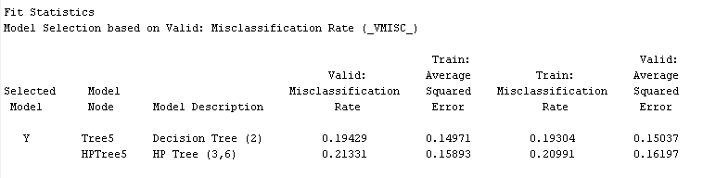

Figure Models fit statistics 2



Figure clustering segment variables importance

For the clustering analysis we have done, we can use it to find the most important features in the dataset. We found that monthly debt, maximum open credit, and current credit balance are the 3 most relevant variables in predicting the status of the loan. Furthermore, we attempted to discover the underneath patterns of loan status behavior. However, it is still the same as the dataset with only two main segments in the result.

Finally, we will choose the final proposed model from our analysis. Before choosing our final model, we also need to review the strength of each of the models we built.

|  |  |  |  |
| --- | --- | --- | --- |
| Algorithm/Model | Advantages | Disadvantages | Preparation model using |
| 3rd degree forward regression | capture more sophisticated relationship between the variables | Not suitable for all of the dataset as the high degree might lead to overfitting and bias | Proportional sampling |
| 2nd degree backward regression | identifies the moderate complex relationship between the variables by removing the variables that is irrelevant | Select the variable by using removing method can cause information loss  The result is certainly affected by the removing order of attributes | Proportional sampling |
| 2-cluster clustering analysis | As the clustering analysis calculates the Manhattan distance between the data and therefore it can discover the underneath behavior in the dataset | The analysis process will be time-consuming if the dataset is huge and having intricate clusters | Proportional sampling |
| 45-hidden unit neural network | connects the nodes based on activation threshold and therefore identifying the associate rules and draw up the conclusion by using explainable surrogate model | The tuning process is challenging, and the neural network needs to be fed with huge dataset to ensure its accuracy | Proportional sampling, regression |
| Decision tree | an excellent model that is suitable for both regression and classification modeling using interpretable way. | Highly depends on structure, entropy, and hierarchical of the dataset | Proportional sampling |
| HP Tree (Highly Pruned Tree) | an enhanced decision tree model that reduces the modeling overfitting while maintaining the interpretability of the modeling process | The pruning will cause the data loss and will not get the best optimized performance if the pruning strategy is not proper | Proportional sampling |

Table 8 Models strength comparison

After reviewing the algorithm’s strengths and drawbacks, we think that model bias will be our main consideration. When the model comes to deployment to solve real-world problems, we might allow it to have a little bit lower accuracy, but it should not have a high bias until the minority class is neglected. Furthermore, the decision tree is highly interpretable that it also provides persuasive node rules that are visible to people. Therefore, the final model we proposed in this project would be the **decision tree** with the MISC of **0.19429 (Accuracy: 80.57%)**.

# Discussion

Data preprocessing is one of the integral parts of the data pipeline and data analysis that deal with raw data that is messy and unorganized. Data analysts always think that good data preprocessing can lead to the best model that helps them in doing data analysis. Nevertheless, there are no tips to do the ‘best’ preprocessing, instead, there is only preprocessing and a model that fits the dataset given. In other words, when and how to use the preprocessing methods is highly dependent on the current situation and dataset. Considering the best methods and models requires including many indicators like ROC, confusion matrix, and learning curve. This also makes the data analysis to be a try-and-error process. According to that, we have implemented a few different preprocessing methods in our data analysis, the main differences are in missing values imputation, data transformation, and resampling techniques.

For the loan status identification, we use cluster analysis to find any other status that we have not considered in the loan status class. In the end, we have not found any undiscovered pattern of the loan status as the clustering analysis result is the same as the level of the loan status (2). In other words, there are no grey areas between fully paid and charged-off loans.

Seeking a tradeoff between accuracy and bias is technically difficult. When the researchers obsess with the high accuracy of the model, it will lead to overfitting, reliance on the training data, and failure to predict the new data input when the model comes to deployment. Meanwhile, when the model training and preprocessing excessively eliminates the data using dimension reduction and drop, it will reduce the variance and entropy within the dataset, generating an oversimplified model. The shallow prediction of the model considers fewer variables and factors that affect the result, leading to an inaccurate prediction and neglecting important undiscovered patterns in the dataset.

# Conclusion

In this project, we have been involved in comparing six different models by using ROC charts and classification charts. We tried to find a balance between bias and accuracy in the models we built. This data analysis project involved the creation and comparison of six different models with distinct preprocessing methods. Each model was evaluated based on various metrics, including iteration plots, ROC curves, misclassification charts, and fit statistics. The project aimed to strike a balance between accuracy and bias while considering the specific strengths and limitations of each algorithm and evaluating the best model which can train the best result outcome. The analysis began by comparing four models—2nd-degree backward polynomial regression, 3rd-degree forward polynomial regression, 2 clustering, and a 45D unit neural network. Among these, the 3rd-degree forward polynomial regression obtains the best performance in terms of ROC curve and validation misclassification rate. The decision tree demonstrated superior performance in terms of ROC curve and misclassification rates, outperforming the HP Tree model. **The decision tree was chosen as the proposed final model due to its interpretability, explanatory node rules, and balanced performance.** It has been recognized that balancing accuracy and bias is difficult because doing so can lead to overfitting or oversimplification.

In conclusion, this study highlighted the dynamic and iterative nature of data analysis, where different preprocessing techniques and models are investigated and evaluated to discover the optimal answer for the issue at hand. It emphasized the significance of thoroughly evaluating models and being aware of the accuracy-bias trade-off to get a balanced and useful outcome.

# References

Brian, A. (2021, na na). *What is CRISP – DM Methodology?* Retrieved from InsideAIML: https://insideaiml.com/blog/What-is-CRISP-%E2%80%93-DM-Methodology%3F-250

Hotz, N. (2023, January 19). *What is CRISP DM?* Retrieved from Data Science Process Alliance: https://www.datascience-pm.com/crisp-dm-2/

IBM. (2021, August 17). *CRISP-DM Help Overview*. Retrieved from IBM: https://www.ibm.com/docs/en/spss-modeler/saas?topic=dm-crisp-help-overview

Rodrigues, I. (2020, February 17). *CRISP-DM methodology leader in data mining and big data*. Retrieved from Toward Data Science: https://towardsdatascience.com/crisp-dm-methodology-leader-in-data-mining-and-big-data-467efd3d3781

S, P. (2022, September 28). *Understanding Polynomial Regression Model*. Retrieved from Analytics Vidhya: https://www.analyticsvidhya.com/blog/2021/10/understanding-polynomial-regression-model/

SAS. (2017, August 30). *HP Tree Node*. Retrieved from SAS Help Center: https://documentation.sas.com/doc/en/emref/14.3/n0vvj2elvaoz3mn1516yd3dx2deu.htm

Simplilearn. (2023, February 14). *What Is Backward Elimination Technique In Machine Learning?* Retrieved from Simplilearn: https://www.simplilearn.com/what-is-backward-elimination-technique-in-machine-learning-article

smartvision. (na, na na). *What is the CRISP-DM methodology?* Retrieved from SMARTVISION-europe: https://www.sv-europe.com/crisp-dm-methodology/

Abhishek Anand, Arvind Govindarajan, Luis Nario, Kirtiman Pathak, Marcia Banks, Som-Iok Leung, & Juliane Saary-Littman. (2022, December 23). *Data and analytics innovations to address emerging challenges in credit portfolio management*.

Khan, M. T. I. (2022). Trust in peer-to-peer (P2P) lending platforms in Malaysia: understanding the determinants from retail investors’ perspectives. *Journal of Economic and Administrative Sciences*. https://doi.org/10.1108/JEAS-08-2021-0148

OECD. (2022). *Financing SMEs and Entrepreneurs 2022*. OECD. https://doi.org/10.1787/e9073a0f-en

Tambunan, T., Santoso, W., Busneti, I., & Batunanggar, S. (2021). The development of MSMEs and the growth of peer-to-peer (P2P) lending in Indonesia. *International Journal of Innovation, Creativity and Change. Www. Ijicc. Net*.

Zhong, W., & Jiang, T. (2021). Can internet finance alleviate the exclusiveness of traditional finance? evidence from Chinese P2P lending markets. *Finance Research Letters*, *40*, 101731. https://doi.org/10.1016/j.frl.2020.101731